USING BREADBOARDS

General description: A breadboard is device that allows for simple assembly and disassembly of a circuit without the need for large numbers of connecting wires or soldering. In the image there is a single strip of conducting metal under holes A1, B1, C1, D1, and E1. This means that if the wires at the ends of two resistors are pushed into any two of the holes listed above those two ends will be connected by a conducting path. The same can be said for holes A2-E2, A3-E3, etc. as well as holes F1-J1, F2-J2, etc. The row of holes down the entire long side, on both sides with a plus at either end are connected by a conducting strip as well as those with a minus at both ends down the length on both sides. Any of the holes that are not connected such as those on rows 2 and 10 could be connected by attaching a jumper wire from anywhere on one row to anywhere on the other row.

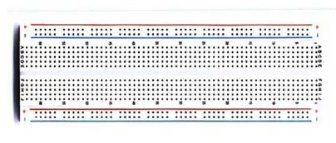
The image below shows the section of the breadboard for the first five rows (the right hand end of the image above, but rotated ninety degrees. The resistors shown on the board are connected in series. The top left resistor is connected from +1 to B1, the right side resistor is connected from E1 to E5 and the bottom left resistor is connected from -5 to C5. Connecting the positive side of a battery to anywhere on the + line and the negative side to anywhere on the negative line would create a complete circuit with current flowing clockwise around the circuit. The two ends of an appropriate meter could also be connected to the + and – row to measure the voltage across, the current through, or the resistance of the set of resistors. Note that connecting any element between any two of the points A1, B1, C1, D1, E1. or A2-E2, or F1-J1, etc would short circuit that element (so don’t do this).
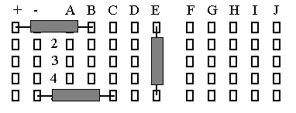

The image below also shows the section of the breadboard for the first five rows. The resistors on the left side connected from B1 to B5, C1 to C5, and D1to D5 are connected in parallel. To measure the voltage drop for each of the resistors, the current supplied to them, or their total (equivalent) resistance the ends of the appropriate meter could be attached to A1 and A5. Note that the resistor connected from G1 to G5 is not electrically connected to any of the other resistors since there is no direct connection between A-E and F-J. A jumper wire could be connected between E1 and F1 and E5 and F5 to bridge this gap and connect the rightmost resistor to the other three.

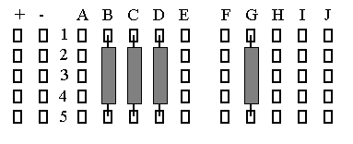

In the image below the jumper wires connecting E1 to F1 and E5 to F5 connect the resistor on the G row to the rest of the circuit (in parallel with the D row resistor).

