IB PHYSICS II
ENREGY AND FREQUENCY
OF LIGHT

DESIGN

Introduction: The purpose of this lab is to determine the affect of the frequency of light (independent variable) on the energy required to produce the light (dependent variable).

Apparatus:

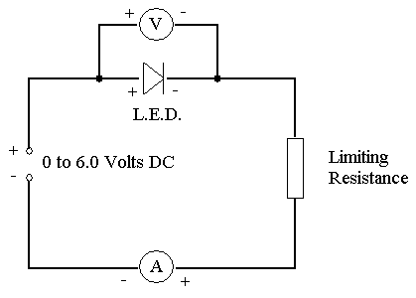

Materials:

- Infrared L.E.D.
- Red L.E.D.
- Yellow L.E.D.
- Green L.E.D.
- Blue L.E.D.
- UV L.E.D.
- Bread board
- Digital multimeter (used as an ammeter)
- Analog voltmeter
- Jumper wires
- Alligator clip lead wires
- Banana plug lead wires
- 150 ohm resistors
- 220 ohm resistors
- Low voltage power supply

L.E.D. information:
- L.E.D.’s are directional circuit elements. This means that current can only flow through them in one direction. The longer lead wire on the L.E.D. is the positive lead.
- When the potential difference across an L.E.D. is large enough an electron is boosted up into the conduction band allowing current to flow.
- When an electron is boosted into the conduction band it leaves a “hole” in a valence electron orbital into which an electron can fall emitting a photon.
- L.E.D.’s are sensitive circuit elements if too much current flows through them or too large a potential difference is placed across them they will fail. To keep the current and voltage within limits and the L.E.D. from failing a limiting resistance is generally placed in series with the L.E.D.
- The table below shows the characteristics of the L.E.D.’s available for this lab.
- The limiting resistance should be slightly smaller than the typical resistance shown but must be larger than the minimum resistance shown.

LED SPECIFICATIONS
color | wavelength (nm) | Typical voltage (V) | Typical current (A) | Typical resistance (ohms) | Maximum Voltage (V) | Maximum Current (A) | Minimum Resistance (ohms)
Infrared | 940 | 1.2 | 0.05 | 96 | 1.6 | 0.10 | 44.0
Red | 660 | 1.9 | 0.02 | 205 | 2.4 | 0.025 | 142.5
yellow | 587 | 2.1 | 0.02 | 195 | 3 | 0.03 | 100.0
green | 570 | 1.9 | 0.02 | 205 | No data available
blue | 430 | 3.2 | 0.02 | 140 | 3.8 | 0.024 | 92.6
UV | 395 | 3.2 | 0.02 | 140 | 3.8 | 0.024 | 92.6

Preliminary Procedure (For each color of L.E.D., due on lab day prior to the start of lab)

- Show a sample calculation for a limiting resistance using only a combination of 150 ohm and/or 220 ohm resistors in series and/or parallel combinations that results in a limiting resistance slightly smaller than the listed typical resistance, but larger than the minimum resistance.
- Draw the circuit diagram above showing each resistor used in the limiting resistance placed appropriately in the circuit.

Procedure (for each color of L.E.D.):

- Using the breadboard, jumper wires and wire leads, connect the circuit as shown in your first circuit diagram. The digital multimeter will be used as an ammeter, and should use the larger (10 A connection). Have the teacher check at least your first circuit before continuing.
- Set the multimeter knob on the 10 A setting.
- Turn the knob on the low voltage power supply counter clockwise until just before it clicks. Once it is plugged in it will now be on, but set at zero volts/amps.
- Plug in the low voltage power supply. It may be left plugged in for the remainder of the lab.
- Turn the knob on the power supply clockwise slowly until the current reading on the multimeter is 0.1 - 0.2 mA. Record the current and voltage reading. Note: Initially as the knob on the power supply is turned clockwise the voltage across the L.E.D. will increase with very little or no change in the current through the L.E.D.
- Continue turning the knob on the power supply clockwise stopping to record the potential difference and current through the L.E.D. every 0.1 - 0.2 mA, until a small change in potential of only 0.1 - 0.2 V results in a several tenths of a mA change in the current.
- Continue turning the knob on the power supply clockwise, but now stop to record the potential difference and current through the L.E.D. every 0.05 - 0.1 V.
- Stop turning the power supply knob clockwise when the potential across the L.E.D. or the current through the L.E.D. approaches the maximum value listed in the L.E.D. table or when the power supply knob can no longer be turned clockwise any further.
- Repeat the procedure for each color of L.E.D.

Analysis Questions:

- For each L.E.D. draw a characteristic graph as shown in the example below. Graph current (I/mA) VS. potential difference (ΔV/V). After plotting each point extrapolate the portion of the graph that appears linear by drawing a straight best fit line through these data points to determine the minimum voltage V₀ for each L.E.D. from the x – intercept. Use a separate coordinate axis system for each graph, and do not forget about uncertainty! (10 marks)

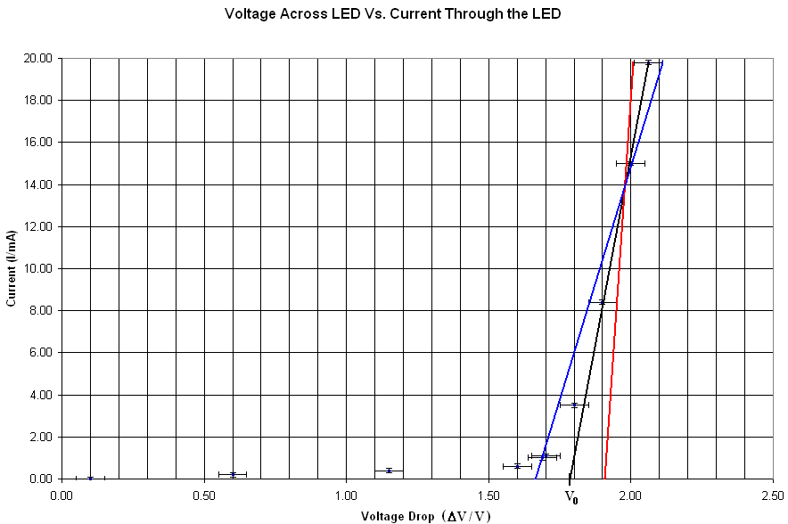

- Show a sample calculation for the frequency of one of the L.E.D.’s. (3 marks)
- Record the color, wavelength, frequency, and characteristic voltage for each of the L.E.D.’s in a single table. (3 marks)
- Graph the minimum voltage V₀ against the frequency of the light emitted by each L.E.D., and do not forget about uncertainty. (3 marks)
- Calculate the slope of the line from the minimum voltage V₀ against the frequency graph. (3 marks)
- Compare the slope value from the minimum voltage V₀ against the frequency graph to a standard value for Planck’s constant (in eVs). Be sure to cite the source of the value you use for Planck’s constant. (3 marks)
- Comment on the value you arrived at for Planck’s constant, as compared to the standard value with reference to uncertainty, errors or limitations in the data or calculations. (2 marks)

- Explain why it is reasonable to compare the slope from the minimum voltage V₀ against the frequency graph to Planck’s constant in eVs, even though the units for the slope of the graph are in V.s. (2 marks)

Assessment criteria: Data collection & course grade for analysis questions. Graphs may be completed by hand or electronically.

