Physics Dept MPTC
AIRLINE GARAGE.

Main Office 102 lab 026
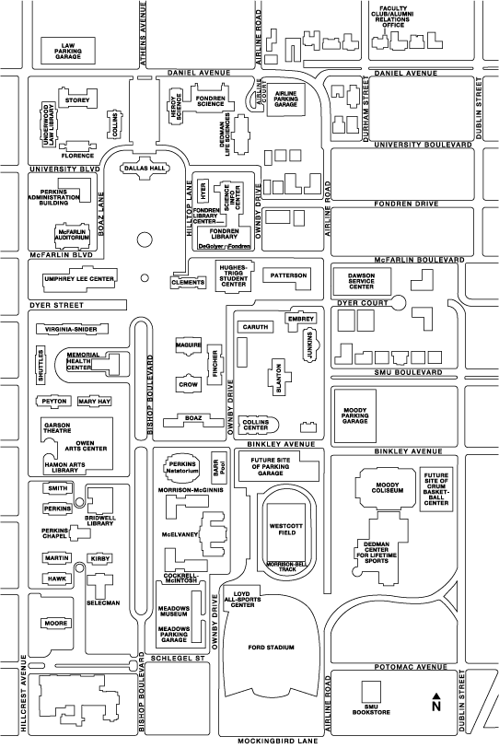
Dalley Office 207
University Blvd surface lot
Mockingbird to Hwy 75
University to Hwy 75

