

Professional Learning Agreement
for
SMU Master Physics Teacher Certificate
Mechanics Module (Modelling Workshop), Summer 2017

Classes for this module will run June 5-23, 9:00 am to 4:00 pm Monday through Friday.
Participants must attend punctually and regularly the classes at SMU. Participants will be assessed on their journal of lab work and meaningful participation in the workshop classes. A certificate of PD will be awarded upon satisfactory completion of the module. This workshop is endorsed by the American Modeling Teachers Association (AMTA). All materials for the course (textbook, AMTA licensed content, lab supplies) will be provided. There are no tuition fees and no graduate credit is awarded by SMU.
To secure your place on this module, please complete your details below and mail/email this form to:
Dr. Simon Dalley, SMU Physics Department, PO Box 750175, Dallas, TX 75275-0175. sdalley@smu.edu

Please fill out your contact details here (type or print legibly):

Name:

School:

Mailing address:

Email: Phone:

(provide an email good for contact in summer, not blocked by school
spamware or add sdalley@smu.edu to allowed senders)

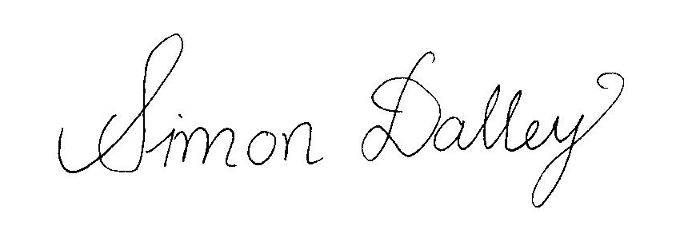 15/12/2016
____________________________ ___________________
Simon Dalley, Ph.D. Date
MPTC Director

_____________________________ ___________________
Participant Date

