

Professional Learning Agreement
for
SMU Master Physics Teacher Certificate
Mechanics Module (Modeling Workshop), Summer 2020

Classes for this module will run June 17- 30, 8:15 am to 3:30 pm Mondays through Fridays. Participants must attend punctually all of the classes at SMU. Participants will be assessed on their journal of lab work and meaningful participation in the workshop classes. A certificate of PD will be awarded upon satisfactory completion of the module. This workshop will be led by Nicholas Park (Greenhill School) and is endorsed by the American Modeling Teachers Association (AMTA).
Cost: Free (sponsored by Fluor Foundation). All materials will be provided.
To Enroll: Complete your details below as soon as possible and email or mail this form to:
Dr. Simon Dalley, SMU Physics Department, PO Box 750175, Dallas, TX 75275-0175 sdalley@smu.edu

We will send an acknowledgement of receipt by email and further workshop details nearer the start date.

Please fill out your contact details here (type or print legibly):

Name:

School:

Mailing address:

Email: Phone:

(provide an email good for contact in summer, not blocked by school
spamware or add sdalley@smu.edu to allowed senders)

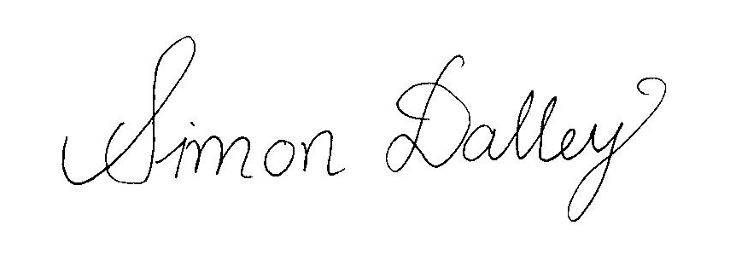 03/01/2020
____________________________ ___________________
Simon Dalley, Ph.D. Date
MPTC Director

_____________________________ ___________________
Participant Date

