**MPTC**

**Error Analysis**

**Introduction**

Error in this context does not mean mistake but rather refers to the uncertainty in a measurement. All measurements in practice and even in principle have some error associated with them; no measured quantity can be determined with infinite precision.

**Statistical Errors (also known as Random Errors)**

Most measurements involve reading a scale. The fineness of the scale markings (how close together they are) is limited and the width of the scale lines is nonzero. In every case, the final reading must be estimated and is therefore uncertain. This kind of scale-reading error is random since we expect that half of the time the estimate will be too small, and the other half of the time the estimate will be too large. We expect that random errors should cancel on average, that is, many measurements of the same quantity should produce a more *precise* estimate. Statistical errors can be controlled by performing a sufficiently large number of measurements. The error estimate on a single scale reading can be taken as the scale width. For example, if you were measuring length with a scale marked in millimeters, you might quote the reading as 17.0 mm ± 0.5 mm or perhaps 17 mm ± 1 mm. If you measured the same length many times, you would expect the error on the measurement to decrease. This is indeed the case. The best estimate of the measured quantity is the mean or average of all the measurements. Simply add all the individual measurements together and divide by the number of measurements. The best estimate of the error associated with the mean value is called the "error on the mean" and is given by (the error on a single measurement) divided by (the square root of the number of measurements). Obviously, this will decrease as the number of measurements increases. The final reading for a quantity should be quoted as: (mean) ± (error on the mean).

Finding the mean and its error is a special case of more generally computing the error on a quantity that you calculate (as opposed to a quantity that you measure directly). Propagated errors can be used to figure out the error on the answer to a calculation in terms of the independent errors on the original data that go into the calculation.

**Error Propagation**

**Addition and Subtraction**

If several quantities with associated independent random errors are given by: x ± Δx, y ± Δy, ... , z ± Δz, then the sum or difference is given by q ± Δq , where q might be

q = x + y - z

and the error on q is propagated from the errors on x, y, ... , and z as follows

http://www.physics.smu.edu/rguarino/mechmanual/error/add.gif

Notice that the errors are added in quadrature, even when the quantities are being subtracted. The error always increases when adding or subtracting quantities.

**Multiplication and Division**

If several quantities with associated independent random errors are given by: x ± Δx, y ± Δy, ... , z ± Δz, then the product or quotient is given by q ± Δq where q might be

q = x*y/z

and the error on q is propagated from the errors on x, y, ... , and z as follows

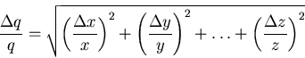

**Systematic Errors**

These errors are more insidious than statistical errors. Systematic errors are difficult to detect, and the sizes of systematic errors are difficult to estimate. Increasing the number of measurements has no effect on systematic errors because the error is always in the same direction (all measurements too high, or all measurements too low) making the result *inaccurate*. Careful instrument calibration and understanding of the measurement being made are part of prevention. For example, suppose that you are using a stopwatch to time runners in the 100-meter dash. You are quite adept at making the measurement, but -- unknown to you -- the watch runs 5% fast. All times will be 5% too high. There will be no immediately obvious indication of a problem. If you happen to be familiar with the runners' normal times, you might notice that everyone seems to be having a slow day. To prevent such problems, one should calibrate the stopwatch with a known standard such as the Nation Institute of Standards and Technology's standard time service on short wave radio.

**General rules are:**

1) the error should have one significant figure; 2) the number of decimal places in the measurement should be the same as the number of decimal places in the error. Always remember: There is no such thing as "human error". Try to find the deeper cause for any uncertainty or variation.

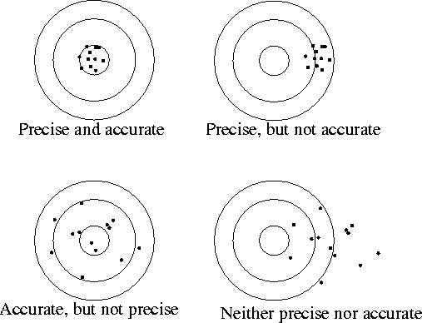

**Procedure 1**

Measure the width of a standard letter-sized page. Remember the units and an error estimate from the measuring device used.   
  
Table measurements by the whole class   
  
Make a histogram of the data.

**Questions**

Do you observe statistical (random) errors in the data plotted on the histogram? Explain.

Do you observe systematic errors in the data plotted on the histogram? Explain.

Identify several sources of error and label them as random or systematic.

What is the mean width of the page? (Use correct data only.)

What is the error on the mean width of the page? (Quote your answer as xbest ± deltax )

Compare the error on the mean length with the error estimate from the measuring device.

**Procedure 2**

Measure the length of a standard letter-sized page.

Using your own measurement of the width, calculate the area with propogated error (Quote your answer as Abest ± deltaA)

**Something to think about….**

Measure the thickness of one page of any text book. Explain your procedure and reasoning in detail so that another student can duplicate your procedure. Remember to include units and an error estimate.

You should find that the error on the thickness is much less than the thickness itself. In general, the error **can** be larger than the measurement -- for example (0 ± 5) meters is perfectly acceptable, but for this particular measurement the error should be smaller.