|  |  |
| --- | --- |
| Lab Supplies for construction of cosmic ray detector at SMU Quarknet | |
|  |  |
|  | |
| Black Felt fabric (Hobby Lobby) | |
| Glass fish tank (PetMart) | |
| Polystyrene insulation Panels, Sheet steel (22 gauge | |
| Safety Glasses, Safety Gloves, Utility knives, | |
| Black paint, Utility tape, rubber hammer, | |
| paint brush, Cooler box (for dry ice | |
| transport), furring strip (Lowes) | |
| Neodymium Magnets (Amazing Magnets) | |
| Isopropyl alcohol | |
| Dry Ice pellets | |

Cut sheet steel to 6” x 12” (or base size of fishtank) paint and allow to dry overnight. Cut the polystyrene panels into 3 sheets somewhat larger than fishtank base. Cut out an area equal to fishtank base in 2 of the panels, stack on top of 3rd panel so as to make well for the dry ice and the fishtank. Soak the felt in alcohol, attach felt to glass bottom of fishtank using magnets, turn over and tape the steel sheet to the open side. 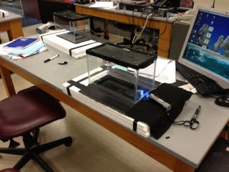Put dry ice in Polystyrene well, fishtank on top. Wait for alcohol vapor to condense near the steel sheet. Use a strong light source to highlight tracks in vapor. Put a radioactive source inside tank for more tracks