QUARKNET MEETING
rm 123 Fondren
AIRLINE GARAGE.

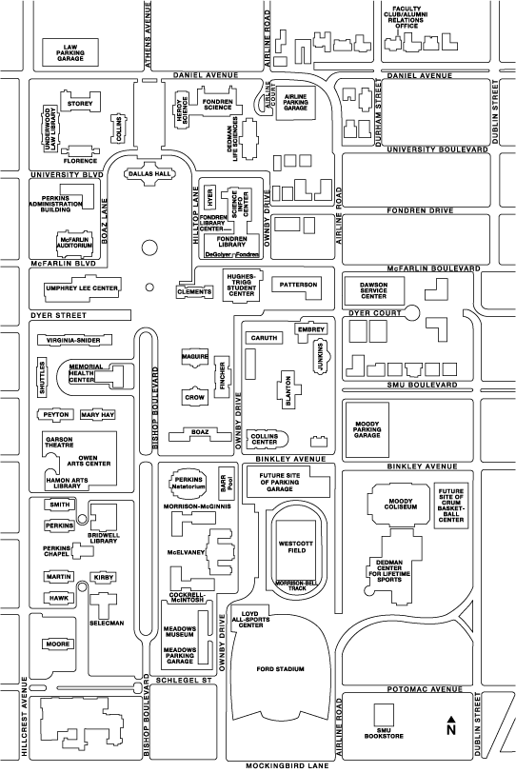
University Blvd surface lot
Mockingbird to Hwy 75
University to Hwy 75

