Question 1 Particulate Nature of Matter v1.2

Benchmark  NCLT Big Ideas  AAAS 2061  4.D.6-8.1 | Particulate nature of matter. Students will understand that all matter is made up of atoms and molecules held together by bonds, that these bonds vary in range and strength, and that an atom’s movement is in proportion to its temperature.  All matter is made up of atoms, which are far too small to see directly through a microscope. The atoms of any element are alike but are different from atoms of other elements. Atoms may stick together in well-defined molecules or may be packed together in large arrays. Different arrangements of atoms into groups compose all substances.
Content Limits | Mathematics should not go beyond geometry.
Stimulus Attributes | Items should use age-, grade-, and experience- appropriate statements or scenarios.
Response Attributes | None specified.
Item | Which one of the following statements describes the compressibility of matter?  - Liquids take up more space than solids. The air between the liquid molecules can be easily compressed.  - Gas molecules are not bound to each other. They can easily be forced into the empty space between molecules.  - Only solids and liquids can easily compress. Compression will rearrange the atoms into the tightest and lowest energy state.  - Both liquids and gasses are easily compressed. This is due to the spaces between atoms.  - All matter is made of atoms and atoms are mostly empty space. Therefore, all states of matter are easily compressible.
Distractor Rationales | - Empty space, not air between liquid molecules.  - Answer  - Misconception that atoms in liquids and solids can quickly rearrange themselves more compactly.  - Misconceptions that liquids have compressible voids.  - Belief in compressibility of atoms.
Item Characteristics | Cognitive Level: High  Performance Expectation: Understanding  Item Type: Multiple Choice
Source | Marcel Grdinic  Nathan A. Unterman

Question 2 Self Assembly v1.2

Benchmark  NCLT Big Ideas  AAAS 2061  11.C.6-8.1 | Self-Assembly. Students should understand that different forces dominate at different length scales  Physical and biological systems tend to change until they become stable and then remain that way unless their surroundings change.
Content Limits | Mathematics should not go beyond arithmetic.
Stimulus Attributes | Items should use age-, grade-, and experience- appropriate statements or scenarios.
Response Attributes | None specified.
Item | Self-assembly is the spontaneous arrangement of objects that put themselves together in ordered patterns or structures.  The phenomenon of self-assembly occurs on which size scale?  Select among the following choices:  - Molecular sizes (submicroscopic)  - Bulk sizes (meters)  - Astronomical sizes (light years)  - I only  - II only  - III only  - I and III  - I, II, and III
Distractor Rationales | - Only small sizes have self-assembly phenomena  - Only macro-sized objects have self-assembly phenomena.  - Only very large sized objects have self-assembly phenomena.  - No self-assembly occurs at the macro scale.  - Answer.
Item Characteristics | Cognitive Level: Low  Performance Expectation: Understanding  Item Type: Multiple-Choice
Source | Nathan A. Unterman

Question 3 Particulate Nature of Matter v1.2

Benchmark  NCLT Big Ideas  AAAS 2061  11.D.9-12.2  4.D.6-8.3 | Particulate nature of matter. Students will understand that all matter is made up of atoms and molecules held together by bonds, that these bonds vary in range and strength, and that an atom’s movement is in proportion to its temperature.  Because different properties are not affected to the same degree by changes in scale, large changes in scale typically change the way that things work in physical, biological, or social systems.  Atoms and molecules are perpetually in motion. Increased temperature means greater average energy of motion, so most substances expand when heated. In solids, the atoms are closely locked in position and can only vibrate. In liquids, the atoms or molecules have higher energy, are more loosely connected, and can slide past one another; some molecules may get enough energy to escape into a gas. In gases, the atoms or molecules have still more energy and are free of one another except during occasional collisions.
Content Limits | Mathematics should not go beyond algebra.
Stimulus Attributes | Items should use age-, grade-, and experience- appropriate statements or scenarios.
Response Attributes | None specified.
Item | Use this table to answer the following question.  Which, if any, of these properties would be the SAME for one single atom of iron?  - Melting Point and Density.  - General Material Characteristics and Reaction with Oxygen.  - Reaction with Oxygen.  - All of these properties would be the same.  - None of these properties would be the same.
  Bulk Properties of Iron
  Melting Point | 1538 ºC
  Density | 7.86 g/cm³
  General Material Characteristics | Hard, brittle, and fusible
  Reaction with Oxygen | Forms Iron Oxide
Distractor Rationales | - Melting point and density are not constant at all size scales.  - General characteristics are not constant at all size scales.  - Answer  - Not all properties are the same at all size scales.  - Confusion that chemical reactivity is size scale dependent.
Item Characteristics | Cognitive Level: High  Performance Expectation: Theorizing, analyzing, and solving problems  Item Type: Multiple Choice
Source | Marcel Grdinic  Nathan A. Unterman

Question 4 Self Assembly v1.2

Benchmark  NCLT Big Ideas  AAAS 2061  11.C.6-8.2 | Self-Assembly. Students will understand that environments and components can be designed and controlled to achieve self assembly by an equilibrium state.  A system may stay the same because nothing is happening or because things are happening but exactly counterbalance one another.
Content Limits | Mathematics should not go beyond geometry.
Stimulus Attributes | Items should use age-, grade-, and experience- appropriate statements or scenarios. Use pictorial representation of situation
Response Attributes | Use narrative and pictorial representations of situation.
Item | 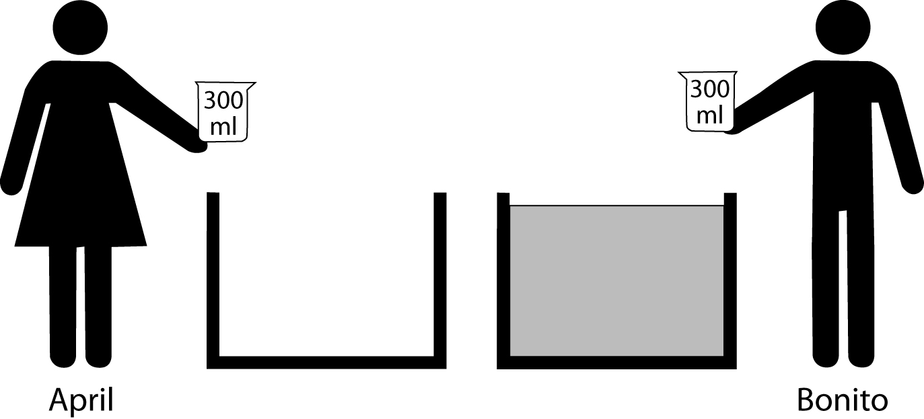  Two students, April and Bonito, are each holding empty 300 mL beakers while standing next to very large, equal sized tanks. April’s tank is empty and Bonito’s tank is filled with water. Each student simultaneously dips his or her beaker deep into his or her respective tank and empties the contents into the other tank. What will happen after many exchanges?  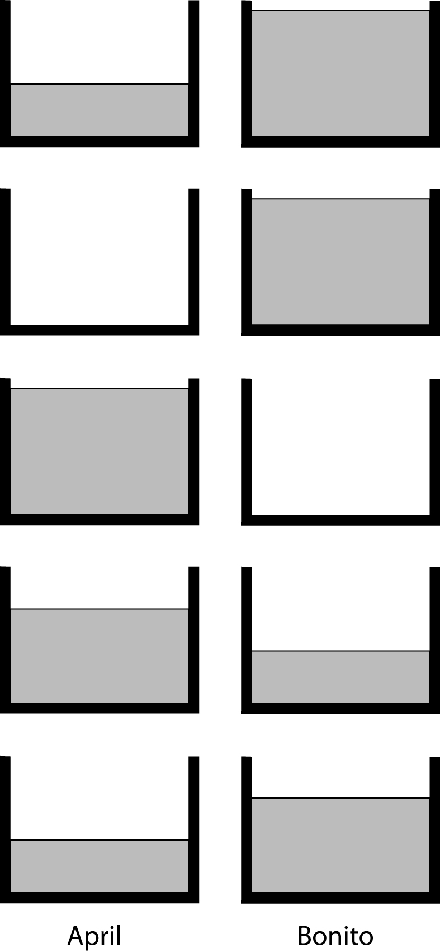  - April’s tank will gain water and Bonito’s water level will remain the same.  - April’s tank will remain empty and Bonito’s will remain full.  - April’s tank will be full and Bonito’s tank will be empty.  - April will have more water than Bonito.  - April will have less water than Bonito.
Distractor Rationales | - Misconception of Conservation of Matter.  - Does not understand transfer.  - No return process for equilibrium understood.  - Transfer process misunderstood.  - Answer.
Item Characteristics | Cognitive Level: Low  Performance Expectation: Theorizing, Analyzing, and Solving Problems  Item Type: Multiple Choice
Source | Nathan A. Unterman  Drawings: Bob Froehlich

Question 5 Self Assembly v1.2

Benchmark  NCLT Big Ideas  AAAS 2061  11.C.9-12.1 | Self-Assembly. Students will understand that environments and components can be designed and controlled to achieve self assembly by an equilibrium state.  A system in equilibrium may return to the same state of equilibrium if the disturbances it experiences are small. But large disturbances may cause it to escape that equilibrium and eventually settle into some other state of equilibrium.
Content Limits | Mathematics should not go beyond geometry.
Stimulus Attributes | Items should use age-, grade-, and experience- appropriate statements or scenarios.
Response Attributes | Surface area to volume ratio consequence in earth science.
Item | 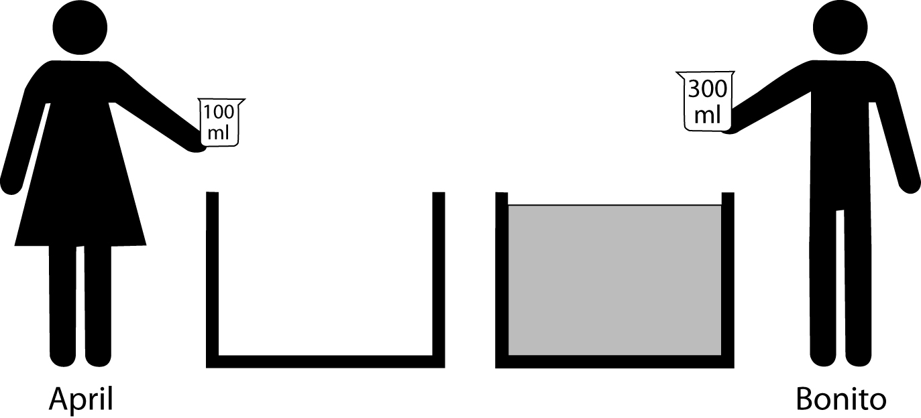  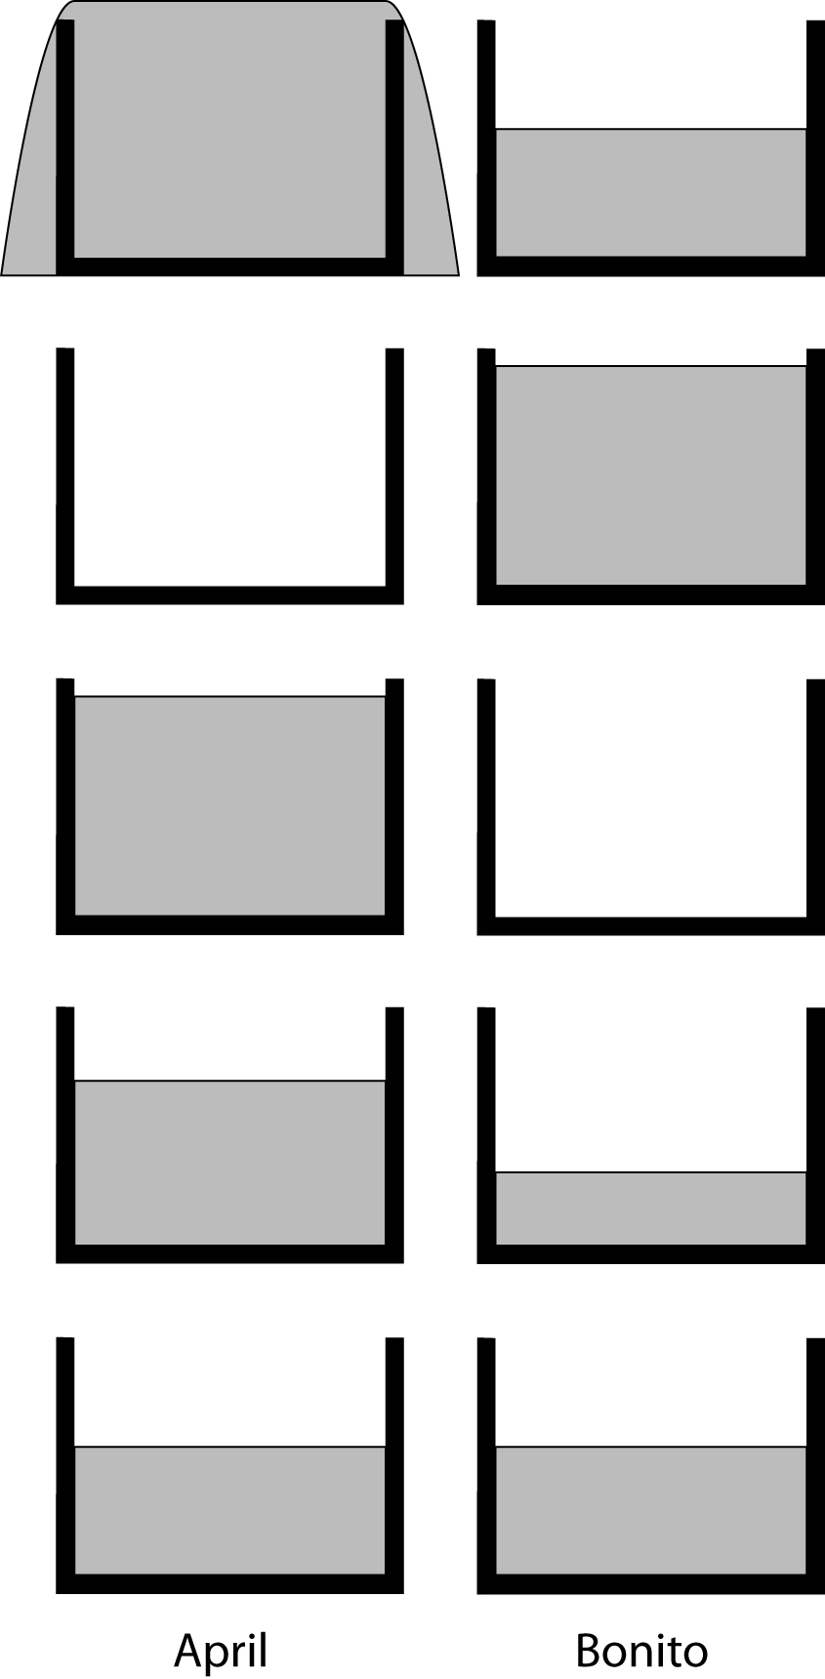  Two students, April and Bonito, are standing next to very large, equal sized tanks. April’s tank is empty and Bonito’s tank is filled with water. April has a 100 mL beaker and Bonito has a 300 mL beaker. Each student simultaneously dips his or her beaker deep into his or her respective tank and empties the contents into the other tank. What will happen after many exchanges?  - April’s tank will overflow as Bonito’s tank will diminish with water.  - April’s tank will remain empty and Bonito’s will remain full.  - April’s tank will be full and Bonito’s tank will be empty.  - April will have more water than Bonito.  - April will have the same amount of water as Bonito.
Distractor Rationales | - Misconception of Conservation of Matter.  - Does not understand transfer.  - No return process for equilibrium understood.  - Answer.  - Misconception that in equilibrium, everything is equal.
Item Characteristics | Cognitive Level: High  Performance Expectation: Theorizing, Analyzing, and Solving Problems.  Item Type: Multiple Choice
Source | Nathan A. Unterman  Drawings: Bob Froehlich

Question 6 Surface Area to Volume v1.2

Benchmark  NCLT Big Ideas  AAAS 2061  4.D.9-12.9  9.C.9-12.2 | Surface area to volume ratios. Students will understand that the surface area to volume ratio increases as particles become smaller.  The rate of reactions among atoms and molecules depends on how often they encounter one another, which is affected by the concentration, pressure, and temperature of the reacting materials. Some atoms and molecules are highly effective in encouraging the interaction of others.  There are formulas for calculating the surface areas and volumes of regular shapes. When the linear size of a shape changes by some factor, its area and volume change disproportionately: area in proportion to the square of the factor, and volume in proportion to its cube. Properties of an object that depend on its area or volume also change disproportionately.
Content Limits | Mathematics should not go beyond geometry.
Stimulus Attributes | Items should use age-, grade-, and experience- appropriate statements or scenarios.
Response Attributes | Surface area to volume ratio consequence in chemistry.
Item | A student conducts two experiments reacting hydrochloric acid (HCl) with metallic zinc (Zn) to produce zinc chloride (ZnCl₂) and hydrogen gas (H₂).  Zn_{(s)} + 2HCl_{(aq)} → ZnCl_{2(aq)} + H_{2(g)}  Both experiments used 25 mL of 6 M HCl.  - In Experiment I, a 5.0 g pellet of zinc was used.  - In Experiment II, 5.0 g of powdered zinc was used.  Experiment II using the powdered zinc was found to go faster to completion than Experiment I. The reason for this result would best be described as:  A. The powdered zinc takes up a greater volume. Therefore, more zinc can react per unit time with the hydrochloric acid present in the reaction vessel.  - The powdered zinc has a greater surface area. Therefore, more zinc can react per unit time with the hydrochloric acid present in the reaction vessel.  - The pellet of zinc is less reactive than the powdered zinc due to stronger metallic bonding.  - Since both experiments used the same number of grams of zinc, the reaction rate should be identical. The results are most likely due to experimental error in measurement.  - When an atom of zinc in powdered form and an atom of zinc in pellet form are both exposed to hydrochloric acid, the atom in the powder reacts faster.

Distractor Rationales | - Confusion between volume and packing.  - Answer  - Confusing atomic bonding with reaction sites.  - Failure to recognize surface area changes impact the number of available reaction sites.  - Confusion of single particle reaction rate with completion time of reactants.
Item Characteristics | Cognitive Level: High  Performance Expectation: Identification and application of variables.  Item Type: Multiple Choice
Source | Marcel Grdinic  Nathan A. Unterman

Question 7 Surface Area to Volume v1.2

Benchmark  NCLT Big Ideas  AAAS 2061  9.C.9-12.2 | Surface area to volume ratios. Students will understand that the surface area to volume ratio increases as particles become smaller.  There are formulas for calculating the surface areas and volumes of regular shapes. When the linear size of a shape changes by some factor, its area and volume change disproportionately: area in proportion to the square of the factor, and volume in proportion to its cube. Properties of an object that depend on its area or volume also change disproportionately.
Content Limits | Mathematics should not go beyond geometry.
Stimulus Attributes | Items should use age-, grade-, and experience- appropriate statements or scenarios.
Response Attributes | Surface area to volume ratio consequence in biology.
Item | Mitochondria are the energy organelles of the cell. They are primarily responsible for the extraction of energy from the nutrients in food using oxygen and transferring it for use in other cellular activities. The proteins required for this extraction are embedded in the folds called cristae within the organelle. (See diagram). Which one of the following best accounts for the highly folded nature of the cristae?  Cristae  - By folding the cristae, additional proteins are housed in the mitochondria. This allows a more efficient conversion of nutrients.  - Nutrient molecules are often very large. They need to fit in the pockets that are formed by the folding of the cristae in order to be transferred.  - The conversion of nutrients into usable energy requires multiple steps in the electron transport chain. The cristae allow the nutrients to pass along in assembly line fashion from one end of the organelle to the other.  - The electron transport proteins need a molecular bridge with a neighbor. The folding of the cristae allows this to occur.  - The folded cristae allow for storage space as some of the nutrients can be converted and stored as fat.
Distractor Rationales | - Answer  - Confusion of molecular shape with cristae shape.  - Description of cristae function, not reason for shape.  - Confusion of function of electron transport with function and structural use of cristae.  E. Confusion of cristae function, not reason for shape.
Item Characteristics | Cognitive Level: Low  Performance Expectation: Identification and application of variables.  Item Type: Multiple Choice
Source | Marcel Grdinic  Nathan A. Unterman
Image Source | SmartDraw 7 image bank

Question 8 Particulate Nature of Matter v1.2

Benchmark  NCLT Big Ideas  AAAS 2061  4.D.6-8.3 | Particulate nature of matter. Students will understand that all matter is made up of atoms and molecules held together by bonds, that these bonds vary in range and strength, and that an atom’s movement is in proportion to its temperature.  Atoms and molecules are perpetually in motion. Increased temperature means greater average energy of motion, so most substances expand when heated. In solids, the atoms are closely locked in position and can only vibrate. In liquids, the atoms or molecules have higher energy, are more loosely connected, and can slide past one another; some molecules may get enough energy to escape into a gas. In gases, the atoms or molecules have still more energy and are free of one another except during occasional collisions.
Content Limits | Mathematics should not go beyond geometry.
Stimulus Attributes | Items should use age-, grade-, and experience- appropriate statements or scenarios.
Response Attributes | Use pictorial representations of atomic arrangements.
Item | Which one of the following best depicts the molecules in a crystalline solid as it melts?  The view shown is from the top of the beaker.  Start  Later  A.  B.  C.  D.  E.
Distractor Rationales | - Non-crystal becoming a gas.  - Confusing crystalline with amorphous structure.  - Answer  - Crystal becoming a gas.  E. Crystal becoming a chain.
Item Characteristics | Cognitive Level: Low  Performance Expectation: Understanding  Item Type: Multiple Choice
Source | Marcel Grdinic  Nathan A. Unterman

Question 9 Self Assembly v1.2

Benchmark  NCLT Big Ideas  AAAS 2061  11.C.6-8.1  4.E.9-12.4 | Self-Assembly. Students should understand that different forces dominate at different length scales  Physical and biological systems tend to change until they become stable and then remain that way unless their surroundings change.  Different energy levels are associated with different configurations of atoms and molecules. Some changes of configuration require an input of energy whereas others release energy.
Content Limits | Mathematics should not go beyond arithmetic.
Stimulus Attributes | Items should use age-, grade-, and experience- appropriate statements or scenarios.
Response Attributes | None specified.
Item | Solid carbon dioxide (dry ice) goes from a solid phase directly to the gaseous stage. How does this happen on the molecular level?  - The individual carbon dioxide molecule at the surface is heated, expands, and becomes a gas.  - The individual carbon dioxide molecule at the surface is warmed by the air in the room, and goes from no movement in the solid to very fast movement in the air.  - The individual carbon dioxide molecule at the surface has significant vibrational energy. This is enough to break the surface bond. The carbon dioxide molecule can escape the solid block into the air.  - The surface molecules of the solid carbon dioxide lose energy. This causes the molecules to go from a more ordered solid state to a less ordered gaseous state.  - At a phase change, the temperature of the solid and gas does not change. No energy is transferred as the surface carbon dioxide molecules break off to form gaseous carbon dioxide.
Distractor Rationales | - The size of the atom determines its phase.  - Atoms in solids do not move.  - Answer.  - Energy loss needed to go from order to disorder.  - Confusion between no temperature change at a phase change, and no energy change.
Item Characteristics | Cognitive Level: Low  Performance Expectation: Understanding  Item Type: Multiple-Choice
Source | Nathan A. Unterman

Question 10 Surface Area to Volume v1.2

Benchmark  NCLT Big Ideas  NSES  D.5-8 Struct.Earth.Sys.3 | Surface area to volume ratios. Students will understand that the surface area to volume ratio increases as particles become smaller.  Land forms are the result of a combination of constructive and destructive forces. Constructive forces include crustal deformation, volcanic eruption, and deposition of sediment, while destructive forces include weathering and erosion.
Content Limits | Mathematics should not go beyond geometry.
Stimulus Attributes | Items should use age-, grade-, and experience- appropriate statements or scenarios.
Response Attributes | Surface area to volume ratio consequence in earth science.
Item | Students investigated the settling characteristics of particles at the mouth of a stream. The students used the same mass of clay, 0.1 grams, (very small) to form differently shaped pieces.  - Spherical pieces, as a small pea 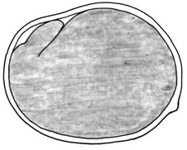  - Ellipsoidal pieces, as a kernel of rice  - Flattened pieces, distorted like a dish but the size of a quarter  They then place the pieces in the stream above the mouth and test for the distance each piece travels from the mouth of a stream until the piece settles on the seabed.  Flow  Ocean  Stream  Mouth  Seabed  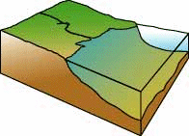  Which answer below best describes their results as we progress outward from the mouth of the stream?  - III will be closest to the mouth, followed by II, and I farthest from the mouth.  - I and II will be equally mixed, while III will be found further out.  - III will settle quickly, while I and II will be equally mixed, further out.  - I will be closest to the mouth, followed by II, and III farthest from the mouth.  - They will all mix and settle equally.

Distractor Rationales | - Opposite order. Confusion that greater surface area to volume settles first.  - Convex shapes do not matter and settle before concave shapes.  - Concave settles before convex, and convex shape does not matter.  - Answer.  - Shape does not effect settling. Perhaps confusion with “all objects fall at the same rate in the absence of friction.”
Item Characteristics | Cognitive Level: High  Performance Expectation: Identification and application of variables.  Item Type: Multiple Choice
Source | Marcel Grdinic  Nathan A. Unterman
Image Source | http://ecosystems.mbl.edu/Research/Clue/estuary.html

Question 11 Size and Scale v1.2

Benchmark  NCLT Big Ideas  NSES  B.K-4 Prop.Obj.Matl.1 | Size and Scale. Students can convert between and understand the relationship between quantitative relative size and absolute scale.  Objects have many observable properties, including size, weight, shape, color, temperature, and the ability to react with other substances. Those properties can be measured using tools, such as rulers, balances, and thermometers.
Content Limits | Mathematics should not go beyond algebra.
Stimulus Attributes | Items should use age-, grade-, and experience- appropriate statements or scenarios.
Response Attributes | None specified.
Item | In which of the following units of measure would it be possible to describe a box?    - Centimeters (cm)  - Square centimeters (cm²)  - Milliliters (mL)  - I only  - II only  - III only  - II and III  - I, II, and III
Distractor Rationales | - Missing that the box may be measured in area and volume.  - Missing that the box may be measured in length and volume.  - Missing that the box may be measured in length and area.  - Missing that the box may be measured in length.  - Answer.
Item Characteristics | Cognitive Level: Low  Performance Expectation: Understanding  Item Type: Multiple Choice
Source | Marcel Grdinic  Nathan A. Unterman
Image Source | MicroSoft clipart

Question 12 Surface Area to Volume v1.2

Benchmark  NCLT Big Ideas  AAAS 2061  9.C.9-12.2 | Surface area to volume ratios. Students will understand that the surface area to volume ratio increases as particles become smaller.  There are formulas for calculating the surface areas and volumes of regular shapes. When the linear size of a shape changes by some factor, its area and volume change disproportionately: area in proportion to the square of the factor, and volume in proportion to its cube. Properties of an object that depend on its area or volume also change disproportionately.
Content Limits | Mathematics should not go beyond geometry.
Stimulus Attributes | Items should use age-, grade-, and experience- appropriate statements or scenarios.
Response Attributes | Surface area to volume ratio consequence in thermal dynamics.
Item | What is the purpose of the fins on the coils of an air conditioner?  - The coils allow a smooth airflow to maximize the heat exchange with the air.  - Since the fins are attached to the coils, the fins increase the rate of heat transfer to the air.  - The fins provide structural support for the coils and make only negligible contributions to the heat exchange.    - The fins cool the coils since metals are cold.  Coils  F  i  n  s  - The additional surface area and mass of the fins are necessary for maintaining high pressure inside the coils.
Distractor Rationales | - Confusing streamlining with thermal flow.  - Answer.  - Fins have little function outside of support.  - Misconception that metal has inherent coldness.  - External mass does not provide inward directed pressure to prevent rupture.
Item Characteristics | Cognitive Level: High  Performance Expectation: Identification and application of variables.  Item Type: Multiple Choice
Source | Marcel Grdinic  Nathan A. Unterman
Image Source | http://www.koolance.com/technical/cooling101/005.html

Question 13 Surface Area to Volume v1.2

Benchmark  NCLT Big Ideas  AAAS 2061  9.C.9-12.2 | Surface area to volume ratios. Students will understand that the surface area to volume ratio increases as particles become smaller.  There are formulas for calculating the surface areas and volumes of regular shapes. When the linear size of a shape changes by some factor, its area and volume change disproportionately: area in proportion to the square of the factor, and volume in proportion to its cube. Properties of an object that depend on its area or volume also change disproportionately.
Content Limits | Mathematics should not go beyond geometry.
Stimulus Attributes | Items should use age-, grade-, and experience- appropriate statements or scenarios.
Response Attributes | Maintain constant mass and volume.
Item | You unwrap a new piece of modeling clay measuring 2 cm x 2 cm x 12 cm. Which one of the following shapes would most increase the surface area?  - Pressing on the long side of the clay to form a box shape 1 cm x 2 cm x 24 cm.  - Shaping the clay into a cube approximately 3.6 cm per edge.  - Forming a cylinder of length 12 cm.  - Making a sphere.  - The shape will not matter since the mass and volume of the clay are constant.
Distractor Rationales | - Answer  - Cube has significantly less surface area.  - Cylinder has somewhat less surface area than the bar.  - Least surface area shape.  - Confusion of conservation of mass with surface area.
Item Characteristics | Cognitive Level: High  Performance Expectation: Theorizing, analyzing, and solving problems  Item Type: Multiple Choice
Source | Marcel Grdinic  Nathan A. Unterman

Question 14 Size and Scale v1.2

Benchmark  NCLT Big Ideas  NSES  B.K-4 Prop.Obj.Matl.1 | Size and Scale. Students can convert between and understand the relationship between quantitative relative size and absolute scale.  Objects have many observable properties, including size, weight, shape, color, temperature, and the ability to react with other substances. Those properties can be measured using tools, such as rulers, balances, and thermometers.
Content Limits | Mathematics should not go beyond geometry.
Stimulus Attributes | Items should use age-, grade-, and experience- appropriate statements or scenarios.
Response Attributes | None specified.
Item | In which of the following units of measure would it be possible to describe a sample of water in a drinking glass?  - Cubic centimeters (cm³)  - Grams (g)  - Milliliters (mL)  - II only  - III only  - I and III  - II and III  - I, II, and III  
Distractor Rationales | - Excludes volume measurement.  - Excludes: 1. cubic centimeters as a measurement of volume and 2. mass measurement.  - Missing the possibility of mass measurement.  - Excludes cubic centimeter measurement.  - Answer.
Item Characteristics | Cognitive Level: Low  Performance Expectation: Understanding  Item Type: Multiple Choice
Source | Marcel Grdinic  Nathan A. Unterman  Drawing: Bob Froehlich

Question 15 Surface Area to Volume v1.2

Benchmark  NCLT Big Ideas  AAAS 2061  9.C.9-12.2 | Surface area to volume ratios. Students will understand that the surface area to volume ratio increases as particles become smaller.  There are formulas for calculating the surface areas and volumes of regular shapes. When the linear size of a shape changes by some factor, its area and volume change disproportionately: area in proportion to the square of the factor, and volume in proportion to its cube. Properties of an object that depend on its area or volume also change disproportionately.
Content Limits | Mathematics should not go beyond geometry.
Stimulus Attributes | Items should use age-, grade-, and experience- appropriate statements or scenarios.
Response Attributes | Surface area to volume ratio consequence in earth science.
Item | To investigate the characteristics of water drops in clouds, students use the same total sample size of water to form differently sized drops.  - One large drop  - 30 medium drops, which total the size of one large drop.  - 3000 tiny drops, which total the size of one large drop.  The students then test for the time the particles take to fall a certain distance through the air. Which answer below best describes their results for the shortest to longest time duration that the drops are in the air?  - III will fall quickly, followed by II, and I will fall the slowest.  - I and II will fall together quickly, while III will fall the slowest.  - III will fall quickly, while I and II will be equally mixed, falling at the same time but taking longer.  - I will fall quickly, followed by II, and III will fall the slowest.  - They will all fall in equal times.
Distractor Rationales | - Opposite order. Confusion that greater surface area to volume falls first.  - Until substantially small, all drops fall at the same rate.  - Smaller objects have more air resistance due to increased surface area to volume.  - Answer  - Shape does not effect settling. Perhaps confusion with “all objects fall at the same rate in the absence of friction.”
Item Characteristics | Cognitive Level: High  Performance Expectation: Identification and application of variables.  Item Type: Multiple Choice
Source | Marcel Grdinic  Nathan A. Unterman

Question 16 Self Assembly v1.2

Benchmark  NCLT Big Ideas  AAAS 2061  4.G.9-12.2 | Self-Assembly. Students should understand that different forces dominate at different length scales  Electromagnetic forces acting within and between atoms are vastly stronger than the gravitational forces acting between the atoms. At the atomic level, electric forces between oppositely charged electrons and protons hold atoms and molecules together and thus are involved in all chemical reactions. On a larger scale, these forces hold solid and liquid materials together and act between objects when they are in contact – as in sticking or sliding friction.
Content Limits | Mathematics should not go beyond arithmetic.
Stimulus Attributes | Items should use age-, grade-, and experience- appropriate statements or scenarios.
Response Attributes | None specified.
Item | In solid materials, why do the atoms stick together?  - When the atoms cool, they slow enough to stick to each other.  - When atoms cool, they slow enough for the gravitational forces between them to hold them together.  - When the air between atoms moves out of the way, atoms can attract and stick to each other.  - The sharing or exchange of electrons creates attractive forces between atoms allowing them to approach each other and form bonds creating solids.  - Atoms can form solids only with covalent, ionic, or metallic bonds.
Distractor Rationales | - Temperature alone does not determine bonding.  - Gravitational forces are not responsible for molecular bonding.  - No air between atoms.  - Answer.  - Ignores secondary bonds, such as van der Waals.
Item Characteristics | Cognitive Level: Low  Performance Expectation: Understanding  Item Type: Multiple-Choice
Source | Nathan A. Unterman

Question 17 Size and Scale v1.2

Benchmark  NCLT Big Ideas  AAAS 2061  12.B.3-5.3 | Size and Scale. Students can convert between and understand the relationship between quantitative relative size and absolute scale.  Judge whether measurements and computations of quantities such as length, area, volume, weight, or time are reasonable in a familiar context by comparing them to typical values.
Content Limits | Mathematics should not go beyond geometry.
Stimulus Attributes | Items should use age-, grade-, and experience- appropriate statements or scenarios.
Response Attributes | Common items from 9-12 science curricula should be used.
Item | The diameter of a DNA strand is approximately 2 nanometers. Which one of the following is closest in size?  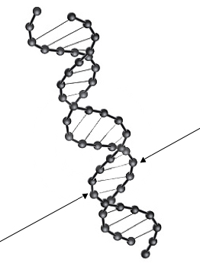  - Rhinovirus  - A white blood cell  - Staphylococcus bacteria  - A proton  - Diameter of a human hair
Distractor Rationales | - Answer  - Micron scale, not nanoscale.  - About 10⁻⁷ m scale, not nanoscale.  - Far below the nanoscale.  - 50 micron scale, not nanoscale.
Item Characteristics | Cognitive Level: Low  Performance Expectation: Understanding  Item Type: Multiple Choice
Source | Marcel Grdinic  Nathan A. Unterman
Image Source | Microsoft Clipart

Question 18 Self Assembly v1.2

Benchmark  NCLT Big Ideas  AAAS 2061  11.C.6-8.1  4.E.9-12.4 | Self-Assembly. Students should understand that different forces dominate at different length scales  Physical and biological systems tend to change until they become stable and then remain that way unless their surroundings change.  Different energy levels are associated with different configurations of atoms and molecules. Some changes of configuration require an input of energy whereas others release energy.
Content Limits | Mathematics should not go beyond arithmetic.
Stimulus Attributes | Items should use age-, grade-, and experience- appropriate statements or scenarios.
Response Attributes | None specified.
Item | When water evaporates from a salt solution, salt crystals are left behind. What is happening?  - The ions in solution experience attractive electrical forces to assemble salt crystals.  - The ions in solution experience attractive gravitational forces to assemble salt crystals.  - The tiny salt crystals in the water solution spin around and fit together like puzzle pieces as the water evaporates.  - The salt molecules experience random, attractive forces creating regular and amorphous salt crystals as the water evaporates.  - The salt crystals gain energy from the evaporating water to become more ordered as a solid crystal.
Distractor Rationales | - Answer.  - Gravitational forces among salt molecules are too weak for assembly.  - Spinning is not the cause of crystal formation (self assembly).  - No amorphous crystals.  - Solution must lose energy for crystal formation.
Item Characteristics | Cognitive Level: Low  Performance Expectation: Understanding  Item Type: Multiple-Choice
Source | Nathan A. Unterman

Question 19 Size and Scale v1.2

Benchmark  NCLT Big Ideas  AAAS 2061  12.B.3-5.3 | Size and Scale. Students can convert between and understand the relationship between quantitative relative size and absolute scale.  Judge whether measurements and computations of quantities such as length, area, volume, weight, or time are reasonable in a familiar context by comparing them to typical values.
Content Limits | Mathematics should not go beyond algebra.
Stimulus Attributes | Items should use age-, grade-, and experience- appropriate statements or scenarios.
Response Attributes | None specified.
Item | In which of the following units of measure would it be possible to describe a donut?  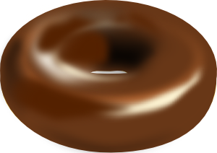  - Grams (g)  - Milliliters (mL)  - Cubic centimeters (cm³)  - I only  - III only  - I and II  - I and III  - I, II, and III
Distractor Rationales | - Missing that the donut has volume in cubic centimeters and milliliters  - Missing that the donut has mass in grams and volume in milliliters  - Missing that the donut has volume in cubic centimeters  - Missing that the donut has volume in milliliters  - Answer
Item Characteristics | Cognitive Level: Low  Performance Expectation: Understanding  Item Type: Multiple Choice
Source | Marcel Grdinic  Nathan A. Unterman
Image Source | http://www.clker.com/clipart-chocolate-donut.html

Question 20 Size and Scale v1.2

Benchmark  NCLT Big Ideas  AAAS 2061  12.B.3-5.3 | Size and Scale. Students can convert between and understand the relationship between quantitative relative size and absolute scale.  Judge whether measurements and computations of quantities such as length, area, volume, weight, or time are reasonable in a familiar context by comparing them to typical values.
Content Limits | Mathematics should not go beyond algebra.
Stimulus Attributes | Items should use age-, grade-, and experience- appropriate statements or scenarios.
Response Attributes | Common items from 9-12 science curricula should be used.
Item | A laboratory technician is looking through an optical microscope and sees a red blood cell, approximately 7 μm (micrometers) in diameter. Which of the following is also on the size scale of 7 μm?    I. Diameter of a single human hair.  II. Infectious anthrax bacillus  - A uranium atom  - I only  - II only  - III only  - I and II  - II and III
Distractor Rationales | - Large by an order of magnitude. Possible contaminant.  - Answer  - Confusion with atomic and biological sizes. Possible confusion with stains.  - Confusion that all cells are the same size.  - Confusion with biological and atomic sizes and possibly confusion with biological and atomic nuclei.
Item Characteristics | Cognitive Level: Low  Performance Expectation: Understanding  Item Type: Multiple Choice
Source | Nathan A. Unterman
Image Source | Microsoft Clipart

Question 21 Particulate Nature of Matter v1.2

Benchmark  NCLT Big Ideas  AAAS 2061  4.D.9-12.9 | Particulate nature of matter. Students will understand that all matter is made up of atoms and molecules held together by bonds, that these bonds vary in range and strength, and that an atom’s movement is in proportion to its temperature.  The rate of reactions among atoms and molecules depends on how often they encounter one another, which is affected by the concentration, pressure, and temperature of the reacting materials. Some atoms and molecules are highly effective in encouraging the interaction of others.
Content Limits | Mathematics should not go beyond geometry.
Stimulus Attributes | Items should use age-, grade-, and experience- appropriate statements or scenarios.
Response Attributes | Use pictorial representations of atomic arrangements.
Item | Which one of the following best depicts the dissolving of sugar particles in water to form a solution?  Sugar molecules = solid circles  Water molecules = open circles  The view shown is from the top a baking dish.  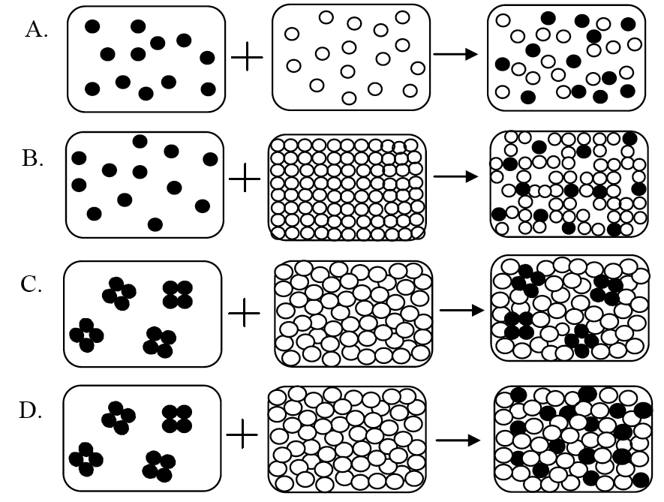

Distractor Rationales | - Gaseous sugar and gaseous water (can be compressed).  - Gaseous sugar and crystalline water.  - Crystalline sugar and liquid water does not become liquid water surrounding the sugar crystal.  - Answer
Item Characteristics | Cognitive Level: Low  Performance Expectation: Understanding  Item Type: Multiple Choice
Source | Marcel Grdinic  Nathan A. Unterman

Question 22 Size and Scale v1.2

Benchmark  NCLT Big Ideas  AAAS 2061  12.C.6-8.3 | Size and Scale. Students can convert between and understand the relationship between quantitative relative size and absolute scale.  Read analog and digital meters on instruments used to make direct measurements of length, volume, weight, elapsed time, rates, and temperature, and choose appropriate units for reporting various magnitudes.
Content Limits | Mathematics should not go beyond algebra.
Stimulus Attributes | Items should use age-, grade-, and experience- appropriate statements or scenarios.
Response Attributes | None specified.
Item |   What is the smallest mass that can be measured with an electronic balance that is accurate to 0.001 grams?  - Contact lens  - Vitamin tablet  - Speck of dust  - Single bacteria  - Human eye lash
Distractor Rationales | - Answer.  - Well above the minimum sensitivity of an electronic balance.  - Below the sensitivity of an electronic balance  - Below the sensitivity of an electronic balance.  - Below the sensitivity of an electronic balance.
Item Characteristics | Cognitive Level: Low  Performance Expectation: Using tools, routine procedures, and science processes  Item Type: Multiple Choice
Source | Marcel Grdinic  Nathan A. Unterman
Image Source | http://www.itinscales.com/images/andhf.jpg

Question 23 Particulate Nature of Matter v1.2

Benchmark  NCLT Big Ideas  AAAS 2061  4.D.6-8.3 | Particulate nature of matter. Students will understand that all matter is made up of atoms and molecules held together by bonds, that these bonds vary in range and strength, and that an atom’s movement is in proportion to its temperature.  Atoms and molecules are perpetually in motion. Increased temperature means greater average energy of motion, so most substances expand when heated. In solids, the atoms are closely locked in position and can only vibrate. In liquids, the atoms or molecules have higher energy, are more loosely connected, and can slide past one another; some molecules may get enough energy to escape into a gas. In gases, the atoms or molecules have still more energy and are free of one another except during occasional collisions.
Content Limits | Mathematics should not go beyond geometry.
Stimulus Attributes | Items should use age-, grade-, and experience- appropriate statements or scenarios.
Response Attributes | Common items from 9-12 science curricula should be used.
Item | Of the following, which can be easily compressed to a significantly smaller size?  - Block of aluminum  - Water in a balloon  - Gas in a balloon  - II only  - III only  - I and II  - II and III  - I, II, and III
Distractor Rationales | - Confusion that since most liquids take up more space than solids, there are compressible empty spaces between molecules.  - Answer  - Belief that atoms can be rearranged and packed in a solid and liquid and/or a belief of empty space or air between particles.  - Belief that all fluids, not just gasses, have empty spaces or spaces filled with air between atoms (or molecules) and can be compressed.  - All matter is easily compressible.
Item Characteristics | Cognitive Level: Low  Performance Expectation: Understanding  Item Type: Multiple Choice
Source | Marcel Grdinic  Nathan A. Unterman

Question 24 Size and Scale v1.2

Benchmark  NCLT Big Ideas  NSES  B.K-4 Prop.Obj.Matl.1 | Size and Scale. Students can convert between and understand the relationship between quantitative relative size and absolute scale.  Objects have many observable properties, including size, weight, shape, color, temperature, and the ability to react with other substances. Those properties can be measured using tools, such as rulers, balances, and thermometers.
Content Limits | Mathematics should not go beyond algebra.
Stimulus Attributes | Items should use age-, grade-, and experience- appropriate statements or scenarios.
Response Attributes | None specified.
Item | Which of the following units of measure may be used to describe a single raindrop?    - milliliters (mL)  - grams (g)  - radians/second (rad/s)  - I only  - II only  - I and II  - II and III  - I, II, and III
Distractor Rationales | - Missing that drop has mass in grams.  - Missing that drop has volume in milliliters.  - Answer  - Missing that drop has volume and mass, and choosing that is has angular momentum.  - Choosing that not only does the drop have mass and volume, but it has angular velocity, too.
Item Characteristics | Cognitive Level: Low  Performance Expectation: Understanding  Item Type: Multiple Choice
Source | Marcel Grdinic  Nathan A. Unterman  Drawing: Bob Froehlich

Question 25 Self Assembly v1.2

Benchmark  NCLT Big Ideas  AAAS 2061  11.C.6-8.1 | Self-Assembly. Students should understand that different forces dominate at different length scales  Physical and biological systems tend to change until they become stable and then remain that way unless their surroundings change.
Content Limits | Mathematics should not go beyond arithmetic.
Stimulus Attributes | Items should use age-, grade-, and experience- appropriate statements or scenarios.
Response Attributes | Pictorial.
Item | In logging operations, the cut trees are often slid down chutes into rivers and then collected downstream. Which one of the following diagrams best matches the arrangement of logs you would find in the moderately flowing, relatively straight river, downstream of the chute?    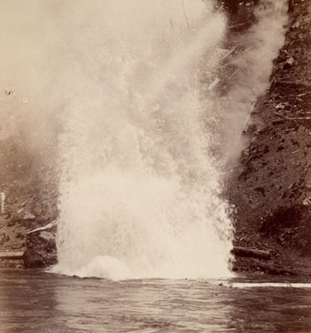

Distractor Rationales | - Answer  - Random; no self assembly.  - Flow direction shows minimal effect and no reduction of energy state.  - Sorted, but perpendicular to flow in a higher energy state. Not streamlined.  - Combination of situation A and D.
Item Characteristics | Cognitive Level: High  Performance Expectation: Theorizing, Analyzing, and Solving Problems  Item Type: Extended-response
Source | Nathan A. Unterman  http://www.urbanlumberco.com/images/ULChead2.gif  http://contentdm.library.unr.edu/cdm4/item_viewer.php?CISOROOT=/tahoe&CISOPTR=222

Benchmark and Question Number Table

Frequency Information

Question Number | Benchmark
1, 3, 8, 21, 23 | NCLT  Particulate nature of matter. Students will understand that all matter is made up of atoms and molecules held together by bonds, that these bonds vary in range and strength, and that an atom’s movement is in proportion to its temperature.
11, 14, 17, 19, 20, 22, 24 | Size and Scale. Students can convert between and understand the relationship between quantitative relative size and absolute scale.
6, 7, 10, 12, 13, 15 | Surface area to volume ratios. Students will understand that the surface area to volume ratio increases as particles become smaller.
2, 4, 5, 9, 16, 18, 25 | Self Assembly. Students will understand that environments and components can be designed and controlled to achieve self assembly by an equilibrium state.
1 | Project 2061  4.D.6-8.1  All matter is made up of atoms, which are far too small to see directly through a microscope. The atoms of any element are alike but are different from atoms of other elements. Atoms may stick together in well-defined molecules or may be packed together in large arrays. Different arrangements of atoms into groups compose all substances.
1, 8, 23 | 4.D.6-8.3  Atoms and molecules are perpetually in motion. Increased temperature means greater average energy of motion, so most substances expand when heated. In solids, the atoms are closely locked in position and can only vibrate. In liquids, the atoms or molecules have higher energy, are more loosely connected, and can slide past one another; some molecules may get enough energy to escape into a gas. In gases, the atoms or molecules have still more energy and are free of one another except during occasional collisions.
6, 21 | 4.D.9-12.9  The rate of reactions among atoms and molecules depends on how often they encounter one another, which is affected by the concentration, pressure, and temperature of the reacting materials. Some atoms and molecules are highly effective in encouraging the interaction of others.
9, 18 | 4.E.9-12.4  Different energy levels are associated with different configurations of atoms and molecules. Some changes of configuration require an input of energy whereas others release energy.
16 | 4.G.9-12.2  Electromagnetic forces acting within and between atoms are vastly stronger than the gravitational forces acting between the atoms. At the atomic level, electric forces between oppositely charged electrons and protons hold atoms and molecules together and thus are involved in all chemical reactions. On a larger scale, these forces hold solid and liquid materials together and act between objects when they are in contact – as in sticking or sliding friction.
6, 7, 12, 13, 15 | 9.C.9-12.2  There are formulas for calculating the surface areas and volumes of regular shapes. When the linear size of a shape changes by some factor, its area and volume change disproportionately: area in proportion to the square of the factor, and volume in proportion to its cube. Properties of an object that depend on its area or volume also change disproportionately.
2, 9, 18, 25 | 11.C.6-8.1  Physical and biological systems tend to change until they become stable and then remain that way unless their surroundings change.
4 | 11.C.6-8.2  A system may stay the same because nothing is happening or because things are happening but exactly counterbalance one another.
5 | 11.C.9-12.1  A system in equilibrium may return to the same state of equilibrium if the disturbances it experiences are small. But large disturbances may cause it to escape that equilibrium and eventually settle into some other state of equilibrium.
3 | 11.D.9-12.2  Because different properties are not affected to the same degree by changes in scale, large changes in scale typically change the way that things work in physical, biological, or social systems.

11, 14, 17, 19, 20, 24 | 12.B.3-5.3  Judge whether measurements and computations of quantities such as length, area, volume, weight, or time are reasonable in a familiar context by comparing them to typical values.
22 | 12.C.6-8.3  Read analog and digital meters on instruments used to make direct measurements of length, volume, weight, elapsed time, rates, and temperature, and choose appropriate units for reporting various magnitudes.
10 | NSES  D.5-8 Struct.Earth.Sys.3  Land forms are the result of a combination of constructive and destructive forces. Constructive forces include crustal deformation, volcanic eruption, and deposition of sediment, while destructive forces include weathering and erosion.

Topical Allocations

Item Number | Total Items | Topic
1, 3, 8, 21, 23 | 5 | Particulate Nature of Matter
2, 4, 5, 9, 16, 18, 25 | 7 | Self Assembly
6, 7, 10, 12, 13, 15 | 6 | Surface Area to Volume Ratio
11, 14, 17, 19, 20, 22, 24 | 7 | Size and Scale

Distributions

Graphics

Items Requiring Graphics | Items with No Graphics
17 | 8

Answer Frequency

Answer | Frequency
A | 6
B | 5
C | 4
D | 5
E | 5

Degree of Difficulty (Bloom’s Taxonomy)

Low Level | High Level
16 | 9

Performance Expectations

Understanding | Theorizing, Analyzing, and Solving Problems | Using Tools, Routing Procedures, and Science Processes | Investigating the Natural World | Estimation | Identification and Application of Variables
14 | 5 | 1 | 0 | 0 | 5

Flesch-Kincaid Grade Level: 7.4

Answer Key
Question  Number | Answer |  | Question  Number | Answer
1 | B |  | 14 | E
2 | E |  | 15 | D
3 | C |  | 16 | D
4 | E |  | 17 | A
5 | D |  | 18 | A
6 | B |  | 19 | E
7 | A |  | 20 | B
8 | C |  | 21 | D
9 | C |  | 22 | A
10 | D |  | 23 | B
11 | E |  | 24 | C
12 | B |  | 25 | A
13 | A

