- Which one of the following statements describes the compressibility of matter?
  - Liquids take up more space than solids. The air between the liquid molecules can be easily compressed.
  - Gas molecules are not bound to each other. They can easily be forced into the empty space between molecules.
  - Only solids and liquids can easily compress. Compression will rearrange the atoms into the tightest and lowest energy state.
  - Both liquids and gasses are easily compressed. This is due to the spaces between atoms.
  - All matter is made of atoms and atoms are mostly empty space. Therefore, all states of matter are easily compressible.

- Self-assembly is the spontaneous arrangement of objects that put themselves together in ordered patterns or structures. The phenomenon of self-assembly occurs on which size scale?
Select among the following choices:
I. Molecular sizes (submicroscopic)
II. Bulk sizes (meters)
III. Astronomical sizes (light years)

  - I only
  - II only
  - III only
  - I and III
  - I, II, and III

Use this table to answer Question 3.

Bulk Properties of Iron
Melting Point | 1538 ºC
Density | 7.86 g/cm³
General Material Characteristics | Hard, Brittle, and Fusible
Reaction with Oxygen | Forms Iron Oxide

- Which, if any, of these properties would be the SAME for one single atom of iron?
  - Melting Point and Density.
  - General Material Characteristics and Reaction with Oxygen.
  - Reaction with Oxygen.
  - All of these properties would be the same.
  - None of these properties would be the same.
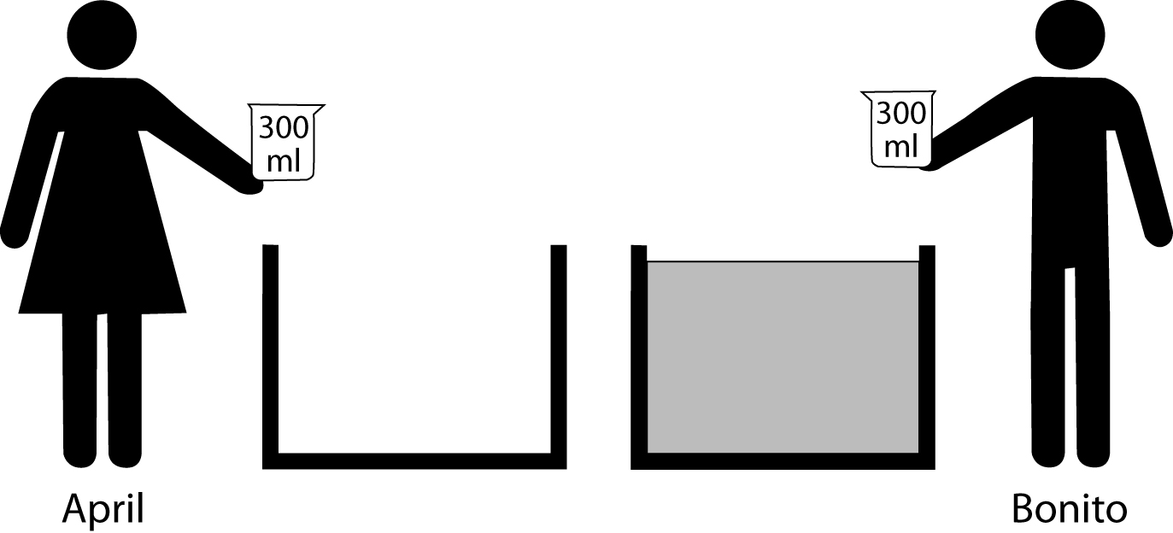
- Two students, April and Bonito, are each holding empty 300 mL beakers while standing next to very large, equal sized tanks. April’s tank is empty and Bonito’s tank is filled with water. Each student simultaneously dips his or her beaker deep into his or her respective tank and empties the contents into the other tank. What will happen after many exchanges?
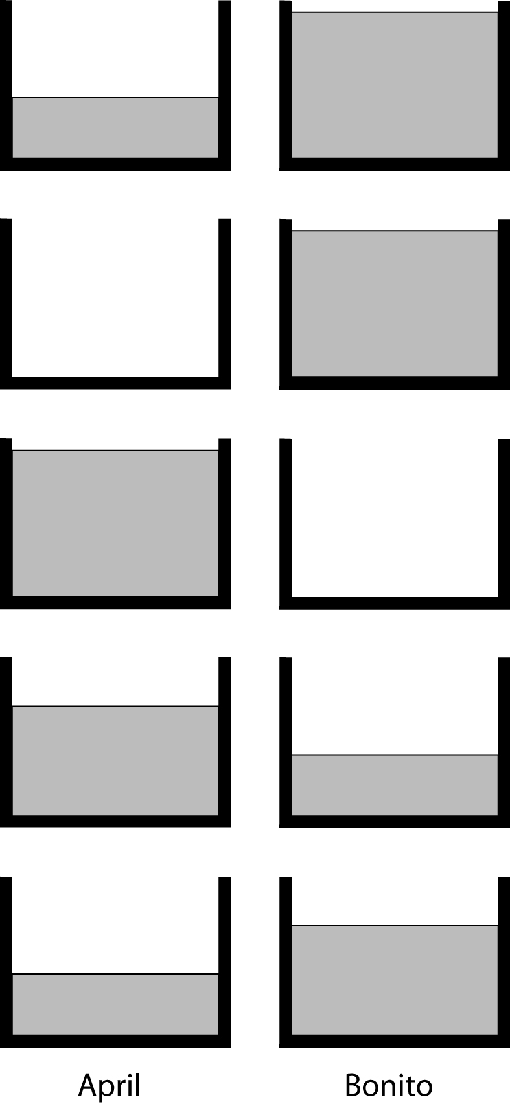
  - April’s tank will gain water and Bonito’s water level will remain the same.
  - April’s tank will remain empty and Bonito’s will remain full.
  - April’s tank will be full and Bonito’s tank will be empty.
  - April will have more water than Bonito.
  - April will have less water than Bonito.
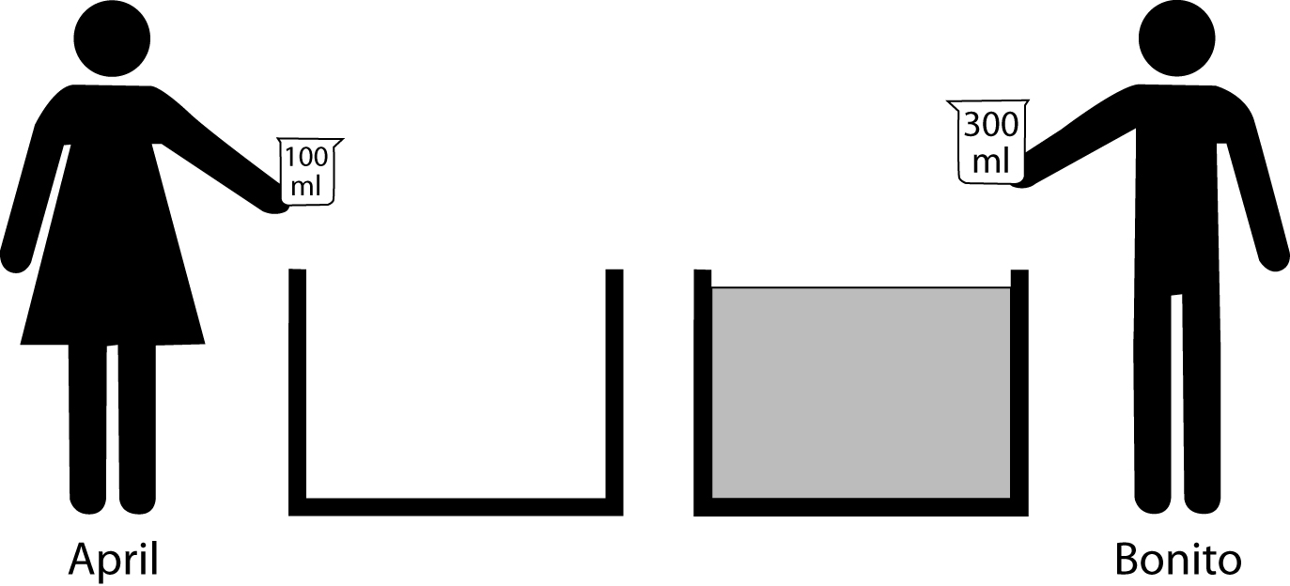
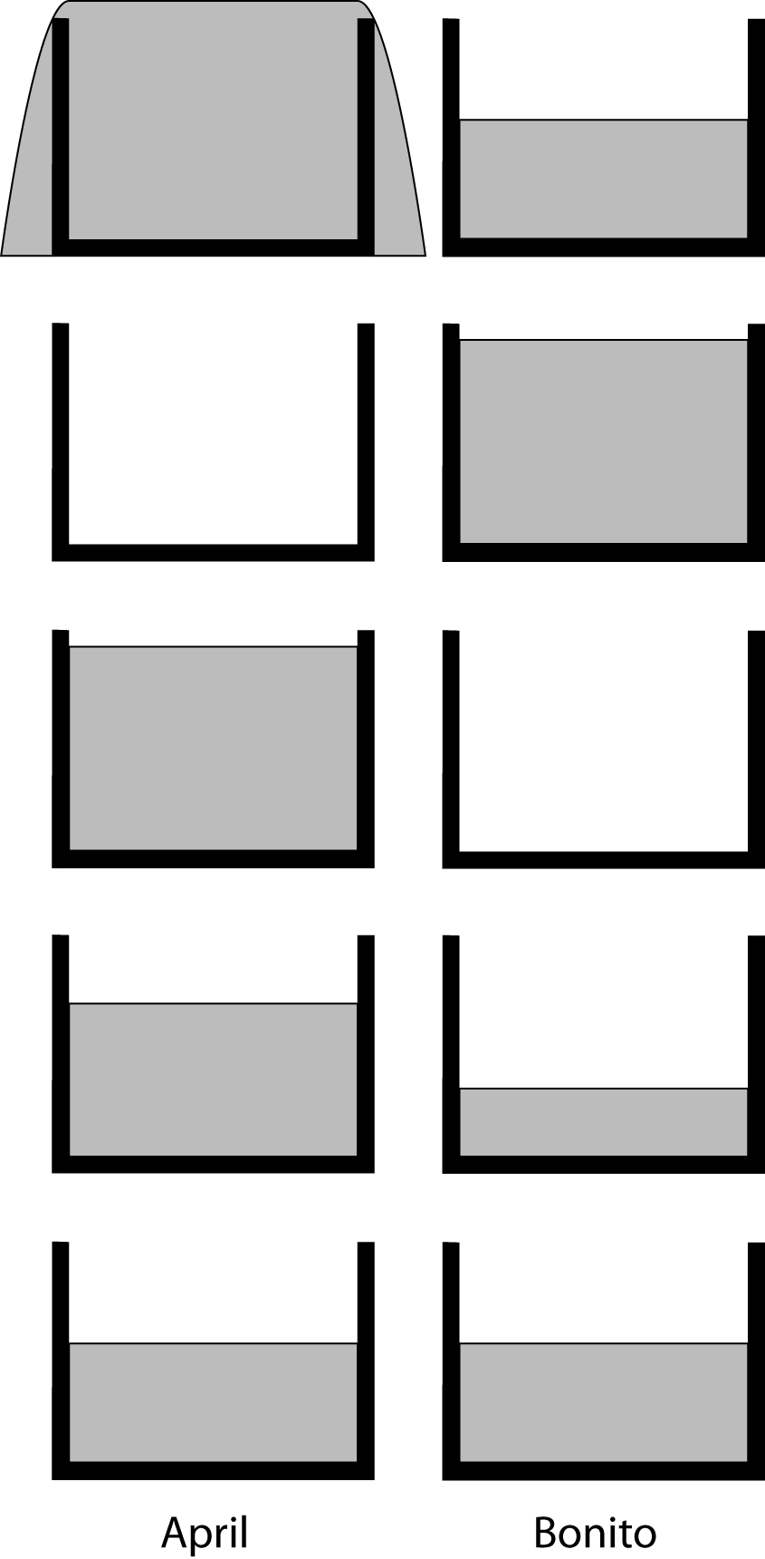
- Two students, April and Bonito, are standing next to very large, equal sized tanks. April’s tank is empty and Bonito’s tank is filled with water. April has a 100 mL beaker and Bonito has a 300 mL beaker. Each student simultaneously dips his or her beaker deep into his or her respective tank and empties the contents into the other tank. What will happen after many exchanges?
  - April’s tank will overflow as Bonito’s tank will have less and less water.
  - April’s tank will remain empty and Bonito’s will remain full.
  - April’s tank will be full and Bonito’s tank will be empty.
  - April will have more water than Bonito.
  - April will have the same amount of water as Bonito.

- A student conducts two experiments reacting hydrochloric acid (HCl) with metallic
zinc (Zn) to produce zinc chloride (ZnCl₂) and hydrogen gas (H₂).
${\text{Zn}}_{(s)}+2H{\text{Cl}}_{(\text{aq})}→\text{Zn}{\text{Cl}}_{2(\text{aq})}+H_{2(g)}$

Both experiments used 25 mL of 6 M HCl.
- In Experiment I, a 5.0 g pellet of zinc was used.
- In Experiment II, 5.0 g of powdered zinc was used.
Experiment II using the powdered zinc was found to go faster to completion than Experiment I. The reason for this result would best be described as:

  - The powdered zinc takes up a greater volume. Therefore, more zinc can react per unit time with the hydrochloric acid present in the reaction vessel.
  - The powdered zinc has a greater surface area. Therefore, more zinc can react per unit time with the hydrochloric acid present in the reaction vessel.
  - The pellet of zinc is less reactive than the powdered zinc due to stronger metallic bonding.
  - Since both experiments used the same number of grams of zinc, the reaction rate should be identical. The results are most likely due to experimental error in measurement.
  - When an atom of zinc in powdered form and an atom of zinc in pellet form are both exposed to hydrochloric acid, the atom in the powder reacts faster.
- Mitochondria are the energy organelles of the cell. They are primarily responsible for the extracting energy from the nutrients in food using oxygen and transferring it for use in other cellular activities. The proteins required for this extraction are embedded in the folds called cristae within the organelle. (See diagram). Which one of the following best accounts for the highly folded nature of the cristae?
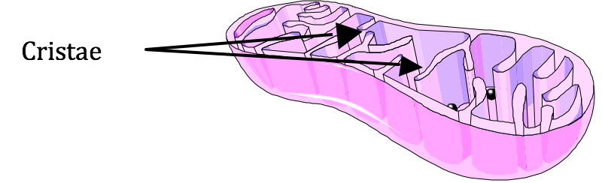
  - By folding the cristae, additional proteins are housed in the mitochondria. This allows a more efficient conversion of nutrients.
  - Nutrient molecules are often very large. They need to fit in the pockets that are formed by the folding of the cristae in order to be transferred.
  - The conversion of nutrients into usable energy requires multiple steps in the electron transport chain. The cristae allow the nutrients to pass along in assembly line fashion from one end of the organelle to the other.
  - The electron transport proteins need a molecular bridge with a neighbor. The folding of the cristae allows this to occur.
  - The folded cristae allow for storage space as some of the nutrients can be converted and stored as fat

- Which one of the following best depicts the molecules in a crystalline solid as it melts?
The view shown is from the top of the beaker.
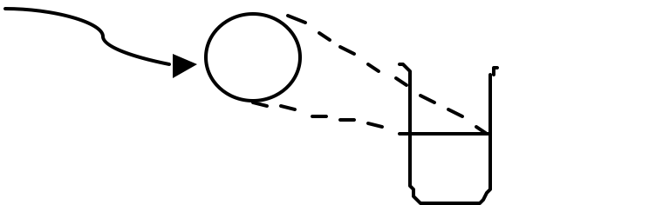
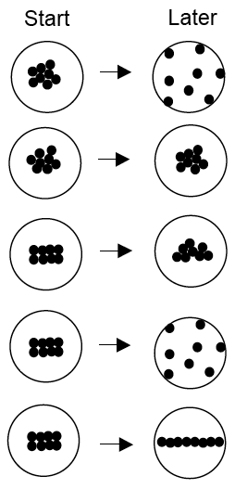
A.
B.
C.
D.
E.
Start Later

- Solid carbon dioxide (dry ice) goes from a solid phase directly to the gaseous stage. How does this happen on the molecular level?

  - The individual carbon dioxide molecule at the surface is heated, expands, and becomes a gas.
  - The individual carbon dioxide molecule at the surface is warmed by the air in the room, and goes from no movement in the solid to very fast movement in the air.
  - The individual carbon dioxide molecule at the surface has significant vibrational energy. This is enough to break the surface bond. The carbon dioxide molecule can escape the solid block into the air.
  - The surface molecules of the solid carbon dioxide lose energy. This causes the molecules to go from a more ordered solid state to a less ordered gaseous state.
  - At a phase change, the temperature of the solid and gas does not change. No energy is transferred as the surface carbon dioxide molecules break off to form gaseous carbon dioxide.

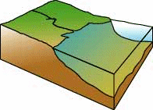
- Students investigated the settling characteristics of particles at the mouth of a stream. The students used the same mass of clay,
0.1 grams, (very small) to form differently shaped pieces.

I. Spherical pieces, as a small pea 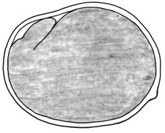

II. Ellipsoidal pieces, as a kernel of rice

III. Flattened pieces, the size of a quarter

They then place the pieces in the stream above the mouth and test for the distance each piece travels from the mouth of a stream until the piece settles on the seabed.
Flow
Ocean
Stream
Mouth
Seabed

Which answer below best describes their results as we progress outward from the mouth of the stream?
- III will be closest to the mouth, followed by II, and I farthest from the mouth.
- I and II will be equally mixed, while III will be found further out.
- III will settle quickly, while I and II will be equally mixed, further out.
- I will be closest to the mouth, followed by II, and III farthest from the mouth.
- They will all mix and settle equally.

- In which of the following units of measure would it be possible to describe a box?
I. Centimeters (cm)
II. Square centimeters (cm²)

III. Millimeters (mm)

  - I only
  - II only
  - III only
  - II and III
  - I, II, and III
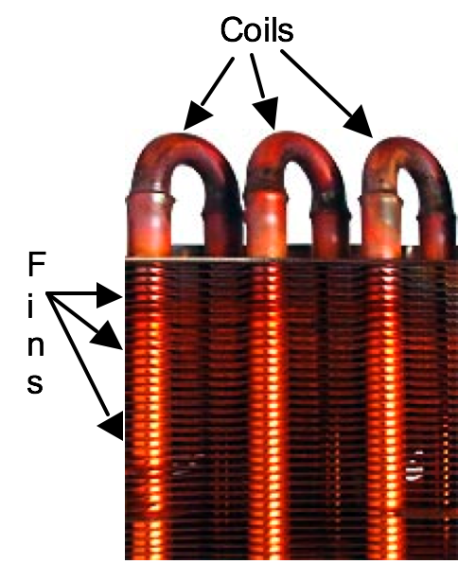
- What is the purpose of the fins on the coils of an air conditioner?
  - The coils allow a smooth airflow to maximize the heat exchange with the air.
  - Since the fins are attached to the coils, the fins increase the rate of heat transfer to the air.
  - The fins provide structural support for the coils and make only negligible contributions to the heat exchange.
  - The fins cool the coils since metals are cold.
  - The additional surface area and mass of the fins are necessary for maintaining high pressure inside the coils.
- You unwrap a new piece of modeling clay measuring 2 cm x 2 cm x 12 cm. Which one of the following shapes would most increase the surface area?
  - Pressing on the long side of the clay to form a box shape 1 cm x 2 cm x 24 cm.
  - Shaping the clay into a cube approximately 3.6 cm per edge.
  - Forming a cylinder of length 12 cm.
  - Making a sphere.
  - The shape will not matter since the mass and volume of the clay are constant.
- In which of the following units of measure would it be possible to describe a sample of water in a drinking glass?
I. Cubic centimeters (cm³)

II. Grams (g)
III. Milliliters (mL)

  - II only
  - III only
  - I and III
  - II and III
  - I, II, and III

- To investigate the characteristics of water drops in clouds, students use the same total sample size of water to form differently sized drops.
I. One large drop
II. 30 medium drops, which total the size of one large drop.
III. 3000 tiny drops, which total the size of one large drop.
The students then test for the time the particles take to fall a certain distance through the air. Which answer below best describes their results for the shortest to longest time duration that the drops are in the air?
  - III will fall quickly, followed by II, and I will fall the slowest.
  - I and II will fall together quickly, while III will fall the slowest.
  - III will fall quickly, while I and II will be equally mixed, falling at the same time but taking longer.
  - I will fall quickly, followed by II, and III will fall the slowest.
  - They will all fall in equal times.
- In solid materials, why do the atoms stick together?
  - When the atoms cool, they slow enough to stick to each other.
  - When atoms cool, they slow enough for the gravitational forces between them to hold them together.
  - When the air between atoms moves out of the way, atoms can attract and stick to each other.
  - The sharing or exchange of electrons creates attractive forces between atoms allowing them to approach each other and form bonds creating solids.
  - Atoms can form solids only with covalent, ionic, or metallic bonds.
- The diameter of a DNA strand is approximately 2 nanometers. Which one of the following is closest in size?
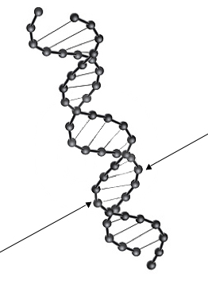
  - Rhinovirus
  - A white blood cell
  - Staphylococcus bacteria
  - A proton
  - Diameter of a human hair

- When water evaporates from a salt solution, salt crystals are left behind. What is happening?
  - The ions in solution experience attractive electrical forces to assemble salt crystals.
  - The ions in solution experience attractive gravitational forces to assemble salt crystals.
  - The tiny salt crystals in the water solution spin around and fit together like puzzle pieces as the water evaporates.
  - The salt molecules experience random, attractive forces creating regular and amorphous salt crystals as the water evaporates.
  - The salt crystals gain energy from the evaporating water to become more ordered as a solid crystal.
- In which of the following units of measure would it be possible to describe a donut?
I. Grams (g)
II. Milliliters (mL)
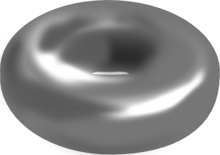
III. Cubic centimeters (cm³)
  - I only
  - II only
  - III only
  - I and III
  - I, II, and III
- A laboratory technician is looking through an optical microscope and sees a red blood cell, approximately 7 μm (micrometers) in diameter. Which of the following is also on the size scale of 7 μm?
I. Diameter of a single human hair.

II. Infectious anthrax bacillus
III. A uranium atom

  - I only
  - II only
  - III only
  - I and II
  - II and III

- Which one of the following best depicts the dissolving of sugar particles in water to form a solution?
Sugar molecules = solid circles
Water molecules = open circles

The view shown is from the top of a baking dish.
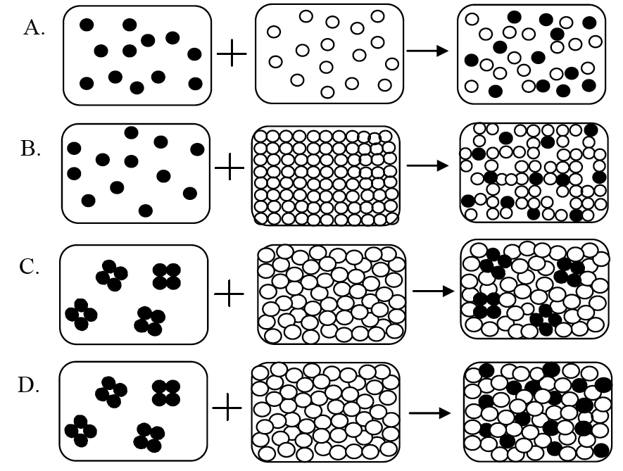


- What is the smallest mass that can be measured with an electronic balance that is accurate to 0.001 grams?
  - Contact lens
  - Vitamin tablet
  - Speck of dust
  - Single bacteria
  - Human eye lash
- Of the following, which can be easily compressed to a significantly smaller size?
I. Block of aluminum
II. Water in a balloon
III. Gas in a balloon
  - II only
  - III only
  - I and II
  - II and III
  - I, II, and II

- Which of the following units of measure may be used to describe a single raindrop?
I. Milliliters (mL)
II. Grams (g)

III. Radians/second (rad/s)
  - I only
  - II only
  - I and II
  - II and III
  - I, II, and III
- In logging operations, the cut trees are often slid down chutes into rivers and then collected downstream. Which one of the following diagrams best matches the arrangement of logs you would find in the moderately flowing, relatively straight river, downstream of the chute?


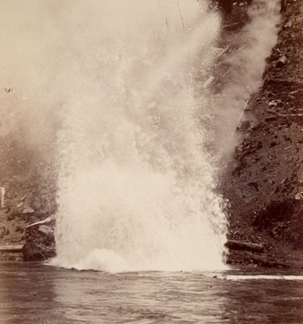
A.
B.

C.
D.
E.

End of Survey

