Nanotechnology Concept Inventory

v1.2

Please
- Do NOT write anything on this survey.
- Mark your answers on the optical scanning sheet.
- Make ONLY ONE mark per item.
- Do NOT skip any of the 25 questions.
- Avoid guessing. Your answers should reflect what you personally think.

On the answer sheet:
- Use pencil only, and follow marking instructions.
- Grid in your ID number.
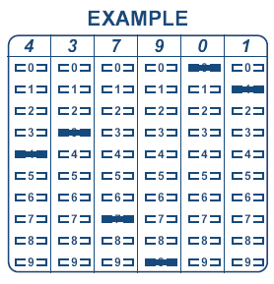
- Mark “v1.2” under Name.
- Enter course name under Subject.
- Place today’s date under Date.
- Place period or time of class meeting under Period.

This should take about 30 minutes to complete all 25 questions.

Thank-you for your cooperation.

