launcher
http://www.pitsco.com/Straw_Rocket_Launcher

class pack of straw rocket materials
http://www.pitsco.com/Straw_Rocket_Class_Pack

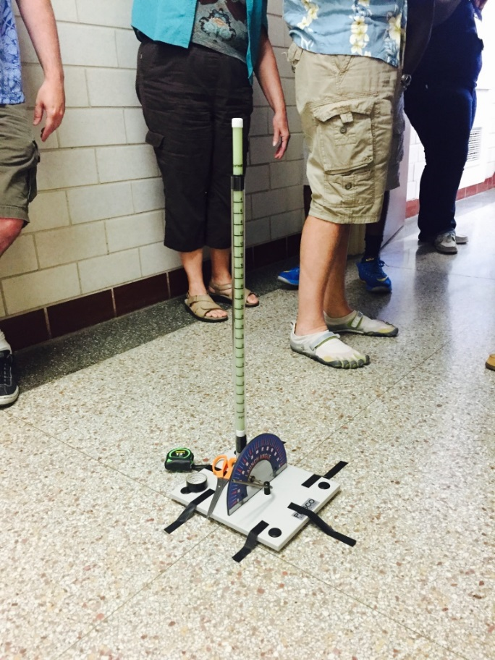
Winning Rocket (range) by Leon and Justin
