
Build Your Own Michelson Interferometer

Subject Area: Scientific processes and physical science

Grade Level: 9-12

OVERVIEW

Build your own Michelson interferometer for under $150. The Michelson interferometer works by splitting a light beam into two separate beams that travel different light paths along two arms. Mirrors at the ends of the arms reflect the beams back to the beam splitter, where they interfere upon being recombined. The interference pattern - typically a set of alternating bright and dark stripes, called fringes - displays subtle differences between the two arms. For instance you can see the fringe pattern shift by one fringe when one arm is stretched relative to the other by 1/3000th of a millimeter! (You can easily bend the metal mirror mounts enough with a plastic coffee stirrer or a soda straw to view this deformation.)

OBJECTIVES

- Students will demonstrate the manual skill that is required to build a precision device
- Students will explain light interference using the basic model of wave behavior
- Students will describe the relationship between the movement of an interferometer mirror and the resulting movement of the pattern of fringes

CONNECTIONS TO STANDARDS

- Wave behavior and properties including the nature of light, development of scientific investigations, the use of technology in investigations, formulating and revising scientific explanations and models, safe practices in investigations.

SAFETY AWARENESS

- Use a laser pointer that is Class IIIa or lower.
- Avoid eye contact with the laser beam when building or using the interferometer.
- Yes, epoxy is capable of gluing a person's fingers together.
- Sliced metal will often have sharp edges or will have small shards or splinters. Consider sanding rough surfaces on the aluminum mounts.

THE PROCEDURE FOR BUILDING THE INTERFEROMETER

This is a picture of the demo in action:

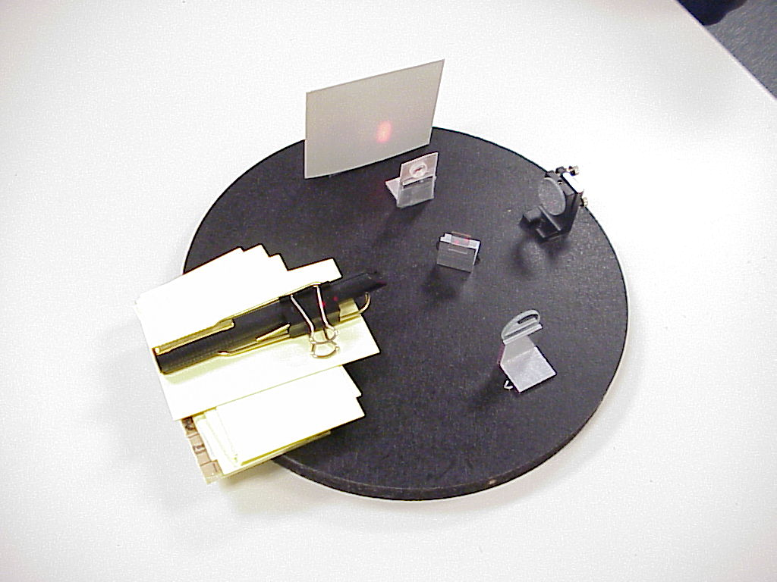

The secret to keeping costs down for this interferometer are: use a cheap laser; keep the number of precision mechanical mounts to a minimum; keep the spots small on the beam splitter and mirrors and then blow the beam up for viewing at the end. We use a laser pointer because you get a surprisingly good and reliable light source for under $25. By keeping the distances between the end mirrors and the beam splitter nearly equal, we mitigate problems caused by multimode behavior of the laser. There are only two critical alignment angles in a Michelson interferometer and we use a single precision mount to make these adjustments. The rest of the mounts are simple and cheap. To get good-looking fringes, you need the laser wave front and the surfaces of the two end mirrors and the beam splitter to be flat to within a small fraction of an optical wavelength. This can be accomplished by expensive extremely high quality optics for large-diameter laser beams or, as we do, by keeping the laser beam small inside the interferometer and only expanding the beam for viewing after the interference occurs at the beam splitter. Relatively cheap optics with flatness of 4-6 waves/inch are actually very flat (lambda/4 or better) over the small size of our laser beam (typically 1mm on a side).

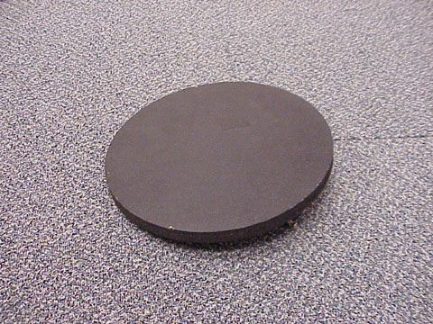
The Base plate

You will need a flat piece of particleboard (or other material) on which to mount the parts. A 1-ft diameter particleboard "round" was used purchased from a local hardware store for this demo. The base plate needs to be smooth and flat to make mounting and adjusting parts easy. We painted our base plate with a thin coat of flat black paint for
purely cosmetic reasons. (Do not spoil the flatness with a thick, crummy paint job!)
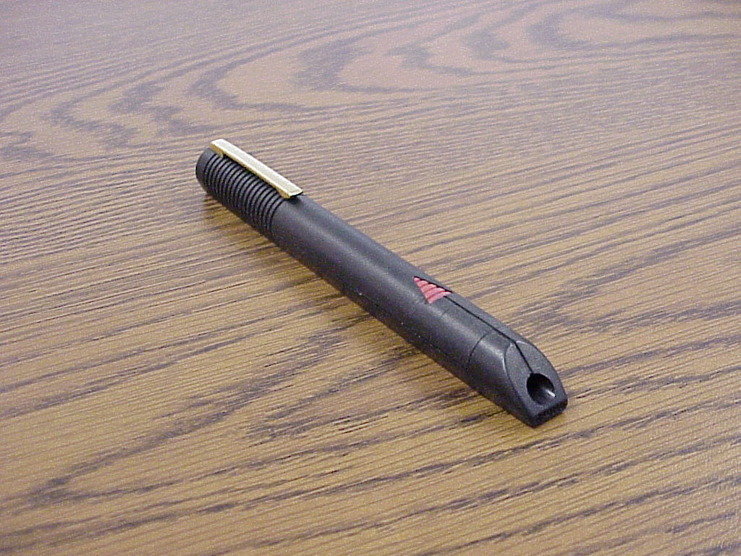
The Laser Pointer

This is the light source for the interferometer. Almost any over-the-counter laser pointer will work for this demo. For safety reasons, make sure that the pointer is Class III-a or lower power as indicated on the labeling. You need to invent a way to hold down the "on" button easily. We have successfully used clothespins, paper clips and even the broken tine from a plastic fork, held down by tape.

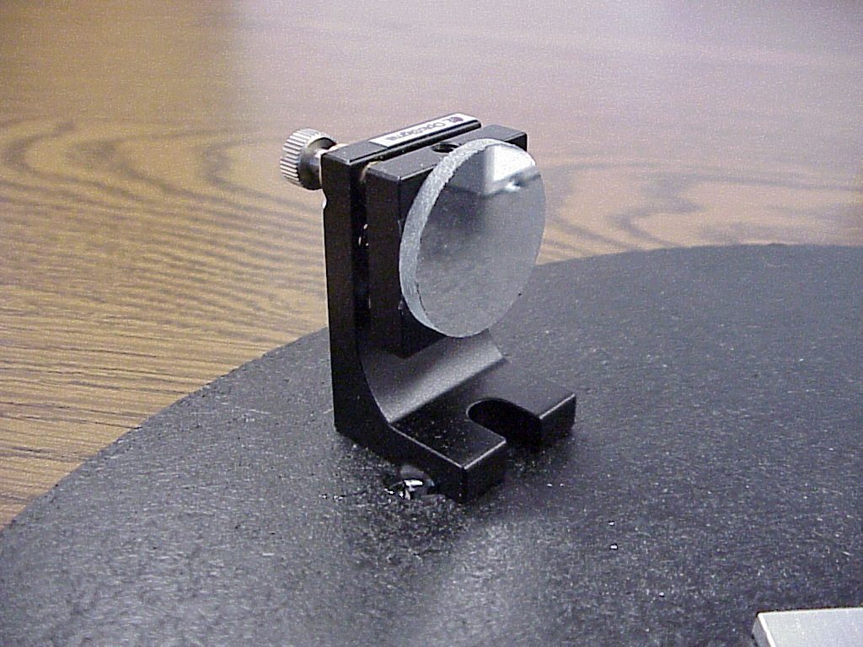
Mirror on Adjustable Mount

The adjustable mirror mount is the most expensive, but necessary, part of the demo. It allows you to make the fine alignment adjustments needed to get a nice fringe pattern. We purchased our mirror mount from www.optosigma.com (part number 112-0250) for under $50. We purchased our two mirrors from www.edmundoptics.com. We used "first-surface" mirrors with an optical quality of 4-6 waves/inch. For reference, our mirrors were 26 mm diameter, which makes handling easy. Since the laser beam uses only a small fraction of this area, one could experiment with smaller mirrors. We used Scotch "double-stick" tape on the back of the mirror to hold it to the mount.
Aluminum Angle for Fixed Mounts
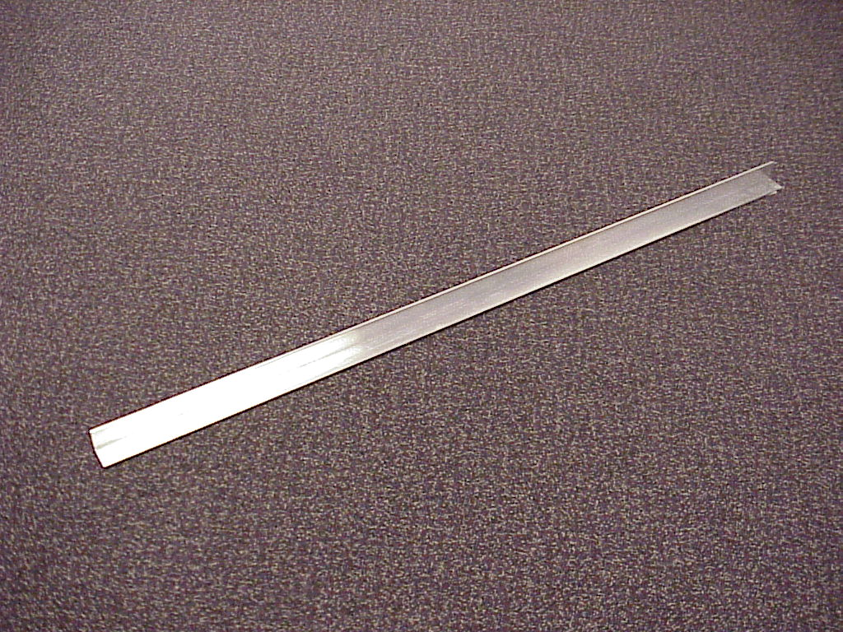
This part can be found at most hardware stores. It is one-inch aluminum angle. (Costs about $1.25 a foot.) Cut it into 1-inch pieces for mounting the other optics. Use a hacksaw or something of that nature to cut it. (Filing the edges after cutting is necessary for safety, but also will keep the optics from rocking on rough edges or cutting into the base plate. The beauty of aluminum angle is that it is made by an extrusion process that holds pretty close to a 90-degree angle. So, be sure not to bend the metal when cutting! You need to preserve the 90-degree angle to keep the beams aligned well enough (within a degree or so). If you do bend it, you can use shims to work around poor alignment, or just cut new pieces more carefully.
Mirror on Fixed Mount
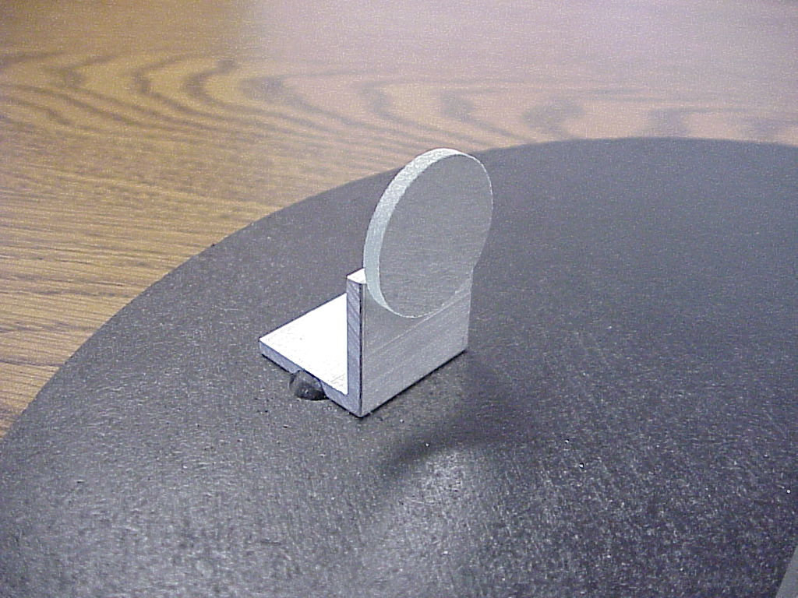

The second of the two mirrors gets mounted to the piece cut from the aluminum angle as shown, using Scotch "double stick" tape. For the 26-mm diameter mirrors, we let about one third of the mirror overlap the mount. If you use smaller mirrors, you need to experiment a bit. The advantage of double stick tape is that mistakes are easily corrected by using a razor blade to get the mount dismounted.

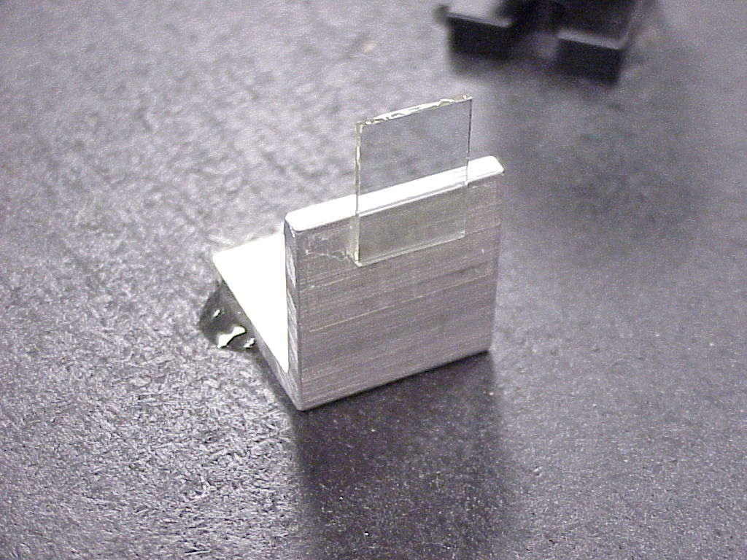
Beam Splitter on Fixed Mount

The beam splitter splits the laser into two separate beams and also recombines the beams after they strike the mirrors. We used a 12.5x17.5 mm 50:50 beam splitter. (Beam splitters are sometimes called "two-way" mirrors.) The term 50:50 means that 50% of incident light is reflected and the beam-splitter coating transmits 50%. You want a non-polarizing beam splitter. Optical quality of 4-6 waves/inch is sufficient, just as for the mirrors. Our beam splitter had an antireflection coating on the side opposite the beam-splitter coating.

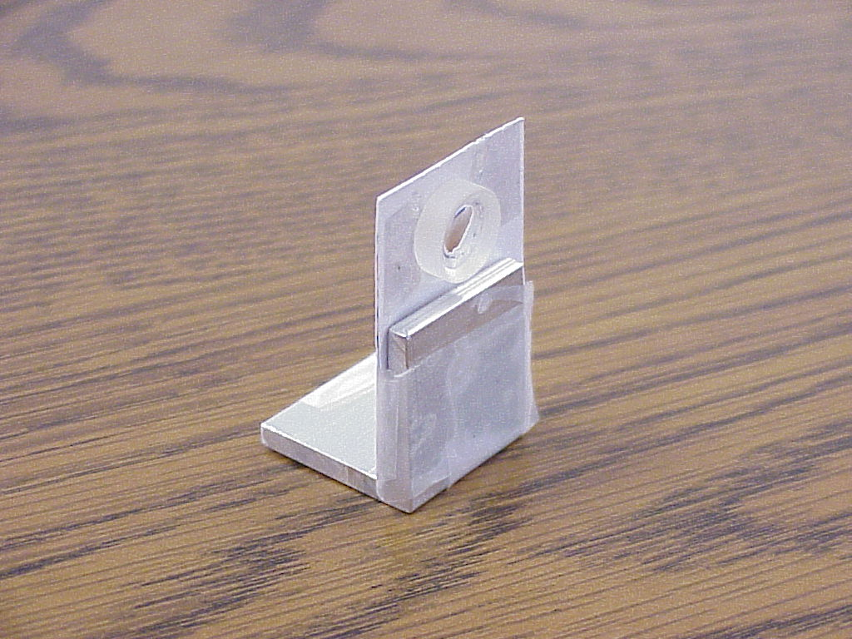
Small diverging lens

This lens spreads the laser interference pattern out for easy viewing on
a screen. We used a planoconcave (PCV) lens from http://www.emundoptics.com/ with diameter of 12 mm and a focal length of -12 mm. (The minus indicates that the lens causes parallel light rays to diverge.) Our lens had an antireflection coating on both sides.

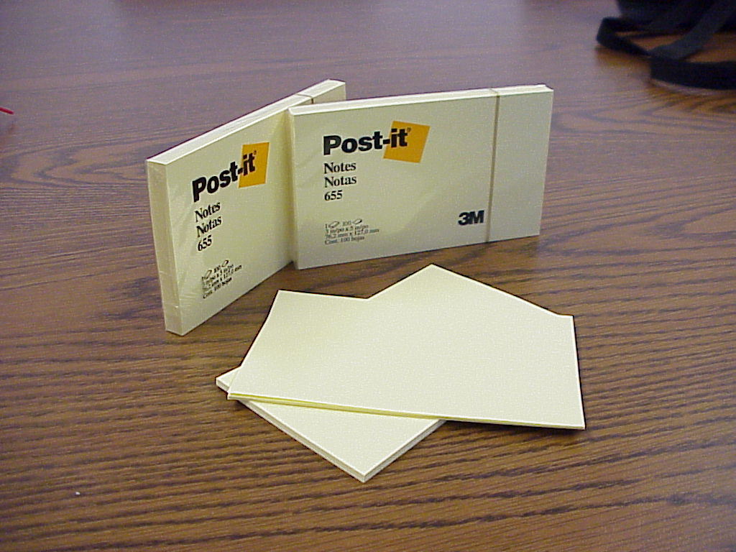
Post-It Notes

These are used to prop the laser up to the correct height for the mirrors. We used this method because it allows nearly infinitely height variation, by adding or removing sheets. You can also use the post-its along one edge of a mount as a shim to make up for alignment difficulties in case your fixed mounts are out of whack. You will need 2 to 3 packs depending on your exact set up.

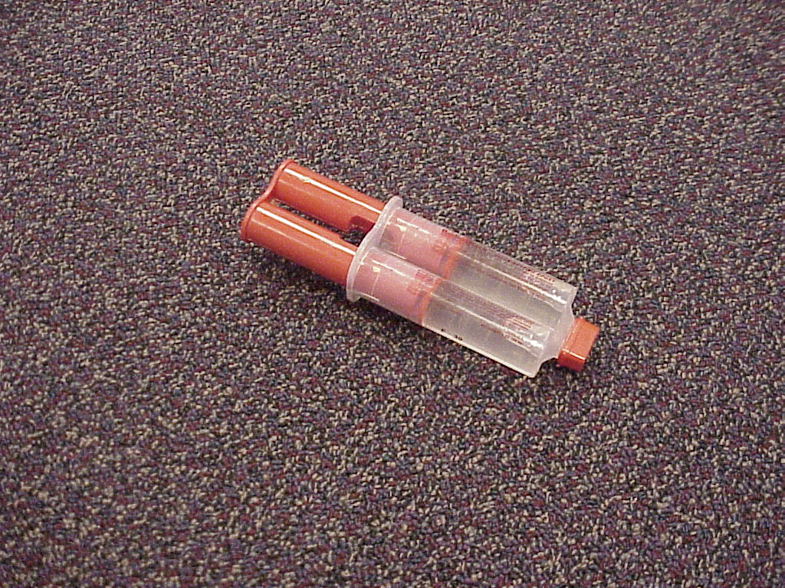
5-minute Epoxy

This is used to bond most of the parts onto the base plate. It can be found at any hardware store. The directions to use it should be on the back. Get this almost anywhere. Do not use the epoxy between two flat surfaces or you will never get them apart without breakage. We position our parts until we get them in the right places and then we mix a very small amount of epoxy, place a small dab (a few cubic millimeters) on each edge of the joint and let it cure. The photos above show the epoxy bonds on one edge holding the fixed and adjustable mirror mounts to the base plate.

How to Build the Device

Note: Throughout these instructions it is very helpful to take a look at the pictures to get an exact idea of what we are talking about. Take an especially good look at the "In action" photo. Click on the links provided to jump up to the appropriate picture.

- After you have the base plate, laser, mirrors and lens and you have cut 4 similar 1 inch wide pieces from your aluminum angle, then you are ready to begin. Take one of the pieces of angle and tape the piece of beam-splitting glass down the way we have shown in the picture above. Make sure that most of it is exposed over the top. Do the same with the round mirror. Then, take one of the two remaining pieces of angle and tape a piece of cardboard onto the inner wall of one side. Make sure that most of it is exposed over the top (see picture above). Then punch a hole that is a little smaller than the lens into the exposed cardboard. Then mount the lens to the hole with some double sided tape or epoxy. Make sure that the tape or epoxy barely touches the lens. Once you have all three pieces made, look closely to make sure they look the way that they do in the pictures above. Move on to step two.

- Set the base plate on a table in front of you. Measure approximately 1 inch in from a quadrant of the circle. Use double stick tape to down the adjustable mirror mount to that spot making sure that it is facing the center of the circle. Later, you will epoxy this mount down. Using double stick now allows you to make small adjustments until you get it all right. Look at the picture above and see how we mounted our mirrors. You will want to mount your mirrors in the same arrangement, using double stick tape to hold them in place. You need to make sure that both of the mirrors are about the same distance away from the beam splitter at the point where the laser light is split. We used a wooden ruler to verify the distances were the same to within 1/16 inch. The actual size of your base plate will affect how far apart the mirrors will be.

- Get your laser out and use a clip or tape a small piece of plastic or a screw over the switch to hold it "on". BE CAREFUL NOT TO SHINE THE LASER INTO ANYONE'S EYES! Set the operating laser onto the post-it notes. Remove or add post-it notes to get the laser light to shine straight at the black mirror mount. You should be able to see the laser beam reflected from the mirror, so that it almost goes back into the laser. Ideally, it should hit the laser next to where the laser beam originates.

- Take the mounted beam splitter and place it in between the laser pointer and the adjustable mirror mount. You should now be able to see a spot reflected from the beam splitter. Align the beam splitter so that this reflected beam travels at roughly 90 degrees to the transmitted beam. Use a pencil to outline the mount onto the base plate. Now place double stick tape on the bottom of the beam splitter mount and place it back down within your marks.

- The double stick tape will hold the beam splitter in place while you measure the distance between the adjustable mirror and the laser spot on the beam splitter. Now place the fixed mirror mount at the same distance from the laser spot on the beam splitter. Align the fixed mount so that you can see the mirror reflect the laser light back to the beam splitter. You should be able to get this return beam to go through the beam splitter close to where it originated. Mark the outline of the mount on the base plate, apply double stick tape and tape the mount down to the base plate.

- You will now see that the laser light from the two mirrors returns to the beam splitter so that some light is directed back toward the laser and some light goes off into space. Put up a screen to stop the beams going off into space. Adjust the adjustable mirror so that the two beams on the screen overlap. Now place the mounted lens between the beam(s) and the screen, but keep the lens close to the beam splitter. You will now see one or two big red splotches on the paper. Typically there will be two splotches, slightly misaligned. Adjust the knobs slowly on the mirror mount to line up the two splotches on the screen better and better. Once you get them very well lined up you should notice black lines running through the splotches. These are your fringes.

- Now with the fringes visible, epoxy the mounts down to the base plate using a small amount (bead) of epoxy on two opposite sides of the mount. You can see an example of one of these epoxy beads in this picture.

A HANDOUT FOR STUDENTS

The Michelson Interferometer

Name:

If you have not done so already, spend some time observing the behavior of the interferometer (please don't touch the optical components). Gently turn the adjustment screw on the adjustable mirror and watch what happens to the interference pattern. With the interferometer completely focused, loop a string around the stand that supports the fixed mirror and gently pull on the loop. There are a variety of other experiments to do with the instrument, such as placing a sample of very hot water near one of the beam paths, halfway between the beam splitter and the end mirror. Those who built the device will just ask that you BE CAREFUL! Use your observations and outside resources (such as a physics book) to help you answer these questions

- What do we mean by 'light interference'?
- Is light the only type of wave that can undergo interference?
- Describe the two types of wave interference.
- Use the concept of interference to explain how the interferometer works.
- If you move the interferometer's adjustable mirror by the slightest amount, the pattern of fringes changes, and eventually it goes away.
- Why is the instrument so sensitive to the position of the mirror?
- Interferometers can be used to measure movements that are much, much smaller that you would measure with tools such as rulers. Using your experience of pulling on the mirror, explain how this is possible.
- Do some quick research (perhaps on the Internet) and see if you can find some ways that interferometers are used in the 'real world'.

