PHYS 5380 – Syllabus
Fall 2017
Ryszard Stroynowski & Stephen Sekula

Course Objective:

Upon completion of this course the students will be able to describe the structure of matter, ranging from atoms and nuclei to quarks and leptons, and the type and strength of forces governing basic interactions among the elementary components of matter. The course will cover particle acceleration and detection techniques and their applications to technologies used in every-day life. There is no single textbook covering this material and the list of books available in the library is appended to this syllabus. Some homework exercises will be taken from Richard Fernow’s “Introduction to experimental particle physics”. Web based reviews and publications can be used as additional resource. Major components of the final grade will be based on the evaluation of a 30 minutes-long public oral presentation with power-point slides on one of the selected topics. The presentation should cover all elements of the course: explanation of the physical phenomena, observation and detection techniques, how the observations affect our understanding of the universe and the direction of future studies on this subject.

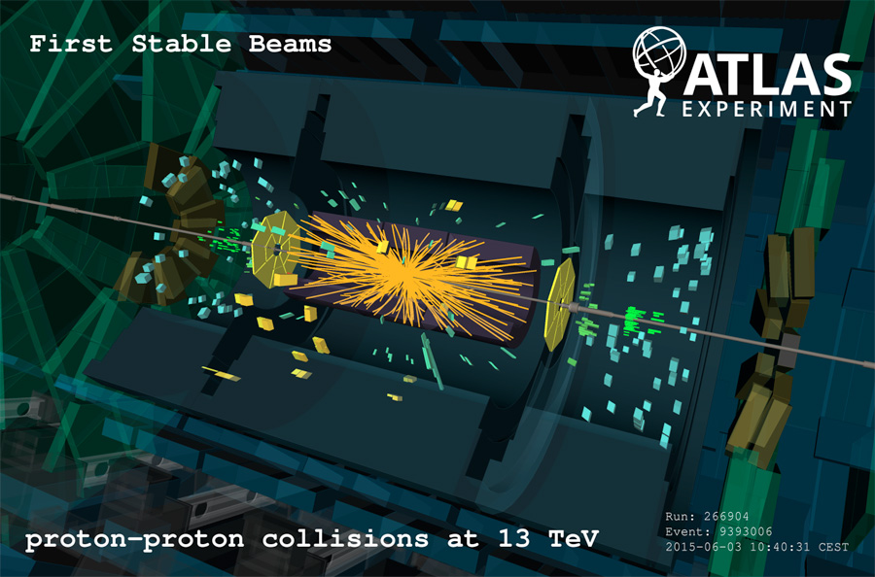

Grading

Homework 40%, Presentation – 40%, class and seminars participation – 20%

Grading of seminar presentations will be done in collaboration with the audience.
Sample grading sheet:
Rate the following aspects in the range of 1 to 10 with 10 being best:
- Introduction of the topic. Is the subject important to physics?
- Organization and logic of the talk:
- Transparencies: was the presentation clear? what was missing?
- Questions: was the speaker able to answer questions?
What element of this presentation would you lie to see expanded further

Syllabus

Aug 21(Mon) Solar eclipse
Aug 23 (Wed) Introduction, discovery of atom’s substructure, electron, neutron,
Aug 25 (Fri) Quantum mechanics, relativity, units
Aug 28 (Mon) History 1920-1940: angular momentum, spin, beta decays
Aug 30 (Wed) Muons, neutrinos, particle interactions with matter
Sep 1 (Fri) Forces and interactions, cross sections, lifetime, resonances
Sep 4 (Mon) LABOR DAY – no class
Sep 6 (Wed) Particles as waves, e+e-, conservation laws
Sep 8 (Fri) Symmetries P, C, CP
Sep 11 (Mon) Isospin, quark model
Sep 13 (Wed) Dynamic evidence for quarks, e-m interactions
Sep 15 (Fri) Strong and weak interactions
Sep 18 (Mon) Accelerators part 1
Sep 20 (Wed) Accelerators part 2
Sep 22 (Fri) Tracking part 1
Sep 25 (Mon) Tracking part 2
Sep 27 (Wed) Solid state trackers
Sep 29 (Fri) Fibers + TOF
Oct 2 (Mon) Cosmic rays
Oct 4 (Wed) Calorimetry part 1
Oct 6 (Fri) Calorimetry part 2
Oct 9 (Mon) FALL BREAK – no class
Oct 11 (Wed) Neutrinos part 1
Oct 13 (Fri) Neutrinos part 2
Oct 16 (Mon) ATLAS detector systems
Oct 18 (Wed) Electronic readout
Oct 20 (Fri) Trigger
Oct 23 (Mon) Computing for particle physics
Oct 25 (Wed) Monte Carlo techniques
Oct 27 (Fri) Probability and statistics part 1
Oct 30 (Mon) Probability and statistics part 2
Nov 1 (Wed) Cosmology part 1
Nov 3 (Fri) Cosmology part 2
------------------------------------------------------------------------------------------------------------
Review
Nov 6 (Mon) Student lecture 1 Oct.30 Nov 8 (Wed) Student lecture 2 Nov. 2
Nov 10 (Fri) Student lecture 3
Nov 13 (Mon) Student lecture 4 Nov. 6
Nov 15 (Wed) Student lecture 5 Nov. 9
Nov 17 (Fri) Student lecture 6 Nov.11
Nov 20 (Mon) Student lecture 7 Nov.14
------------------------------------------------------------------------------------------------------------Nov 24 (Fri) Thanksgiving – no class
Nov 27 (Mon) Applications
Nov 29 (Wed) Applications
Dec 1 (Fri) Future of particle physics: Grand unification, superstrings
Dec 4(Mon) Future machines: proton-proton - HL-LHC,
Neutrino - Dune,
electron-positron - NLC, CEPC

Subjects for seminar presentations
Particle physics: magnetic monopole, neutrino oscillations, CP violation,
Higgs boson. antimatter, ,supersymmetry, charge leptons,
quark mixing +CKM, photodetectors
Astroparticle physics: dark matter, dark energy, gravitational waves
Machines and detectors: application of particle beams in medicine
application of photon beams in medicine

Textbooks
* first choice

Elementary level (general)

*Donald Perkins, Introduction to High Energy Physics
Cindy Schwartz, The subatomic ZOO
R.M. Barnett, H. Muhry and H. Quinn, The Charm of Strange Quarks

Medium Level (theory)

L. Okun, Leptons and Quarks
C. D. Coughlan and J. E. Dodd, The ideas of particle physics
*David Griffith, Introduction to Elementary Particles
Martinus Veltman, Facts and Mysteries in Elementary Particle Physics

Advanced (theory)

Abraham Seiden, Particle Physics, a comprehensive introduction
F. Halzen and A. Martin, Quarks and Leptons
K. Gottfried and V. Weiskopf, Concepts of Particle Physics
* Gordon L. Kane: “Modern Elementary Particle Physics: Updated Edition”
Chris Quigg, Gauge Theories of Strong, Weak and Electromagnetic Interactions
Bjorken and Drell, Quantum Field Theory
Kerson Huang, Quarks, Leptons and Gauge Fields
B.R. Martin and G. Shaw, Particle Physics
W.N. Cottingham and D.A. Greenwood, An Introduction to the Standard Model
of Particle Physics
Byron P. Roe, Particle Physics at the New Millenium

Experimental techniques

* Richard Fernow, Introduction to experimental particle physics
Bruno Rossi, High Energy Physics
Konrad Kleinknecht, Detectors for Particle Radiation
Claus Grupen and Boris Shwartz: “Particle Detectors”
Claude Leroy and Pier-Giorgio Rancoita: “Principles of Radiation Interaction In Matter And Detection” (3rd Edition)

Disability Accommodations: Students needing academic accommodations for a disability must first register with Disability Accommodations & Success Strategies (DASS). Students can call 214-768-1470 or visit http://www.smu.edu/Provost/ALEC/DASS to begin the process. Once registered, students should then schedule an appointment with the professor as early in the semester as possible, present a DASS Accommodation Letter, and make appropriate arrangements. Please note that accommodations are not retroactive and require advance notice to implement.

• Religious Observance: Religiously observant students wishing to be absent on holidays that require missing class should notify their professors in writing at the beginning of the semester, and should discuss with them, in advance, acceptable ways of making up any work missed because of the absence. (See University Policy No. 1.9.)

• Excused Absences for University Extracurricular Activities: Students participating in an officially sanctioned, scheduled University extracurricular activity should be given the opportunity to make up class assignments or other graded assignments missed as a result of their participation. It is the responsibility of the student to make arrangements with the instructor prior to any missed scheduled examination or other missed assignment for making up the work. (University Undergraduate Catalogue)

