RESISTANCE CALIBRATION MEASUREMENTS ON THE M WHEEL
OF THE LIQUID ARGON CALORIMETER FOR
THE ATLAS EXPERIMENT AT CERN

Approved by:

_____________________________
Prof. Ryszard Stroynowski

_____________________________
Prof. Fred Olness

_____________________________
Prof. Yongsheng Gao

_____________________________
Prof. Werner Horsthemke

RESISTANCE CALIBRATION MEASUREMENTS ON THE M WHEEL
OF THE LIQUID ARGON CALORIMETER FOR
THE ATLAS EXPERIMENT AT CERN

A Thesis Presented to the Graduate Faculty of
Dedman College
Southern Methodist University
in
Partial Fulfillment of the Requirements
for the degree of
Master of Science
with a
Major in Physics
by

Matthew R. Knee
(B.S. Eastern Michigan University)

December 11, 2004

Copyright © 2004
Matthew R. Knee
All Rights Reserved

Knee, Matthew R. B.S., Eastern Michigan University, 1997 B.S., Eastern Michigan University, 2001
Resistance Calibration Measurements on the M Wheel
of the Liquid Argon Calorimeter for
the ATLAS Experiment at CERN
Advisor: Professor Ryszard Stroynowski
Master of Science degree conferred December 11, 2004
Thesis completed August, 2004

Tests to measure the resistances of the complete electronics chain for all channels in the M-Wheel half of the ATLAS liquid argon (LAr) electromagnetic (EM) barrel calorimeter at CERN were performed in July 2003. The test was conducted with the EM barrel calorimeter filled with air, i.e. before the adding of the liquid argon. The test revealed that 50 channels out of a total of 58386 had resistances that exceeded their expected values by +/- 0.2 %. This indicates that less than 0.1 % of the channels in the M-Wheel operate outside of the experimental requirements. Therefore, these results show that the M-Wheel half of the LAr EM barrel calorimeter is working within acceptable limits and ready for operations with liquid argon.

TABLE OF CONTENTS

LIST OF TABLES | vii
LIST OF FIGURES | ix
ACKNOWLEDGEMENTS | xi
Chapter | Page
I. INTRODUCTION | 1
1.1 LHC and ATLAS | 7
1.1.1 Inner Detector | 9
1.1.2 Electromagnetic Calorimeter | 11
1.1.3 Hadronic Calorimeter | 12
1.1.4 Muon system | 14
1.1.5 Magnet system | 15
1.2 Physics goals of the ATLAS experiment | 16
1.3 Electronics chain in the EM Calorimeter | 18
II. ELECTROMAGNETIC CALORIMETER | 20
2.1 Barrel Calorimeter | 24
2.2 Presampler | 28
2.3 Electronics | 30
2.4 Feedthroughs | 33
III. TEST OF COMPLETE READ-OUT ELECTRONICS CHAIN | 37
3.1 Set-up and Equipment | 39
3.2 Operational Procedure | 40
3.3 Measurement Expectations | 43
IV. RESULTS | 46
4.1 Presampler | 46
4.2 Front | 48
4.3 Middle | 50
4.4 Back and Barrel End | 54
4.5 Calibration | 56
4.6 Summary and Conclusions | 57
APPENDIX | 61
REFERENCES | 95

LIST OF TABLES

Table | Page
1.1 Table of quarks [1]. | 3
1.2 Some properties of leptons [1]. | 4
4.1 Summary of results for each section. | 58
A.1a List of all found problem channels by module (M00 – M07). | 61
A.1b List of all found problem channels by module (M08 – M15). | 62
A.2 FT00 (M00) | 63
A.3 FT01 (M01) | 64
A.4 FT02 (M01) | 65
A.5 FT03 (M02) | 66
A.6 FT04 (M02) | 67
A.7 FT05 (M03) | 68
A.8 FT06 (M03) | 69
A.9 FT07 (M04) | 70
A.10 FT08 (M04) | 71
A.11 FT09 (M05) | 72
A.12 FT10 (M05) | 73
A.13 FT11 (M06) | 74
A.14 FT12 (M06) | 75
A.15 FT13 (M07) | 76
A.16 FT14 (M07) | 77
A.17 FT15 (M08) | 78
A.18 FT16 (M08) | 79
A.19 FT17 (M09) | 80
A.20 FT18 (M09) | 81
A.21 FT19 (M10) | 82
A.22 FT20 (M10) | 83
A.23 FT21 (M11) | 84
A.24 FT22 (M11) | 85
A.25 FT23 (M12) | 86
A.26 FT24 (M12) | 87
A.27 FT25 (M13) | 88
A.28 FT26 (M13) | 89
A.29 FT27 (M14) | 90
A.30 FT28 (M14) | 91
A.31 FT29 (M15) | 92
A.32 FT30 (M15) | 93
A.33 FT31 (M00) | 94

LIST OF FIGURES

Figure | Page
1.1 Three dimensional view of the ATLAS detector. | 8
1.2 Interaction of various particles with the different components  of a detector. | 9
1.3 EM and hadronic calorimeters. | 13
2.1 Simplified development of an EM shower. | 20
2.2 Simulation of an electromagnetic shower in the barrel EM  calorimeter. | 24
2.3 Longitudinal slice of the EM calorimeter showing that the barrel  section covers |η| = 1.475. | 25
2.4 Structure of the read-out electrodes. | 27
2.5 Sketch of the accordion structure in a section of the EM calorimeter  showing its depth of 26Χ₀ along with coverage in η and φ. | 28
2.6 Sketch of the layout of the EM barrel calorimeter and presampler. | 29
2.7 Presampler module with motherboard. | 30
2.8 A back mother board on a module. | 31
2.9 Sketch of a section of the EM calorimeter showing the summing  boards and mother boards. | 32
2.10 Sketch of the barrel showing the EM barrel calorimeter, the  presampler, cabling, and the feedthroughs. | 34
2.11 Side view of a feedthrough. | 36
3.1 Sketch of a feedthrough flange showing fifteen rows and two  columns. Each row of each column consists of 64 pins  (128 for each full row). | 40
3.2 Schematic of the complete read-out electronics chain. | 41
3.3 Actual view of two adjoining feedthroughs with HV protection  cards and scanner card inserted. | 42
3.4 View of the PC, multimeter, and power source used during  the test. | 43
3.5 Ben Wakeland and myself (left) performing tests on the  feedthroughs at the top of the M-wheel. | 45
4.1 Graphs of the presampler data with variation respect to 2030 Ω vs.  a) feedthrough position, b) position in η, c) position in φ, and  d) the measured resistance distribution. | 47
4.2 Graphs of the front data with variation respect to 3037 Ω vs.  a) feedthrough position, b) position in η, c) position in φ, and  d) the distribution of measured resistance. | 49
4.3 Diagram illustrating the position of the protection circuits. | 51
4.4 Graphs of the middle (η < 0.8) data with variation respect to  1061 Ω vs. a) feedthrough position, b) position in η, c) position  in φ, and d) the distribution of the measured resistance. | 52
4.5 Graphs of the middle (η > 0.8) data with variation respect to  735 Ω vs. a) feedthrough position, b) position in η, c) position  in φ, and d) the distribution of the measured resistance. | 53
4.6 Graphs of the back data with variation respect to 1061 Ω vs. a)  feedthrough position, b) position in η, c) position in φ, and  d) the distribution of the measured resistance. | 55
4.7 The comparison of FT09-Back 0 (top) and FT00-Middle 1 (bottom)  shows some correlation. | 56
4.8 Data from two different scanner card tests on FT 23 – Mid 2.  The plot shows a clear correlation in the different sections. | 59

ACKNOWLEDGEMENTS

First and foremost, I would like to thank my advisor Ryszard Stroynowski. I have been very fortunate to have his guidance, support, and patience during my graduate studies at Southern Methodist University (SMU). The knowledge and expertise that he has shared has helped me to better understand the aspects of particle physics research. I am very thankful for being given the unique opportunity to work on the ATLAS detector at CERN. I am also grateful to him for introducing me to wonderful Swiss cuisine, and for a fantastic journey to the top of Aiguille du Midi to see Mont Blanc.
I am very grateful to Lydia Fayard, Christophe De la Taille, and Laurent Serin for all of their help and support during the test of the M-Wheel. I want to especially thank Ben Wakeland, who assisted in taking data. The data for this thesis would not have been able to be fully collected without his “magic carpet” rides. I want to also thank Laurent for the results of the data on which this thesis is based, and for all the help and insight he has provided to help me better understand these results.
I feel a deep gratitude towards the SMU Physics Department. I would like to thank the entire faculty for their support, and all of the knowledge they have shared during my graduate studies. I am very grateful for being given the opportunity to study in a department with so many talented faculty members. I can only hope that I will be able to inspire my students as much as they have inspired me. I want to also thank Shirley Melton and Carol Carroll helping me with all of my administrative problems.
I am indebted to all of my fellow graduate students I have worked along side during my time at SMU. I especially want to thank Liang Lu, Pavel Zarzhitsky, Eliana Vianello and Yurii Maravin for their help with physics and other matters.
During my stay in Dallas, I thoroughly enjoyed the time I spent with my friends Yurii, his wife Anya, and Eliana. Thank you all for the many great times we had out having diner and watching movies. It was not the same after you left.
I am very grateful to my aunt and uncle, John and Brenda Knee, for everything they have done for me while I have been in Dallas. Thank you so much. I am so thankful that I was able to have family nearby. I only wish that we were able to spend more time together.
I want to thank Benjamin Gross for his support and advice, and Zac Johnson for all the great music he sent me. You guys are great friends.
Finally, I would like to thank my parents Randy and Lita for all the support, encouragement, and love they have given me during my studies. I could not have asked for better parents.

CHAPTER I
INTRODUCTION

Particle physics is the study of the basic elements of matter and the forces that act on them. The aim of particle physicists is to determine the fundamental laws that control the make-up of matter and the physical universe. One of the many tools used to study particle physics is the accelerator. It allows for the creation of the types of particle collisions that we want to study. Experiments at particle accelerators collide sub-atomic particles at very high energies, and they reveal details about particles and the conditions that prevailed just after the Big Bang, which occurred over 15 billion years ago. The high energy collisions between particles that physicists are interested in do occur naturally, and are caused by cosmic rays. However, these events are unpredictable and the number that can be observed is low. Therefore, we must create machines (accelerators) that can make a large number of these events so that they can be better studied, and results can be reproduced.
Accelerators work by accelerating charged particles using electric fields. There are two basic types of accelerators: linear and circular. Linear colliders accelerate particles in a straight line, while circular colliders accelerate particles in a circle. The circular machines are more common due to economic factors. In addition to accelerating the particles using an electric field, circular accelerators need to use a magnetic field to bend their paths. In these machines, particles are accelerated in opposite directions until they are brought together and forced to collide. One drawback to the circular machines is loss of energy. Particles like to travel in a uniform direction. When they are forced to change direction, such as in a circle by magnetic fields, they radiate energy in the form of photons. This energy loss is known as Bremsstrahlung. This effect can be minimized by increasing the radius of the ring, thereby reducing the curvature, but this increases the cost of the accelerator.
At a collision point, a detector is needed to examine the particles that are produced when accelerated particles collide. There are two basic types of detectors: tracking detectors and calorimeters. Tracking detectors reveal the trajectories of individual charged particles, and calorimeters measure the energies of both charged and neutral particles. A modern detector is built using both. They are built with layers of trackers and calorimeters to give as much information as possible about the particles produced in each collision.
The main reason for studying particles is to enhance our knowledge, and understanding, of matter, forces, and interactions. Theories and discoveries over the last century by thousands of physicist have led to a remarkable picture of the fundamental structure of matter, but not including gravitation. This picture is known as the Standard Model of Fundamental Particles and Interactions, or Standard Model (SM) for short. The SM has long (~20 yrs.) been a well tested physics theory that has been used to explain a wide variety of phenomena. Many high precision experiments have been able to repeatedly verify subtle effects that were predicted by the SM. The SM is a simple yet comprehensive theory that explains all the hundreds of particles and their interactions with 60 matter particles and 13 force carrying particles [1].
There are two families of matter particles: the quarks and the leptons. All of these are point-like particles (they have no internal structure) and carry ½ integer spins. The quark family consists of six quarks: bottom (b), charm (c), down (d), strange (s), top (t), and up (u). The quarks are grouped in three generations because of similarities in their properties of mass and charge, shown in Table 1.1: u/d, c/s, and t/b. Each of these six quarks can have one of three different values (red, green, or blue) of a property known as color, and for all of these 18 (6 × 3) quarks, there is an antiquark, making 36 total quarks.

Table 1.1: Table of Quarks [1].
Flavor | Name | Spin | Charge | Mass (GeV) | Generation
u | up | 1/2 | 2/3 | 0.0015 - 0.004 | 1
d | down | 1/2 | −1/3 | 0.004 - 0.008 | 1
c | charm | 1/2 | 2/3 | 1.15 – 1.35 | 2
s | strange | 1/2 | −1/3 | 0.080 – 0.130 | 2
t | top | 1/2 | 2/3 | 174.3 ± 5.1 | 3
b | bottom | 1/2 | −1/3 | 4.1 – 4.4 | 3

There are also six leptons and six antileptons. Three of the leptons have mass and charge: the electron (e⁻), muon (μ), and tau (τ). The other three have no charge and very little mass: the electron-neutrino (ν_{e}), muon-neutrino (ν_{μ}), and tau-neutrino (ν_{τ}). Each of the charged leptons associated with their respective neutrinos and quark pair make up the first, second, and third generations of matter (i.e. e⁻, ν_{e}, and u/d make up the first generation). Each generation is heavier than the one before it. Some of the properties of the leptons are shown in Table 1.2.

Table 1.2: Some properties of leptons [1].
 | Name | Spin | Charge | Mass (MeV) | Generation
e⁻ | electron | ½ | -1 | 0.511 | 1
ν_{e} | electron neutrino | ½ | 0 | < 3 × 10⁻⁶ | 1
μ | muon | ½ | -1 | 105.7 | 2
ν_{μ} | muon neutrino | ½ | 0 | < 0.19 | 2
τ | tau | ½ | -1 | 1776.99 | 3
ν_{τ} | tau neutrino | ½ | 0 | < 18.2 | 3

Forces are transmitted between particles by the exchanging of the force carrying particles which are called bosons. The SM includes three of the four known forces: strong, weak and electromagnetic. Gravity, the weakest of the four, is not yet part of the SM. They transfer small amounts of energy from one particle to another because they have integer spin and follow Bose-Einstein statistics. These bosons are associated with a specific force. The gluon (g; there are 8 colors of gluons) is associated with the strong force, the photon (γ) is associated with the electromagnetic force, and the W± and Z bosons are both associated with the weak force.
Early theories predicted that there was a symmetry between the photon, and the W and Z bosons (Gauge Symmetry). These particles were predicted to all have zero rest mass. However, observations have shown that in reality, this is not the case. In actuality, the symmetry is “broken” or hidden [2]. The photon is massless (the gluon is also massless), but the W and Z bosons were found to have significant mass. The W mass is about 80 GeV, and the Z mass is about 91 GeV [1]. This large mass of the carrier bosons restricts the weak force to a short range, unlike the electromagnetic force whose range is infinite because photons have no mass. A complete internal symmetry is found in the mathematical description of weak and electromagnetic interactions, except for the effects of the masses. This physical phenomenon is known as electroweak symmetry breaking, and the mechanism behind it has yet to be discovered.
The SM predicts that a new particle, the Higgs boson, interacts with both matter and force carrying particles to give mass to all particles (Higgs mechanism) [2]. According to the theory, the mass is related to the strength of the interaction with the Higgs boson: the stronger the interaction, the greater the mass. The Higgs boson is the only undiscovered particle predicted by the SM.
The theory of supersymmetry (SUSY) is a possible extension of the Standard Model. It differs from all other symmetries because it relates two types of fundamentally different elementary particles: fermions (spin = 1/2, 3/2, 5/2, etc.) and bosons (spin = 0, 1, 2, etc.) [2]. According to the SUSY theory, every particle has a supersymmetric partner that differs in spin by 1/2. So, to clarify, fermions have bosonic supersymmetric partners, and bosons have fermionic supersymmetric partners. The strength of interactions of these supersymmetric particles is identical to the corresponding ‘ordinary’ particles. These SUSY particles are named in the following way: the bosonic supersymmetric partners of the fermions have the prefix ‘s-’ added to the fermion name, and the fermionic supersymmetric partners of the bosons have the suffix ‘-ino’ added to the boson name. So, for example, a spin 1/2 electron (e) has a spin 0 SUSY particle called a selectron (e), and a spin 1 photon (γ) has a spin 1/2 SUSY particle called a photino (γ). SUSY particles are denoted by a tilde (~) above the partner’s symbol.
There are a few different models for SUSY, but the general idea is that there is a broken symmetry in supersymmetry. This comes from the experimental evidence, or lack of evidence in this case. If SUSY was without broken symmetry, we would see sleptons with the same masses as leptons, squarks with the same masses as quarks, and so on [2]. No such particles have been observed, and so if SUSY is to be a true symmetry of particle physics, it must be broken. This breaking of symmetry allows for the SUSY particles to be much heavier than their partners [2]. This could explain why SUSY particles have not yet been seen because we haven’t been able to reach the energies required to create these heavy particles.
Heavy SUSY particles are thought to decay like the ‘ordinary’ particles that they resemble (not like their partners). Starting with the primary SUSY partner (X), X will decay all the way down to the lightest supersymmetric particle (LSP) plus some other normal particles. The observation of this LSP is the important starting point for ATLAS to verify whether SUSY exists or not.
Experiments to date have not been able to show that these theories are correct. Current particle accelerators have not had the ability to reach a high enough energy to be able to detect a Higgs boson or SUSY particles. However, this may soon change. There is a new collider being built that will go beyond the expected range needed (according to the theories). It is called the Large Hadron Collider (LHC), and it is expected to go online in 2007. One of two experimental detectors that will focus on trying to find the Higgs boson is called ATLAS (A Toroidal LHC ApparatuS) [3].
In this chapter, after a brief introduction to the ATLAS detector and the physics goals of the experiment, I will give an introduction to the testing of the electronics chain of the electromagnetic barrel calorimeter.

1.1 LHC and ATLAS
The Large Hadron Collider (LHC) is a large particle accelerator project at the European Laboratory for Particle Physics (CERN) located in Geneva, Switzerland. The LHC is designed to collide bunches of protons every 25 ns. These beam crossings will occur when two bunches of protons are accelerated in opposite directions around a 27 km ring (circumference). Each bunch, with an energy of 7 TeV, is then brought together into a collision. The proton-proton collisions will have a center of mass energy of 14 TeV. At the desired luminosity (10³⁴ cm⁻²s⁻¹), there will be a total of ~23 interactions per beam crossing every 25 ns apart. The main goal of the LHC is to maximize the discovery potential for new physics such as the Higgs boson and supersymmetric particles, while still being able to measure known objects such as heavy quarks and gauge bosons with a high degree of accuracy.
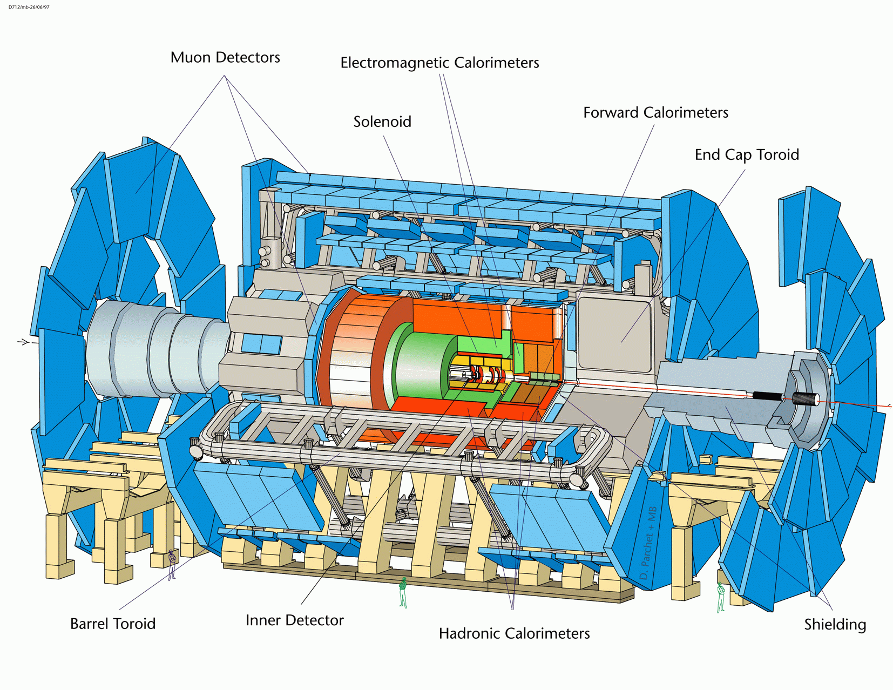
Figure 1.1: Three dimensional view of the ATLAS detector.

The ATLAS detector is one of the experiments at the LHC. This experiment will study these proton-proton collisions at energies seven times larger than the highest available to date. The group that is working on ATLAS is comprised of nearly 2000 collaborators from over 150 institutions from all over the world [3]. It consists of five major components: the inner detector, the electromagnetic calorimeters, the hadronic calorimeters, the muon spectrometer, and the magnet system. The ATLAS components can be seen in Fig. 1.1. The reason that detectors are divided into different components is that each component measures a special set of particle properties. The different types of particles react in unique ways, so it is important to have specialized detector parts. These
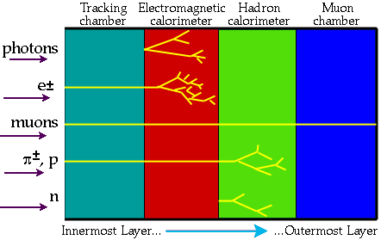
Figure 1.2: Interaction of various particles with the different
components of a detector.

components are stacked so that all particles will go through the different layers in a preferable order. A particle will be noticeable when it either interacts with the detector in a measurable fashion, or decays into detectable particles. An illustration of how particles interact with the different parts of the detector can be seen in Fig. 1.2.

1.1.1 Inner Detector
The Inner Detector is the first detector the particles will interact with as they move out from the collision point [3]. It is comprised of a set of tracking devices to track charged particles from the collision point to the electromagnetic calorimeter, and determine these trajectories with a high degree of accuracy. The Inner Detector is also designed to take momentum and vertex measurements, and identify electrons. It accomplishes all of this by being constructed of three major subdetector parts: the Pixel detector, SemiConductor Tracker, and Transition Radiation Tracker. The Pixel detector and the SemiConductor Tracker are responsible for taking the momentum and vertex measurements, and the Transition Radiation Tracker is responsible for finding the trajectories of the particles.
The Pixel detector is designed to take three high-precision measurements as close to the collision point as possible. It accomplishes this with three layers of pixels arranged in a barrel shape with radii of ~ 4 cm, 10 cm, and 13 cm. There are also five disks of pixels located on each side of the pixel barrel. One of its primary functions is to find short lived particles (i.e. B hadrons and tau leptons) by detecting secondary vertices away from the collision point.
The SemiConductor Tracker is located just after the pixel detector. It is composed of highly segmented sensing devices made from strips of silicon. As the charged particles pass through the silicon, they deposit a measurable amount of energy. The SemiConductor Tracker is designed to take eight precision measurements. Its design is similar to the pixel detector, as it also has a barrel and end-cap disks, but the SemiConductor Tracker is comprised of eight layers.
The outer most part of the Inner Detector is the Transition Radiation Tracker. It is designed to take an average of 36 precision measurements through ~36 layers of straw tube detectors. In addition to the tracking information, its main purpose is to identify electrons by detecting transition radiation photons. To accomplish this, xenon gas is used between the straws. When the electrons pass through the xenon gas, they give off photons.

1.1.2 Electromagnetic Calorimeter
The ATLAS electromagnetic (EM) calorimeter is a lead-liquid argon detector with accordion shaped geometry [3]. It is comprised of three main parts: the barrel, and two end-caps. They are shown in Fig. 1.3. The main focus for ATLAS is to search for the Higgs boson (H). As stated above, the Higgs boson is theorized to be the key to how particles acquire mass. A decay of the Higgs into a pair of photons is a favored channel because of its clear signature [6]. Therefore, the EM calorimeter is a crucial part of ATLAS. A detailed description of the EM calorimeter parts will be discussed in Chapter II.
The EM calorimeter is designed to measure the total energy of electrons, positrons (e⁺), and photons. Essentially the EM calorimeter will be measuring the energy deposited by electromagnetic showers. Electromagnetic showers are cascading events that are caused when electrons or positrons interact with matter in the calorimeter causing them to radiate photons. The photons then convert into e⁺ e⁻ pairs, which then also interact and radiate photons that will then also decay into more e⁺ e⁻ pairs. This cascade will continue until the average energy of the particles in the shower drops below the critical energy for the electron pair conversion.
There are two different types of material that can be used for the active material layer: gas or liquid. The use of liquids has some advantage over gasses when used as detectors for charged particles. The density of liquids is almost one thousand times greater than that of gasses [4]. Also, the energy absorbed per unit thickness of the layer is much larger in liquids by about the same factor, and the number of electrons formed in the shower process is much greater as well. The only drawback is that liquids are harder to purify. To minimize this problem, noble gases (He, Ne, Ar, Kr, Xe, Rn) are chosen because their chemically inert properties make it relatively easy to maintain their purity to a standard that is required in the detector. They are also chosen because they are inexpensive, readily available, and can be easily transformed into their liquid state by being cooled below their boiling point. Impurities such as oxygen (O₂) will readily absorb electrons, and thus negatively affect the measurements by reducing the shower. Liquid argon (LAr) has been chosen to be used in ATLAS, with an impurity level below 2 parts per million (ppm) [5]. The boiling point for LAr is 87.45 K, which is about -303° F.
The extremely cold temperature that the LAr needs requires special cooling, and isolation from warm temperatures. Therefore, the EM calorimeter is housed in what is known as the cryostat. The cryostat acts like a refrigerator, keeping the inside cold and the warm air out.

1.1.3 Hadronic Calorimeter
The hadronic calorimeter is comprised of two sections located in the outer areas of the same barrel and end-caps as the EM calorimeter [3]. Its primary function is to measure the total energy of hadronic particles by measuring the hadronic showers. A hadronic shower starts when a hadron interacts with the calorimeter material and the interaction creates secondary hadrons. These secondary hadrons then interact with the calorimeter material and form tertiary hadrons. This process will continue until they are stopped by ionization energy loss or they are absorbed. An important aspect in the design of the hadronic calorimeter is its thickness. It is important for the hadronic calorimeter to contain as much of the hadronic showers as possible so that it minimizes the carry over into muon system [4]. The hadronic calorimeter is also used to measure missing transverse energy, which is important for many physics signatures including searches for supersymmetric particles.

Figure 1.3: EM and hadronic calorimeters.

There are two different parts of the hadronic calorimeter, and they are constructed of different material. The first part is constructed with iron as the absorber material and scintillating tiles as the active material for sampling [3]. This design has parts in the outer portion of the barrel and the end-caps. The second part is located only in the end caps. This part uses copper as the absorber material and electrodes for the sampling. Both parts are oriented radially around the beam axis. This design can be seen in Fig. 1.3.

1.1.4 Muon system
The purpose of the muon system is to detect muons, one of only two types of particles to penetrate all material of the detector (the other are neutrinos). It is a three layer system of chambers in a toroidal magnetic field that provides precise measurements of the momentum of muons [3]. This information can be combined with information from the inner tracker to further improve the momentum measurement. The muon system is composed of two main parts: the muon toroidal magnets and the muon detector.
The muon toroidal magnet system has two parts: the barrel toroids and two end-cap toroids. They both can be seen in Fig. 1.1. The barrel toroid consists of eight toroidal magnets that generate a toroidal magnetic field that runs through the center of the toroids, and which surrounds the inner portion of the detector. The end-cap toroids are located in the end-cap region just at the end of the barrel toroids. This set up provides a radial overlap and optimizes the bending power is this area. The magnetic field is important because it will bend the path of the muons. This magnetic deflection is important for the momentum measurements needed to be taken in the muon system. The radius of curvature along with its direction will determine a particles momentum and the sign of its charge. Having the magnetic system also minimizes the amount of material through which the muons have to travel, which reduces multiple scattering and therefore improves the muon momentum measurement.
There are two parts in the muon detector system. They are designed to take three measurements of particles originating from the interaction point. The first part is arranged around the barrel, and consists of three concentric cylinders. The second part consists of four concentric disks located on each side of the interaction point at the ends of the detector.

1.1.5 Magnet system
The magnet system in ATLAS is comprised of two main parts: the toroidal magnets discussed above, and the solenoid magnet. As stated above, magnets play a key role in providing a magnetic field to bend charged particles so that important physics measurements can be made. Since the toroids have already been discussed, this section will only focus on the solenoid magnet.
The solenoid magnet (see Fig. 1.1) provides a magnetic field for the inner detector. The solenoid is a large coil of wire wound cylindrically to generate a straight uniform magnetic field inside the coil [3]. It provides the magnetic field to the inner detector by being constructed on its outer radius. The trajectory of charged particles curve in the magnetic field (B), and the radius of curvature R is proportional to the particles momentum (p) by the expression p ∝ 0.3 B R, where B is in teslas and R is in meters [1].
1.2 Physics goals of the ATLAS experiment
Most of us are familiar with forces that are associated with electric, magnetic, and gravitational fields. It is theorized that there is a new field that has yet to be discovered that is responsible for giving the particles mass. It is proposed that this field, called a Higgs field, permeates all of space, and that when particles interact with this field, they acquire mass. It is also proposed that the strength of the interaction is proportional to the mass that a particle will acquire. A particle that interacts strongly with the Higgs field will be heavy, while a particle that interacts weakly will be light. According to the theory, particles interacting with the Higgs field will actually be interacting with a new particle that is associated with this field, called the Higgs boson. The discovery of the Higgs boson at ATLAS would be one of the greatest scientific discoveries to date.
Another important question that ATLAS hopes to answer is if the electroweak and the strong forces can be unified. In the 1967, there was a major breakthrough in particle physics. This was the development of a unified description of the electromagnetic and weak forces (electroweak) by Steven Weinberg, a physicist from Harvard [2]. Physicists are now attempting to broaden this unification into a “grand unification” by including the strong force.
Experiments have shown that the effects of the strong force become weaker as the interaction energies increase. This suggests that at very high energies, the strengths of the electromagnetic, weak and strong forces are the same. The forces would basically be indistinguishable. Unfortunately, the energies involved are a trillion times greater than particle accelerators can reach. However, there is some good news. The grand unified theories have some consequences at lower energies; therefore, they can still be tested. Supersymmetry (SUSY; see above) is one type of grand unified theory (GUT). If SUSY is right, then supersymmetric particles should be found by ATLAS.
Measurements by astronomers have lead to a conclusion that 90 % or more of the Universe does not emit electromagnetic radiation, and therefore is not visible. Scientists call this invisible material dark matter. Very little is known about the nature of dark matter and its role in the universe. It is probable that dark matter is made of several different components, including neutrinos and supersymmetric particles. ATLAS hopes to answer some questions about dark matter by finding some of these particles.
Another fundamental question that ATLAS hopes to answer is why there are three generations of matter (see above). This puzzle is linked to one of the great mysteries of the universe. For a long time scientists have been trying to figure what happened to all the antimatter. Experiments in particle physics have shown that matter and antimatter are always created in equal quantities. This indicates that this equal creation should also have happened at the Big Bang. We also know that when matter and antimatter collide, they annihilate. However, there is a lot of matter that remains in the universe, and no antimatter. Therefore it is puzzling as to why the antimatter did not completely annihilate all the matter.
The fact that there is a lot of matter left in the universe seems to point to some small but significant asymmetry between matter and antimatter. This asymmetry could come from an effect that is called CP-violation. Thus far, CP-violation has been seen affecting particles that contain the strange quark from the 2nd generation. The LHC should easily produce particles containing the heavier bottom quark from the 3rd generation. If the theory is correct, ATLAS should be able to detect the symmetry breaking CP-violation in these particles as well.

1.3 Electronics chain in the EM Calorimeter
Many of the important physics processes at the LHC involve particles that decay into electrons or photons. The detection and reconstruction of these events depend on very good electromagnetic calorimetry. Therefore, it is very important the signals from the EM calorimeter are able to be read out accurately. This requires many important tests to ensure that the electronics are well understood and working properly. One such test is the testing of the complete electronics chain in a warm environment, before the liquid argon is added. This test will be performed in four different parts because of the separate EM calorimeter parts (two half-barrels, and two end-caps). One of these tests took place during July 2003 at CERN (bldg. 180). It was performed on one of the half-barrels. This thesis will focus on that test, and a detailed description will be given in Chapter III.
The complete electronics chain in the EM barrel calorimeter is fairly complex, and its individual components will be discussed in detail in Chapter II. Essentially, the signal is read out from electrodes in the accordion section. Multiple electrodes are added together to form one channel in summing boards. From here, the signals from the channels are sent through mother boards, which ensure the signal routing. The signals are then routed out of the module by 64 coaxial cables that are attached to the mother boards. The total cable route is comprised of two sets of cables in parallel separated by a patch panel. The signals are then routed out of the EM calorimeter by way of feedthroughs, special chambers that are required to separate the cold environment of the cryostat from the warm environment of the electronics required to analyze the signals. The feedthroughs are comprised of a vacuum chamber with cables that are attached to a pin interface at both ends.
A detailed description of the electromagnetic barrel calorimeter will be discussed in Chapter II. Then in Chapter III, I will focus entirely on the set-up and procedure of the test that was performed on the complete electronics chain of one of the half-barrels in the electromagnetic barrel calorimeter. Finally, the results and conclusions of this test will be given in Chapter IV.

CHAPTER II
ELECTROMAGNETIC CALORIMETER

An electromagnetic (EM) calorimeter is a device that measures the energy of particles that interact primarily through the EM force. Such particles are electrons, positrons, and photons. When electromagnetically interacting particles pass through matter, they deposit energy by a number of processes. At the energies that the LHC will operate, the dominant interaction will be e⁺e⁻ pair production (γ → e⁺e⁻) and bremsstrahlung (e± → e± γ) [7]. The e⁺e⁻ pair is created through the interaction of the photon with the electric field of a nucleus in the material. Alternating sequences of these two types of interactions leads to a cascade of electrons, positrons, and photons. This cascade is known as an EM shower. A simplified sketch of the development of an EM

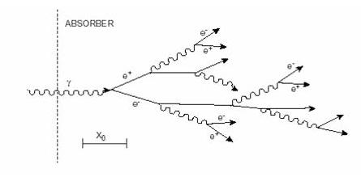
Figure 2.1: Simplified development of an EM shower.
shower is shown in Fig. 2.1. Bremsstrahlung is the radiating of a photon by an energetic electron or positron that passes through matter and is scattered by the electric fields of nuclei in the material.
The initial particles will radiate bremsstrahlung photons and lose energy due to ionization and scattering until they are stopped in the medium. This will occur when the average energy of the particles in the shower drops below the critical energy (E_{c}) that is characteristic of the material. The critical energy is defined to be the point at which the energy loss of electrons by ionization equals the energy loss by bremsstrahlung. It is given by an approximate formula E_{c} ≈ 800 (MeV)/ (Z +1.2) [7], where Z is the atomic number of the material.
The characteristics of an EM shower are influenced by the electron density of the material. This density is proportional to Z. The longitudinal and transverse dimensions of an EM shower are described by two material independent quantities. The radiation length (Χ₀) characterizes the longitudinal shower dimension. It is defined to be the average distance over which an energetic (> 1 GeV) electron will radiate 63 % (1 -1/e) of its energy by bremsstrahlung only [7]. The transverse spread of an EM shower is caused by three things: multiple scattering of electrons away from the shower axis, the angle between the particles in e⁺e⁻ pairs, and bremsstrahlung photons that are emitted away from the shower axis. The unit that describes the width of the spread is the Moliere radius (R_{m}). It is defined by R_{m} = E_{s}Χ₀/E_{c}, where E_{s} ≈ 21 MeV [7]. Approximately 95 % of a shower’s energy will be contained within an infinite cylinder of radius 2 R_{m}.
An equivalent distance for the interaction of photons is called the mean free path (Χ_{γ}). The mean free path is the distance after which the number of photons of identical energy has decreased by 1/e through pair creation. This is given by the formula: Χ_{γ} = 9/7 Χ₀. The two processes, bremsstrahlung and pair creation, have a comparable importance in that the function of depth is almost equal. However, the fraction of the cascade energy carried by the photons will increase as the depth of the shower increases.
A simple model of an EM shower can be obtained by considering the total number N of particles present in a shower after n radiation lengths of material. This is given by N ≈ 2^{n}. The average energy of each particle is E (n) ≈ E₀/2^{n}, where E₀ is the energy of the electron or photon which initiates the shower. When the average particle energy drops below E_{c}, fewer particles are produced than are absorbed by the medium. The maximum number of particles in a shower is therefore given by N_{max} ≈ E₀/E_{c}. Since we can assume that the shower will end when the particle energy drops below E_{c}, we can then find the shower’s penetration depth by E (n_{max}) = E₀/2^{nmax} = E_{c}. Solving for n_{max} we then have
n_{max} = ln (E₀/E_{c}) / ln 2.
The penetration depth is therefore related to the log of the particle energy. Typically about 25 Χ₀ are required to contain 95 % of the energy of a 100 GeV EM shower. Since the longitudinal shower energy containment is scaled in this way, it means that the overall size of the calorimeter can be kept rather compact.
Each charged particle in an EM shower will lose energy through ionization of the medium. This produces a large number of electrons that can be used to produce a measurable signal. The measurable signal produced in a calorimeter can take a number of forms depending on the type of calorimeter. One of these forms, which is utilized in the ATLAS EM calorimeter, is an electric current produced by the drift of ionization charge in the layers of active material in the calorimeter.
The ATLAS EM calorimeter utilizes liquid argon (LAr) as its active medium. A simplified description of a cell in a LAr calorimeter consists of a liquid argon gap, bounded on two sides by absorber layers. A read-out electrode layer is placed in the middle of the gap and a high voltage is applied to the electrode relative to the absorbers in order to produce an electric field in the gap. An ionizing particle crossing the LAr gap in a direction perpendicular to the absorber plates creates a line of electrons that drift toward the read-out electrodes by the influence of the electric field. These charges are then collected at the read-out electrodes, producing a current. This current pulse is then amplified and combined with the signals from other cells to reconstruct the energy of the incident particle. A more thorough description will be discussed in detail in section 2.1.
As stated in the Introduction, the ATLAS EM calorimeter has three sections: two end-cap EM calorimeters and an EM barrel calorimeter composed of two half-barrel calorimeter sections. Since this thesis focuses on the test that was preformed on the complete electronics chain of one of the EM half-barrel calorimeters, the detailed description of the ATLAS EM calorimeter here will be limited to just the half-barrel section, and it will focus on the parts of the calorimeter that directly relate to the test. I will first give a detailed description of the design of the EM barrel calorimeter in sec. 2.1, and in sec. 2.2 the design and purpose of the presampler will be discussed. Then in sections 2.3 and 2.4, I will give a description of the important electronics and the feedthroughs that are important to the reading out of the signals from the calorimeter.

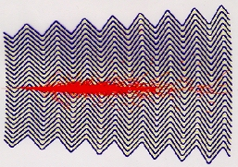
Figure 2.2: Simulation of an electromagnetic shower in
the barrel EM calorimeter.

2.1 Barrel Calorimeter
The EM barrel calorimeter is a lead Liquid Argon (LAr) detector with accordion shaped geometry. A view of this accordion geometry can be seen in Fig. 2.2. This accordion shaped geometry provides complete coverage in the φ direction (the φ direction is the radial direction around the beam axis) without any gaps. The EM barrel calorimeter is comprised of two half-barrels of equal design. Each half-barrel is made of 1024 accordion shaped absorbers alternated with read-out electrodes [8]. This setup has an advantage in that the read-out electronics can be placed on the inner and outer radius of the electrodes instead of having them run in the radial direction. This reduces the inductance in the on-detector electronics, thereby improving the pulse shape and timing for the read-out electronics. Even though there are no gaps, each half-barrel is divided into 16 modules.
The half-barrels are separate from each other, and each is connected to their respective ends of the cryostat. The length of each half-barrel is 3.2 m, and they both have an inner diameter of 2.8 m, and an outer diameter of 4 m. Each half-barrel is designed to cover the psuedorapidity from |η| = 0 to |η| = 1.475, illustrated in Fig. 2.3.
The structure of the absorbers is comprised of three parts. The main part of the absorber is made of lead sheets of different thickness. The thickness varies from 1.53 mm for η < 0.8 to 1.13 mm for η > 0.8. This variation in thickness is important because it decreases the sampling frequency at high η. The lead sheets are glued between

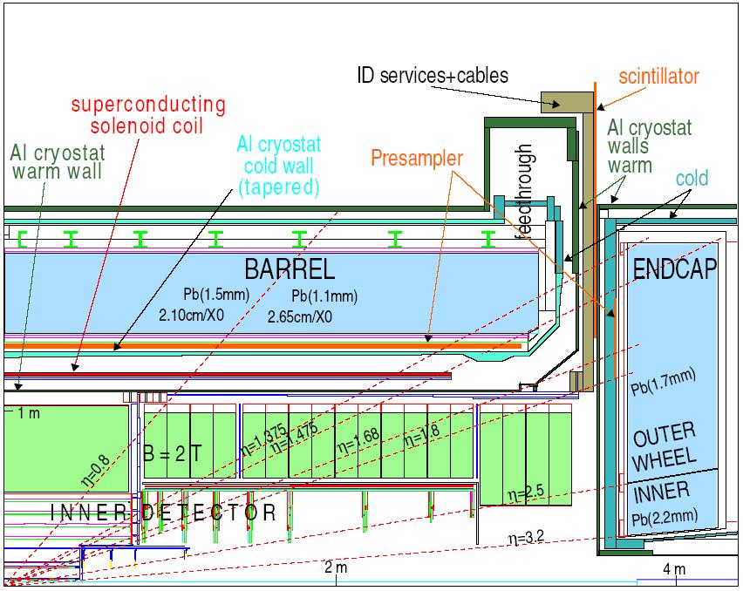
Figure 2.3: Longitudinal slice of the EM calorimeter showing that the barrel section covers |η| = 1.475.
two 0.2 mm thick stainless steel sheets. The lead and steel sheets are glued together by using resin soaked fiberglass fabric. The fiberglass compensates for the variation in thickness to give the absorbers a nominal thickness of 2.2 mm. The purpose of the steel sheets is to provide mechanical strength for the absorbers.
The read-out electrodes are composed of three layers of conductive cooper with insulating kapton polyimide sheets separating them. The structure of the read-out electrodes is shown in Fig. 2.4. The inner layer is used to read out the signal, while the outer layers are used to create an electric field by keeping a high voltage potential. The electrodes have a total thickness of 275 μm [5].
The accordion shape of the absorbers is designed so that the folding angles are decreasing with increasing radius. This insures that there is an approximately constant gap of 4.5 mm between to adjacent sides. The accordion structure is shown in Fig. 2.5. The electrodes are placed in the center of these gaps, giving them a 2.1mm liquid argon gap on either side. The EM barrel calorimeter is divided into three sections by depth: front, middle, and back.

Figure 2.4: Structure of the read-out electrodes.

Figure 2.5: Sketch of the accordion structure in a section of the EM calorimeter
showing its depth of 26 Χ₀ along with coverage in η and φ.

2.2 Presampler
The presampler is located just before the EM barrel calorimeter, as shown in Fig. 2.6. It is needed to correct for energy lost upstream in the material located between the collision point and the front face of the calorimeter. It provides shower sampling in an 11 mm layer of liquid argon [8]. The presampler is comprised of 32 azimuthally identical sections for each half-barrel. Each section is 3.1 m long and 0.28 m wide, and spans

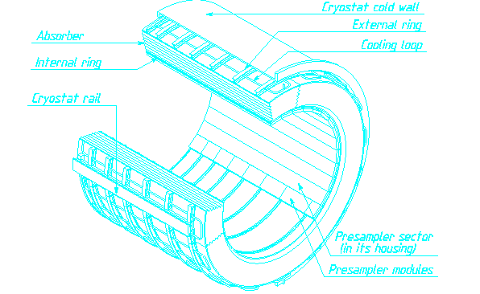
Figure 2.6: Sketch of the layout of the EM barrel
calorimeter and presampler.

0.2 in φ and 1.52 in η [5]. There are eight different modules that have an increasing length with increasing η. This is to obtain a uniform 0.2 coverage in η for all modules except the module located at the end of the barrel which only covers 0.12 in η.
The modules are composed of alternating cathode and anode electrodes that are glued between glass-epoxy insulation (FR4) layers. The cathodes are double-sided printed circuit boards, and the anodes are made of three conductive layers that are separated by FR4 layers. The cathodes are 270 μm thick and the anodes are 327.5 μm thick [5]. The outer layers of the anodes are kept at a high voltage of 2 kV, while the inner layer is used to read out the signal. The spacing of the electrodes varies between 1.9 and 2.0 mm for the different sized modules.
Each module has a mother board attached to it, as seen in Fig. 2.7. The mother boards are matched in size to the modules, thus there are eight different sized mother boards. The mother boards are used to collect the readout signals, and to inject the calibration pulses.

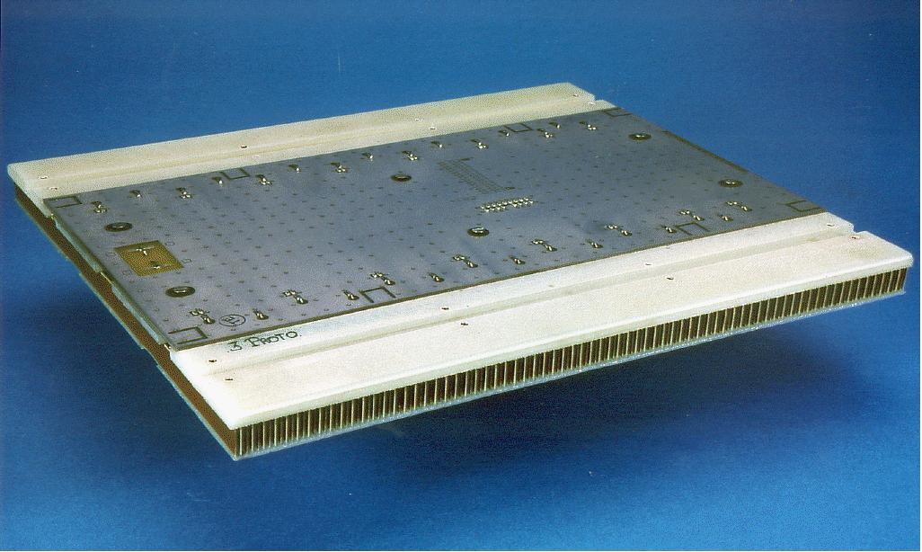
Figure 2.7: Presampler module with motherboard.

2.3 Electronics
The signals from the front section of the EM barrel calorimeter are read out from the inner side of the electrodes, while the middle and back sections are read out from the outer side of the electrodes [8]. The calorimeter signals from adjacent read-out electrodes are summed together from the φ direction by summing boards. In the back and middle

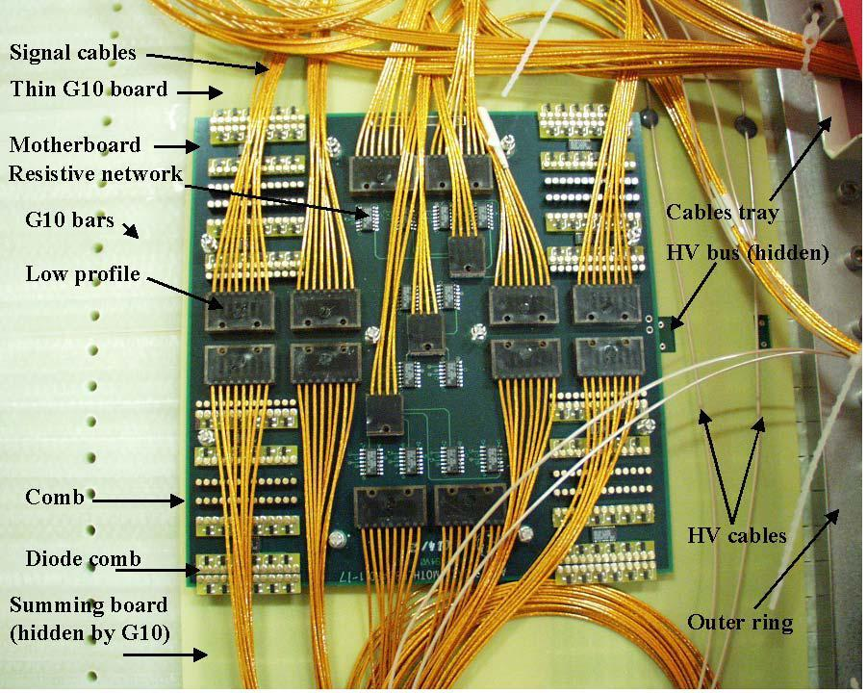
Figure 2.8: A back mother board on a module.

sections, four adjacent electrodes are summed together, and in the front, 16 adjacent electrodes are summed together. Each of these sums is considered one read-out channel.
The signal is then passed on to mother boards. Each mother board in the front section provides read-out for 16 summing boards, while the mother boards for the back and middle sections provide read-out for 4 summing boards. A mother board from the back section can be seen in Fig. 2.8. The size of the mother boards increases with rapidity because they read-out a constant rapidity (η) region. There are 7 different types
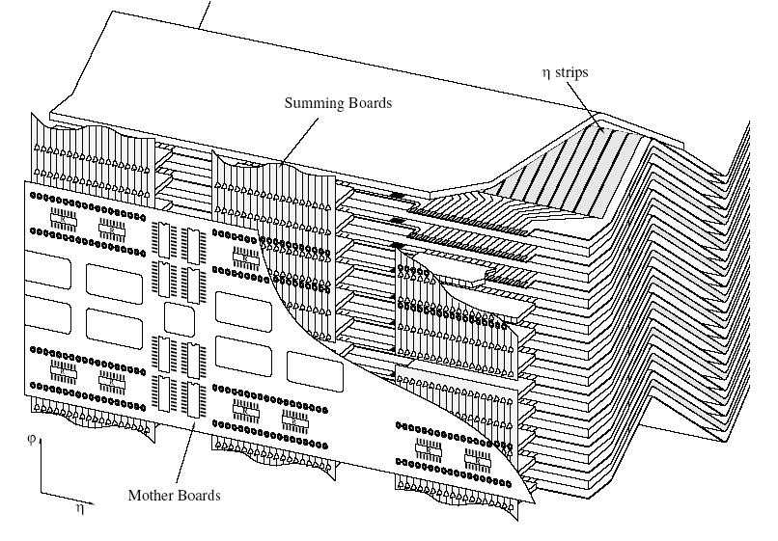
Figure 2.9: Sketch of a section of the EM calorimeter showing the
summing boards and mother boards.

of mother boards for the back section, and 8 different types for the front section. For each barrel module, there are a total of 14 back mother boards and 16 front mother boards.
The mother boards are connected to the summing boards by pins mounted on 2 thin PC-boards. The position of the mother boards and summing boards can be seen in Fig. 2.9. There are over 100 pin connections between each mother board and summing board. One of the two PC-boards houses a voltage suppressor to protect against any accidental discharge that could damage the calibration resistors on the mother boards. It is a low capacitance transient voltage suppressor that turns on at 6 V. There is also a 15 μm thick G10 board that electrically separates the mother board and summing board (see Fig. 2.8).
The mother boards route the signals to the read-out cables, shown in Fig. 2.8. This is done through a “low profile” connector which minimizes cross-talk between the read-out channels. Two different types of cables are used for this because of the different impedance needed in each section of the EM barrel calorimeter. A cable of 50 Ω is used for the front section, and a cable of 25 Ω is used for the middle and back sections. These cables are mini coaxial cables. They are bundled together in groups of 64. These bundles are called harnesses. Two harnesses complete the connection from the mother boards to the feedthroughs. The first harnesses go from the mother boards to patch panels, and the second harnesses go from the patch panels to the feedthroughs.

2.4 Feedthroughs
Each of the two half-barrels has their signals brought out by feedthroughs located at both ends of the cryostat. There are 32 feedthroughs located radially around each end of the barrel cryostat, for a total of 64. These feedthroughs, as seen in Fig. 2.10, are responsible for bringing the 122,880 signal, monitoring, and calibration lines into a warm environment from the cold liquid argon environment [8]. Each feedthrough provides connections for 1920 signal and calibration lines. The feedthroughs are an insulating vacuum that minimizes heat contamination of the liquid argon area.

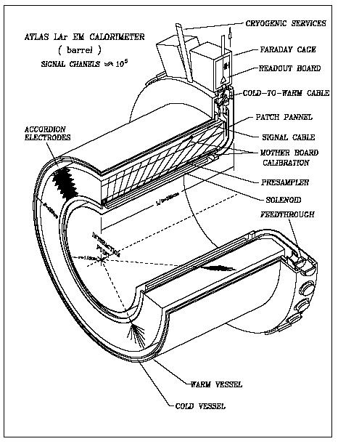
Figure 2.10: Sketch of the barrel showing the EM barrel calorimeter,
the presampler, cabling, and the feedthroughs.

The feedthroughs are mainly comprised of a cold flange and a warm flange, and a flexible stainless steel bellows. A diagram of the feedthroughs can be seen in Fig. 2.11. The purpose of the flexible bellows is to allow for the near 1.5 cm movement of the two flanges during the cool down from room temperature to the temperature of the liquid argon. All three pieces are welded together. The cold flange is attached to the cryostat, and the warm flange is connected to the front end crate electronics.
Both flanges have the same electrical connection design. They consist of two 7-row and two 8-row pin carriers. Each pin carrier consists of 64 pins in dual-inline rows separated by a row of pins that are grounded. The pins are gold-plated to ensure excellent, low resistivity contacts, and are sealed in glass for insulation.
The connections that transfer the signals from the cold flange to the warm flange are comprised of flat cables that are approximately 25 cm long. The impedance of 35 Ω was chosen so that they could use the same cables for both the 25 Ω and 50 Ω cables from the mother boards.
At the warm flange, the cables are connected to the base-plane of the front-end crate. This is essentially a group of pins, whose function is the transmission of the signals to the read-out electronics. The tests performed in July 2003 utilized these base-plane pins to inject a test signal into the complete read-out electronics chain and measure the reflected pulse.
Figure 2.11: Side view of a feedthrough.

CHAPTER III
TEST OF COMPLETE READ-OUT ELECTRONICS CHAIN

The test of the complete read-out electronics chain is one of the important tests that need to be preformed on the EM calorimeter. The motivation for ensuring that all ~220,000 channels work properly comes from all of the physics processes that ALTAS hopes to look for, especially the search for supersymmetric particles.
The LSP (discussed in Chapter I) is expected to be a neutral particle that will not interact in the detector, and thus escapes. However, its signal will show up as missing transverse energy (E_{T}^{miss}) in the event. Therefore, E_{T}^{miss} is an important measurement.
Missing transverse energy (E_{T}^{miss}) is a measurement that comes from summing all the signals of the detector. We are able to perfectly reconstruct the energy deposited in the detector, and if there is a supersymmetric particle that escapes detection, it will carry out some transverse energy and in the overall balance there will be missing transverse energy. If the number of observed events with a large amount of E_{T}^{miss} is larger than expected from normal statistical principles, then this is a signal of some new physics, very likely a supersymmetry.
It should be easy to see that we do not want to see an artificial high E_{T}^{miss} generated by detector malfunction or mis-calibration. Therefore, it is important to minimize fake E_{T}^{miss} events so that genuine E_{T}^{miss} events can be observed. One possible way to get a fake E_{T}^{miss} event is by having holes in the EM calorimeter. So, it is important to ensure that the EM calorimeter is working properly. Therefore, it must be tested before it is installed in the ATLAS detector.
There are two other important aspects of the test performed for this thesis. The first is that the EM barrel calorimeter is warm, and only filled with air, i.e. the liquid argon has not yet been inserted. It is important for us to test the calorimeter in its warm state because once the liquid argon is added it would be very time consuming to have to fix something if a problem was found. If a repair was needed, it would require warming up the calorimeter and then removing the liquid argon that will be at around 300° F below room temperature. This is a process that would take over four months to complete. The other important aspect is that the test was preformed before the EM barrel calorimeter is assembled together with the rest of the detector. If a problem is found after the whole detector is assembled, it would take many more months (~12) to take the detector apart to get to the EM barrel calorimeter.
The test was conducted on the complete read-out electronics chain of the M-wheel of the barrel EM calorimeter (the other end is designated as the P-wheel) during July 2003 in Building 180 at CERN. In Chapter II, all of the individual sections of the complete electronic chain are described in detail. In the remainder of this chapter, I will describe the set-up and procedure for the test. A photograph taken during the test can be seen in Fig. 3.5.

3.1 Set-up and Equipment
The test of the complete read-out electronics of the M-wheel was conducted using a plug-in dedicated scanner card at the base-planes of the connectors in the feedthroughs. The connectors are arranged in two columns and 15 rows (see Fig. 3.1); each row is comprised of a connector from both columns, and contains 128 channels in total. Each connector consists of 64 pins, and each channel corresponds to a pin in the feedthrough flange. All 128 channels (A and B columns together) measured, are chosen one after the other by the scanner. The scanner software was commanded through a GPIB.
A schematic of the complete read-out electronics chain can be seen in Fig. 3.2. A power supply, set at approximately + 8 V, connected to the scanner card was used to send a pulse through the complete read-out electronics chain. The pulse bounced back at the end of the chain and the resistance of the entire chain was then measured by a Keithlay multimeter. The measurement of the resistance was then recorded and stored on a laptop PC. The actual power supply, multimeter, and laptop PC used in the test can be seen in Fig. 3.4.

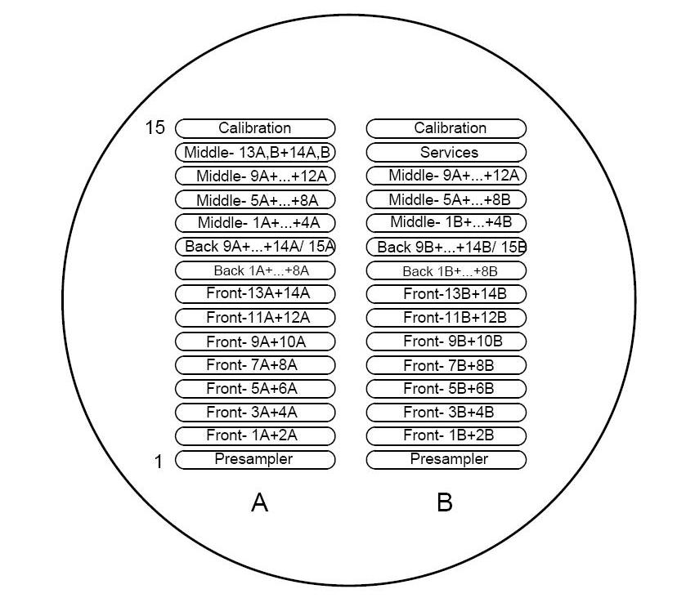
Figure 3.1: Sketch of a feedthrough flange showing fifteen rows and two columns.
Each row of each column consists of 64 pins (128 for each full row).

3.2 Operational Procedure
The resistance measurements in each of the feedthroughs followed the same procedure. The first step was to remove the metal box that covered two adjoining feedthroughs. The metal box was used to protect the feedthrough connections until the
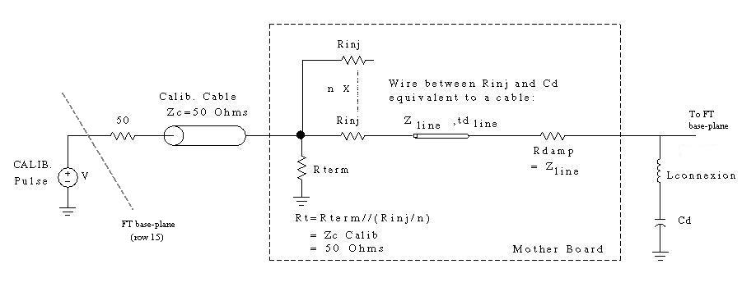
Figure 3.2: Schematic of the complete read-out electronics chain.

front end crate electronics are installed. The next step was to remove the 50 Ω high-voltage (HV) protection cards that were plugged into each of the connectors. These HV protection cards were used to protect against damage from high voltage, and they can be seen in Fig. 3.3. After these cards were removed, the next step was to conduct the measurements in both of the adjoining feedthroughs.
The measurement procedure consisted of four steps. The first step was to insert the scanner card into the connector slot that was to be tested. The second step was to then make sure that the multimeter and power supply were both turned on, and at the correct settings. The next step was to initiate the computer program that started the test and recorded the resistance measurement on every channel. The final step was to save the data file for each set. It can be seen in Fig. 3.1 that every feedthrough has a component of the each of the calorimeter sections: front, middle, back, and presampler.
The final steps of the entire test were to plug the HV protection cards back into the connectors, and then reconnect the metal box to protect the two feedthroughs.

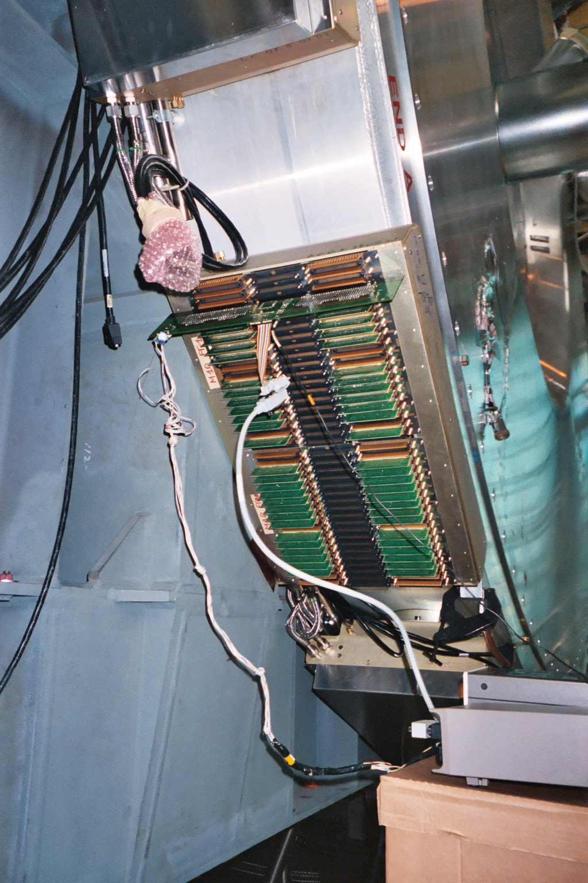
Figure 3.3: Actual view of two adjoining feedthroughs with HV
protection cards and scanner card inserted.

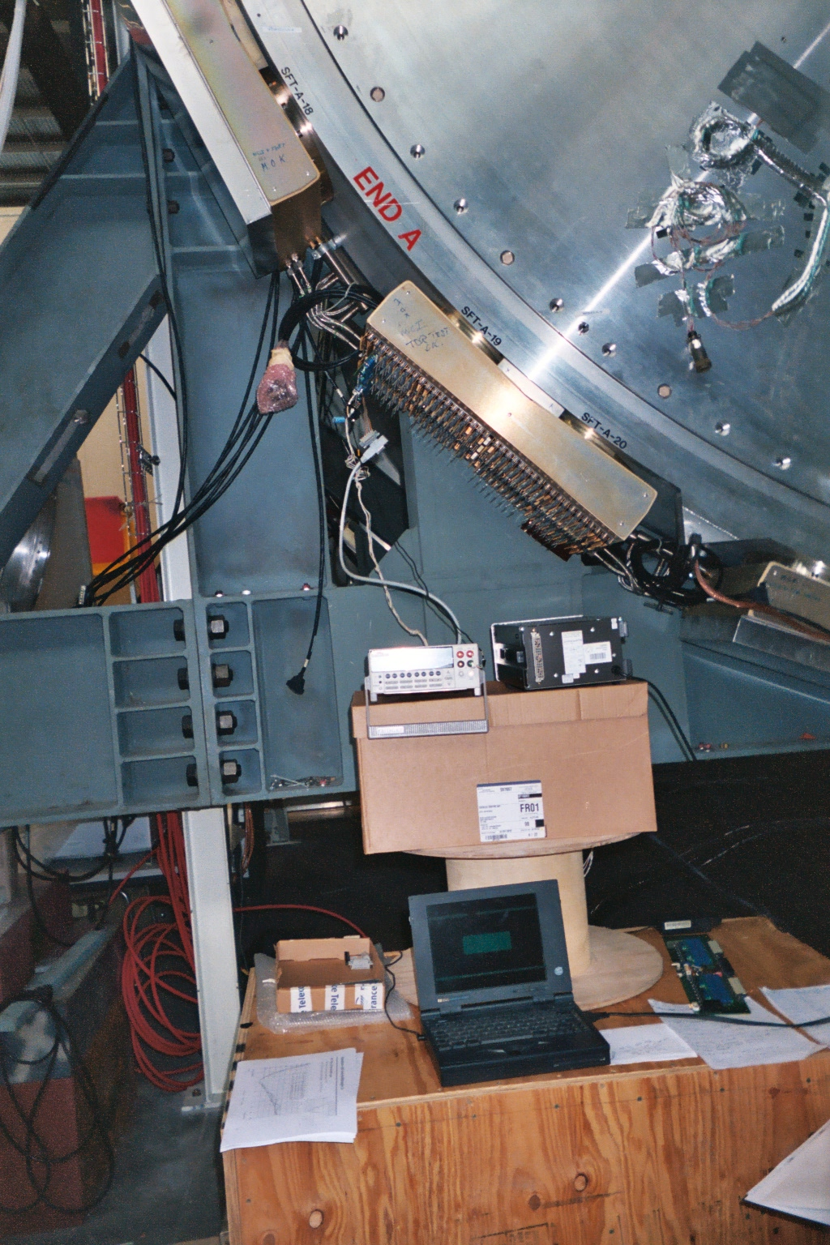
Figure 3.4: View of the PC, multimeter, and power
source used during the test.

3.3 Measurement Expectations
It has been established by the collaboration that the entire set of resistance measurements for the complete read-out electronics chains of the EM barrel calorimeter need to be at a predetermined nominal value to a precision of +/- 0.2 %. Each of the presampler, front, middle, and back sections are to have a different resistance value, and each section should be found to be working within this same +/- 0.2 % requirement.
Problems will arise when the value of a channel is found to be more than +/- 0.2 % away from the nominal value. When this happens, it will require some analysis as to why the value is not within expected parameters. The first step would be to determine if there is a random or systematic error in the measurement equipment. If it is determined that the problem is not in the measuring equipment, but in fact is in the calorimeter, then this will require some speculation as to why there is a problem. This is because the barrel is closed and the electronics chain is not able to reached to check the individual parts to find where exactly the problem lies. Channels that are found to be more than +/- 0.2 % away from the nominal value are required to be measured again to verify that the erroneous value is not due to a random error.
There are three possible problems that could be found. The first is that the values could be 1-1.5 % away from the nominal value. These resistance measurements that are found to be a little above or below the nominal value will most likely be due to the variations in the length of the cables that carry the signals from the mother boards to the feedthroughs. It is also possible that these values could be the result of damage to part of the electronics chain or a bypass (short) of one of the components. The other possibilities are that the values will be found to be either very high or very low. The values that are found to be very high will likely be the result of damage to a part of the electronics chain. The explanation with highest probability will be that this high value will be the result of high voltage damage to the delicate resistors in the chain. The values that are very low will most likely be the result of a short in the chain, or a break in the chain, which will result in no signal, indicating that the channel is dead.

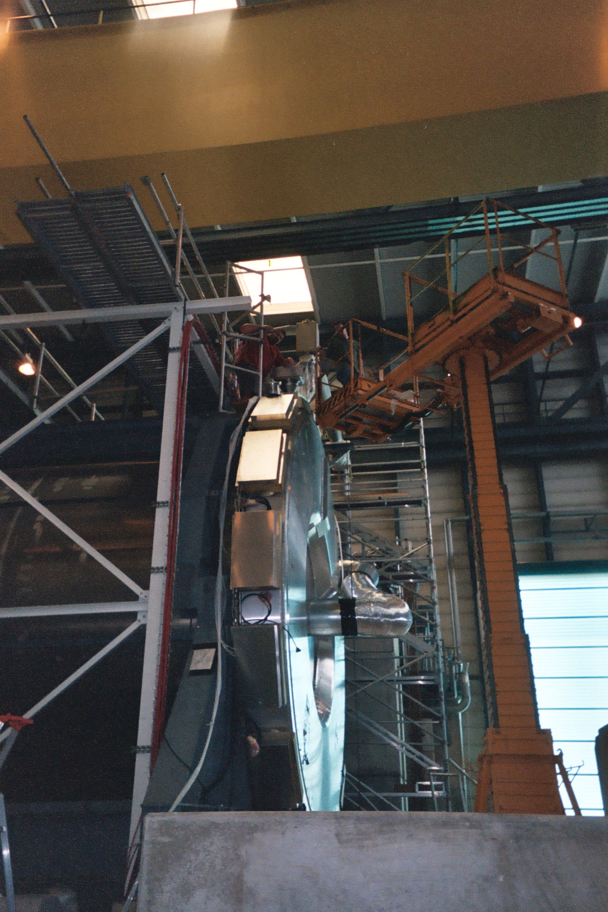
Figure 3.5: Ben Wakeland and myself (left) performing tests on the
feedthroughs at the top of the M-wheel.

CHAPTER IV
RESULTS AND SUMMARY

4.1 Presampler
There is only a single presampler connector row in every one of the 32 feedthroughs, and each row has 128 channels (4096). This is row is designated as PS (row 1 in Fig. 3.1). The channels numbered 122-127 in each row are not connected to any internal calorimeter element. These 192 channels (6 x 32) measured between 3.45-3.75 Ω, and were not included in the results. During the test performed in July of 2003 a total of 3904 measurements were made. The expected resistance of each of the presampler channels is 2030 Ω. Five channels were found to exceed this nominal value by +/- 0.2 %. This means that only 0.1 % of the presampler deviates from expected results.
Only 8 channels exceeded +/- 0.1%. The maximum deviation of these channels was 1.5%, and the standard deviation, σ, of the entire spread of measurements was 0.5 Ω. This can be seen in Fig. 4.1d. A plot of the fractional deviation from the expected resistance of 2030 Ω versus the position of the calorimeter channels with respect to η reflects the variation in the overall length of the cables that are connected from the mother boards to the feedthroughs. The varied positions of these mother boards (located from near the feedthroughs to near center of the barrel), and the lack of space in the calorimeter itself requires that the cable lengths be of different length. This effect is illustrated by the downward slope in Fig. 4.1b. Plots of the fractional deviation from the expected resistance versus the position of the calorimeter channels with respect to the feedthrough position and versus the calorimeter channels with respect to their position in φ do not reveal any interesting results. These two plots are shown in Figs. 4.1a and 4.1c.

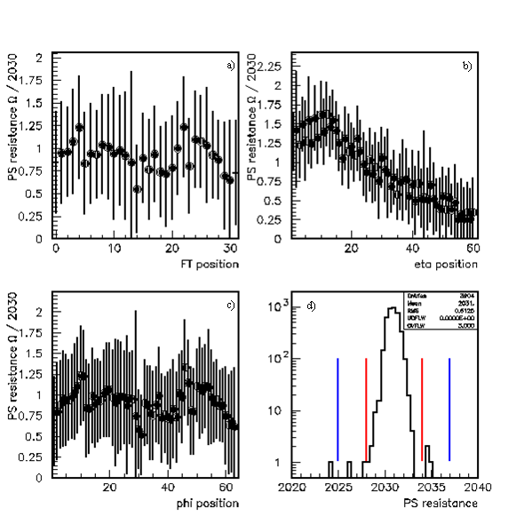
Figure 4.1: Graphs of the presampler data with variation respect to 2030 Ω vs. a) feedthrough position, b) position in η, c) position in φ, and
d) the measured resistance distribution.

4.2 Front
All of the feedthroughs have 7 connector rows for a total of 28672 channels. These rows can be seen in Fig. 3.1. However, the figure does not illustrate the naming scheme used to refer to the rows. The front positions are referred to as Front 0 (row 2), Front 1 (row 3), Front 2 (row 4), Front 3 (row 5), Front 4 (row 6), Front 5 (row 7), and Front 6 (row8). The expected value of the resistance for each of the front section channels is 3037 Ω. A total of 16 channels were found to deviate from this nominal value by +/- 0.2 %, with σ = 1.1 Ω for the entire set of data (see Fig. 4.2d). This result indicates that only 0.05 % of the channels in the front section are not within the acceptable parameters.
A plot of the fractional deviation from the expected resistance of 3037 Ω versus the position of the calorimeter channels with respect to η reveals the effects of the variation in cable length in the front section. This effect is shown in Fig. 4.2b. The effect of cable length vs. resistance (Ω) gives a slope of about 0.5 Ω/m.
Two adjoining feedthroughs are taken together to make up a single module (M). Two of the modules on the M-wheel, M14 and M15, are comprised of feedthroughs FT27 - FT30. These modules were found to have resistances 2-3 Ω higher than expected. The reason for this is unknown. A plot of the fractional deviation from the expected resistance versus the position of the calorimeter channels with respect to their feedthrough position illustrates the higher resistances found in these feedthroughs. This plot is shown in Fig. 4.2a.
A previous test, the Time Pulse Analysis (TPA) test, found 4 dead channels in this region, but in the test for this thesis, only one dead channel was observed (FT28-Front 6, channel 115). The TPA test measured the capacitance of each channel using a signal that was pulsed into the electronics chain through the calibration section (row 15).
There are two possibilities that could explain why this test did not observe the 3 other dead channels. The first possibility is that there is a problem in the connection of the electrodes to the mother boards in these channels causing a problem with the

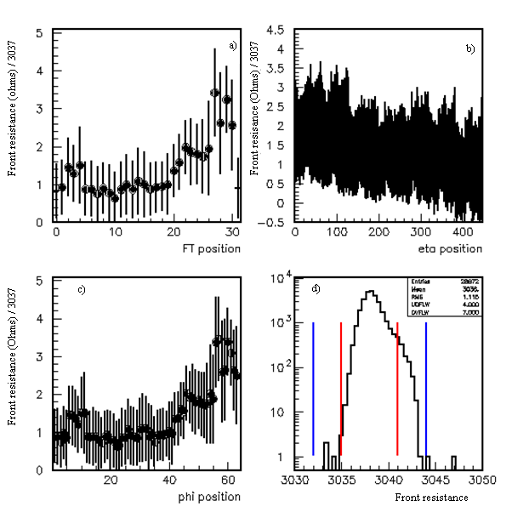
Figure 4.2: Graphs of the front data with variation respect to 3037 Ω vs. a)
feedthrough position, b) position in η, c) position in φ, and
d) the distribution of measured resistance.

measurement of the capacitance, and since the test for this thesis is insensitive to capacitance, it was able to measure a resistance signal in these 3 channels. The other possibility, which is more probable, is that there were bad contacts between the pins on the base-plane and the test equipment that was plugged into the connectors during the TPA test. The reason this is thought to be the more probable explanation is that in the measuring of over 58,000 channels, it is not impossible that there could be 3 bad contacts.
A plot of the fractional deviation from the expected resistance versus the position of the calorimeter channels with respect to φ also reveals the problems found in M14 and M15, as well as the problems found in M12 and M13. The majority of problems in the front layer were found in these 4 modules, shown by the clear tail in Fig. 4.2c.

4.3 Middle
There are four rows that comprise the middle sections in the feedthroughs. They are designated Mid 0 (row 11 (see Fig. 3.1)), Mid 1 (row 12), Mid 2 (row 13), and Mid 3 (row 14). The expected value in the channels of the middle section is broken into two parts divided at η = 0.8 because of two different nominal resistances. For η < 0.8, the expected value of each channel is 1061 Ω. Here, only 2 channels out of 8192 were found to be outside +/- 0.2%, and σ = 0.5 Ω for the whole set of data (see Fig.4.4d). They were 0.7 and 1.2% away from the nominal value. For η > 0.8, the expected value of each channel is 735 Ω. Here, 11 channels out of 6144 were found to be outside +/- 0.2%, and σ = 0.35 Ω for the entire spread of data (see Fig. 4.5d). The total result for the middle is that 13 channels out of 14336 were found to deviate from the accepted range. This result indicates that only 0.07% of the middle section is working outside the acceptable range.
Eight of the 11 channels were found to be off by ~1%. All of these channels are associated with the same module (M06). This is one of only a few modules that were tested at the temperature of liquid nitrogen (“cold tested”) at CERN before their mother boards were retrofitted with protection circuits. The design of the protection circuits consists of a diode and a resistor connected to the electronics chain by long pins. They are connected by being inserted into the motherboard. The position of insertion is shown in Fig. 4.3. The purpose of these protection circuits is to protect the calibration resistors from damage due to accidental sparking at high voltage. The diode will close when high voltage is present, not allowing it to pass and damage the delicate resistors that have been selected for the low voltage signal pulses that will generated by events in the calorimeter.

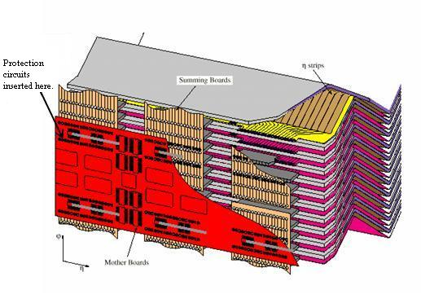
Figure 4.3: Diagram illustrating the position of the protection circuits.

It is expected that in the presence of the protector diodes, the measured resistance values will be stable. All of the channels in the middle and back layers have been equipped with the protection diodes. Unfortunately, due to a lack of space caused by the design of the calorimeter, the front and barrel end layers are not able to be equipped with the protective diodes. These protection diodes are referred to as diode combs, shown in Fig. 2.8.
The plots of the fractional deviation from the expected resistance of 1061 Ω versus the position of the η < 0.8 calorimeter channels with respect to φ and feedthrough

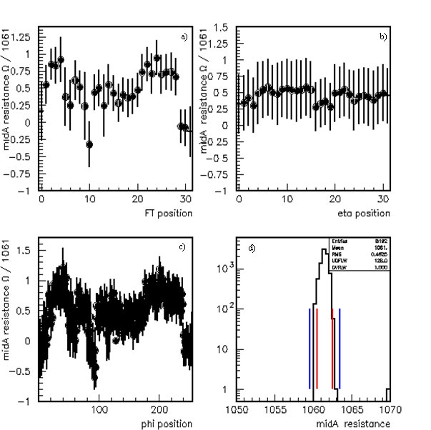
Figure 4.4: Graphs of the middle (η < 0.8) data with variation respect to 1061 Ω vs. a)
feedthrough position, b) position in η, c) position in φ, and
d) the distribution of the measured resistance.
position reveal an erratic structure. These plots are shown in Figs. 4.4a and 4.4c. Unfortunately, the reason behind this erratic structure is not known. The plot with respect to η does not reveal any interesting results (Fig. 4.4b).
The plots of the fractional deviation from the expected resistance of 735 Ω versus the position of the η > 0.8 calorimeter channels with respect to feedthrough position and φ also reveal an erratic structure that has an unknown explanation. These plots are shown in Figs. 4.5a and 4.5c. The plots of the fractional deviation from the expected

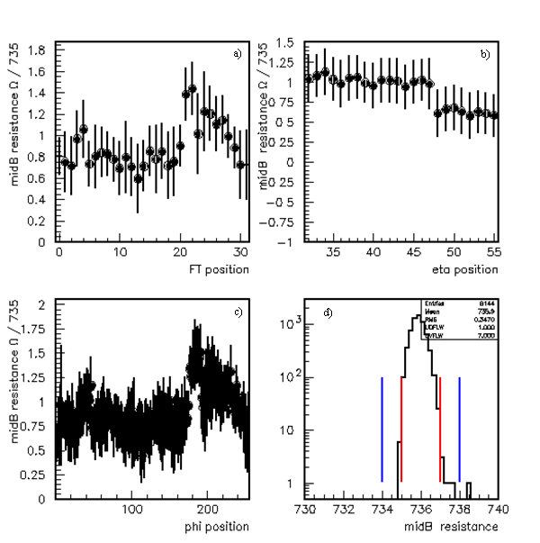
Figure 4.5: Graphs of the middle (η > 0.8) data with variation respect to 735 Ω vs. a)
feedthrough position, b) position in η, c) position in φ, and
d) the distribution of the measured resistance.
resistance versus the position of calorimeter channels with respect to η in this same section clearly illustrates the variation in cable length. The channels in the last portion of the graph have a clearly lower resistance which is derived from these channels having shorter cables. This plot is shown in Fig. 4.5b.

4.4 Back and Barrel End
The back and barrel end sections were measured together because they are in the same layer. There are only two rows of connectors in each feedthroughs associated with the back layer. They are referred to as Back 0 (row 9), and Back 1 (row 10). The expected value for each of the channels in the back section is 1061 Ω. A total of 12 channels out of 7936 were found to be outside of +/- 0.2%, and σ = 0.5 Ω for the entire set of data for the back section (see Fig. 4.6c). This result indicates that only 0.13% of the back section is working outside of the nominal range.
Most of the problem channels were found in the Back 1 positions (η > 0.8). This is shown in Tables A.1a and b in the Appendix. The plots of the fractional deviation from the expected resistance of 1061 Ω versus the position of the calorimeter channels with respect to the feedthrough position and φ reveal a pattern that bears a striking resemblance to the corresponding plots of the η > 0.8 middle layer. This effect, which seems to be correlated in relation to the particular feedthrough, is shown in Figs. 4.6a and 4.6c. It is seen in both the middle and back layers, which use different harnesses (see section 2.3). However, they are associated with the same mother board. The channels corresponding to the same mother boards that cover 0.6 < η < 0.8 were found to be lower in the middle and back layers. A clear 32 channel correlation between a channel from each layer is shown in Fig. 4.7. This correlation effect is believed to be the result of a different resistor batch being used in this mother board. A plot of the fractional deviation from the expected resistance versus the position of the calorimeter channels with respect to η reveals the variation in cable length in this layer (see Fig. 4.6b).
One dead channel was found (FT06 – Back 0). This channel is in module M03, and it was not found in the TPA test mentioned in section 4.2. There currently is no known reason that is thought to explain this.

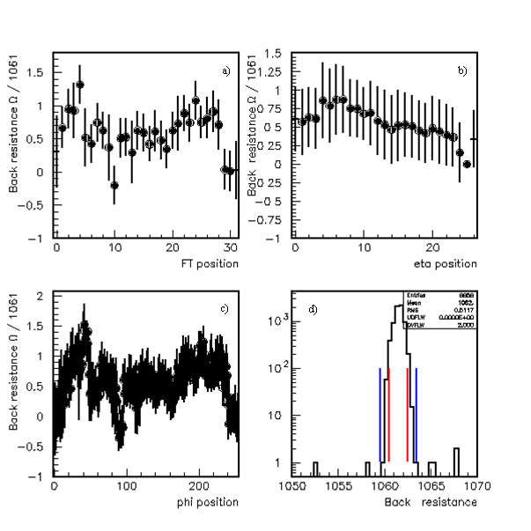
Figure 4.6: Graphs of the back data with variation respect to 1061 Ω vs. a)
feedthrough position, b) position in η, c) position in φ, and
d) the distribution of the measured resistance.

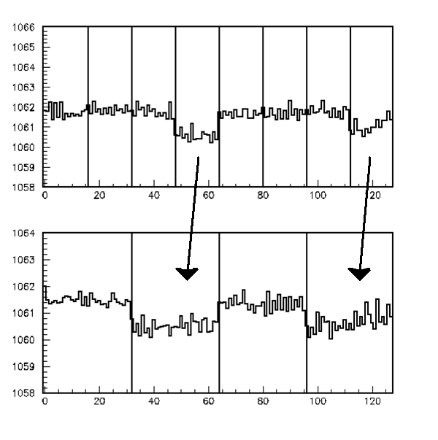
Figure 4.7: The comparison of FT09-Back 0 (top) and FT00-Middle 1 (bottom)
shows some correlation.

4.5 Calibration
There is only one calibration row in the feedthroughs, and it is row 15. Each individual calibration channel is connected to a single channel in the front, middle, or back layers (see Fig. 3.2 (left)). Therefore the resistance in the calibration channels will vary depending on to which layer the calibration channel is connected. The expected resistance value for each of the channels in these rows is split into three sections: 83.3 Ω, 110 Ω, and 250 Ω. Only 4 channels out of 3410 were found to exceed the nominal values by +/- 0.2 %. This result indicates that only 0.05 % of the calibration channels work outside the accepted range.
The problems in 3 out of 4 of these channels are able to be explained. Channel 68 in FT12 of M06 is off by + 0.4 %. This channel is connected to the middle layer in this feedthrough, and is therefore related to problems discussed in the previous section (4.4). Channels 34 and 35 in FT25 of M13 are off by – 2 %. These channels are connected to channels 2 and 3 in the front layer. These front channels are off by – 50 %, and are therefore the cause of the problem in the calibration channels. Channel 60 in FT09 of M05 is off by + 10 %. The reason for this channel deviating from the nominal value by such a great amount is not yet known.

4.6 Summary and Conclusions
All of the data is summarized in tables located in the Appendix. Tables A.1a and A.1b display all of the channels, grouped by module, where problems were found. The results for each feedthrough are shown in Tables A.2 - A.33. The tables include the average of the measured resistances for the 128 channels for each row, the percentage of variation, and comments on any problems that were found.
A few modules are clearly worse than others, especially M06 (FT11 and FT12). It seems to be clear that this module has suffered HV damage to the resistors in 13 channels. This module was the first cold tested at CERN (not in a beam test) and then retrofitted with the protection diodes afterwards, so this may explain why the middle and back resistors in this module are damaged. Most of the other problems that were found in the rest of the modules are located in the front and barrel end layers where no protection diodes exist.
The result for each section of the EM calorimeter is summarized in Table 4.1. The overall results of the test of the complete read-out electronics chains for the M-Wheel half of the EM barrel calorimeter is that a total of 50 channels out of 58386 were found to be working outside of the accepted +/- 0.2 %. This is an overall result of less than 0.1 %, which is the acceptable limit for the entire calorimeter.

Table 4.1: Summary of results for each section.
Presampler | 5 / 3904 = 0.1 %
Front | 16 / 28672 = 0.05 %
Middle | 13 / 14336 = 0.07 %
Back | 12 / 12556 = 0.13 %
Calibration | 4 / 3410 = 0.05 %

Although the results are within 0.1 %, some positions show a clear pattern that is not coming from the measurement equipment in the setup but from the calorimeter itself. One of these effects is a clear 32 channel structure that forms a pattern of sections differing by about 0.6 Ω. Data from tests using two different scanner cards on channel FT23 – Mid 2 revealed the same pattern. The measurements were also taken manually with a multimeter and they also differed by the 0.6 Ω found by both scanner cards. This
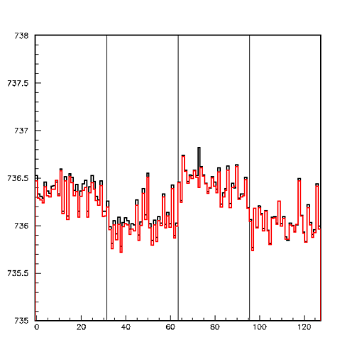
Figure 4.8: Data from two different scanner card tests on FT 23 – Mid 2.
The plot shows a clear correlation in the different sections.

effect was found to corresponds to two different mother boards. This pattern is believed to most likely derive from resistors that are either damaged or come from different batches. Another possibility is that there is a link to the calibration line in the front section. However, there is no convincing explanation that can truly account for these effects.

There were also a few instances were an odd/even effect was measured in a few places. It was found that the measured resistance of odd channels is systematically higher than the measured resistance of the even channels in these areas. It is believed that this problem could be derived from a bad ground connection when the scanner card is plugged into the connectors
This thesis has presented results from the resistance measurements of the complete electronics chains of the M-Wheel half of the EM barrel calorimeter. The result of less than 0.1 % of the 58,386 channels operating outside of the parameters specified by the collaboration indicates that this half of the barrel is within the acceptable limits in order for it to operate properly in the ATLAS experiment. Therefore the M-Wheel half of the barrel is ready to be sealed. The next steps will be to test the P-Wheel half of the barrel. If it is also found to be within the 0.1 % limit, then the entire barrel can be sealed and filled with the liquid argon, and tested under these cold conditions before it will be inserted into the ATLAS detector.

APPENDIX

Table A.1a: List of all found problem channels
by module (M00 – M07).

Module | Description of problems
M00 | Back 0 (FT00) : Clear Structure of 2 Ω.  Front 3 (FT31) : channel 49 off by +10 %, channel 70 off by +10 %  Front 4 (FT31) : channel 3 off by +1%, channel 85 off by +20 %  Mid2 (FT31) : channel 127 off by +0.3 %
M01 | Front 5 (FT02) : channel 4 off by +1 %
M02 | Back 0 (FT03) : channel 47 off by +0.4 %
M03 | Back 0 (FT06) : channel 55 dead (not common to TPA test; unknown reason)
M05 | Front 6 (FT09) : channel 41 off by +1%  Calib (FT09) : channel 60 off by +10 %
M06 | Back 1 (FT12) : channel 0 off by –1%  channel 1 off by +0.3 %  channel 4 and 5 off by +0.6 %  channel 36 off by 10 %  Mid 2 (FT12) : channel 0 off by +0.3 %  1 off by +1%  4 off by +1%  5 off by +1%  8 off by +1%  9 off by +1%  12 off by +1%  13 off by +4%  Calib (FT12) : channel 68 off by +0.4 % (calibration line of middle problems cells) Looks like a HV problem.
M07 | PS (FT13) : channel 8 off by + 1.5 %  Back 1 (FT14) : channel 60 off by + 0.3 %

Table A.1b: List of all found problem channels
by module (M08 – M15).

Module | Description of problems
M08 | PS (FT16) : channel 121 off by + 0.7 %
M10 | Back 1 (FT19) : channel 19 off by +2%  Mid 2 (FT19) : channel 110 off y +1.2 %  Back 1 (FT20) : channel 11 off by +2%  Mid 2 (FT20 ) : channel 22 off by 0.3 %
M12 | Front 4 (FT24) : channels 76 and 78 off by –1.5 %  channels 79, 80, 82 off by –0.2 %
M13 | Front 2 (FT25) : channels 2 and 3 off –50 %  Calib (FT25) : channel 34,35 off by –2% (connected to front problems)  Mid 2 (FT26) : channel 42 off by –1%
M14 | Front 6 (FT28) : channel 115 dead (common to TPA test)  Back 1 (FT28) : channels 62 and 63 off by –50 %  Mid 0 (FT28) : channel 19 off by +0.7 %
M15 | Front 6 (FT29) : channel 62 off by +0.2 %  Front 5 (FT30) : channel 70 off by +0.2 %

Table A.2: FT00 (M00)

ATI Position | <R> (Ω) | σ/R (%) | Comments
FT00-1 PS | 2030.8 | 0.029
FT00-2 Front 0 | 3038.2 | 0.021
FT00-3 Front 1 | 3037.9 | 0.020
FT00-4 Front 2 | 3037.7 | 0.022
FT00-5 Front 3 | 3037.7 | 0.018
FT00-6 Front 4 | 3037.8 | 0.022
FT00-7 Front 5 | 3038.1 | 0.020
FT00-8 Front 6 | 3037.2 | 0.028
FT00-9 Back 0 | 1061.5 | 0.048 | Channels 47-63 and 111-127: lower by ~2 Ω
FT00-10 Back 1 | 1060.0  1039.1  2984.7 | 0.042  0.018  0.023
FT00-11 Mid 0 | 1061.3 | 0.026
FT00-12 Mid 1 | 1061.0 | 0.046 | Structure same as Back 0 in 32 channels
FT00-13 Mid 2 | 735.9 | 0.025
FT00-14 Mid 3 | 735.6 | 0.019
FT00-15 Cal | 86.3  110.4  249.3 | 0.10  0.13  0.05

Table A.3: FT01 (M01)

ATI Position | <R> (Ω) | σ/R (%) | Comments
FT01-1 PS | 2030.9 | 0.028
FT01-2 Front 0 | 3038.7 | 0.018
FT01-3 Front 1 | 3037.8 | 0.020
FT01-4 Front 2 | 3038.0 | 0.021
FT01-5 Front 3 | 3037.8 | 0.022
FT01-6 Front 4 | 3037.7 | 0.022
FT01-7 Front 5 | 3037.9 | 0.024
FT01-8 Front 6 | 3037.6 | 0.019
FT01-9 Back 0 | 1061.7 | 0.028
FT01-10 Back 1 | 1061.6  1040.1  2984.9 | 0.030  0.022  0.016
FT01-11 Mid 0 | 1061.6 | 0.028
FT01-12 Mid 1 | 1061.5 | 0.026 | Odd/even on second connector
FT01-13 Mid 2 | 735.9 | 0.023
FT01-14 Mid 3 | 735.4 | 0.025
FT01-15 Cal | 86.2  110.2  249.2 | 0.14  0.18  0.05

Table A.4: FT02 (M01)

ATI Position | <R> (Ω) | σ/R (%) | Comments
FT02-1 PS | 2031.0 | 0.026
FT02-2 Front 0 | 3039.0 | 0.019
FT02-3 Front 1 | 3039.0 | 0.022
FT02-4 Front 2 | 3038.3 | 0.029
FT02-5 Front 3 | 3038.4 | 0.025
FT02-6 Front 4 | 3038.2 | 0.021
FT02-7 Front 5 | 3038.0 | 0.023 | Channel 4: 3054 Ω; unknown
FT02-8 Front 6 | 3038.3 | 0.019
FT02-9 Back 0 | 1062.1 | 0.024
FT02-10 Back 1 | 1061.7  1040.2  2985.0 | 0.019  0.016  0.015
FT02-11 Mid 0 | 1061.8 | 0.023
FT02-12 Mid 1 |  |  | Missing measurement
FT02-13 Mid 2 | 735.9 | 0.026
FT02-14 Mid 3 | 735.4 | 0.021
FT02-15 Cal | 86.0  110.2  249.1 | 0.15  0.17  0.05

Table A.5: FT03 (M02)

ATI Position | <R> (Ω) | σ/R (%) | Comments
FT03-1 PS | 2030.1 | 0.030
FT03-2 Front 0 | 3038.5 | 0.020
FT03-3 Front 1 | 3038.3 | 0.016
FT03-4 Front 2 | 3038.6 | 0.029 | First 64 channels: odd/even effect
FT03-5 Front 3 | 3038.0 | 0.026
FT03-6 Front 4 | 3038.5 | 0.020
FT03-7 Front 5 | 3038.4 | 0.023
FT03-8 Front 6 | 3037.7 | 0.024
FT03-9 Back 0 | 1062.0 | 0.042 | Channel 47: 1058.0 Ω
FT03-10 Back 1 | 1061.8  1040.2  2984.7 | 0.030  0.026  0.022
FT03-11 Mid 0 | 1061.9 | 0.027
FT03-12 Mid 1 | 1061.8 | 0.024
FT03-13 Mid 2 | 736.1 | 0.024
FT03-14 Mid 3 | 735.7 | 0.026
FT03-15 Cal | 86.5  110.6  249.5 | 0.11  0.15  0.07

Table A.6: FT04 (M02)

ATI Position | <R> (Ω) | σ/R (%) | Comments
FT04-1 PS | 2031.2 | 0.025
FT04-2 Front 0 | 3038.6 | 0.017
FT04-3 Front 1 | 3040.1 | 0.043 | Calibration lines effect
FT04-4 Front 2 | 3038.1 | 0.024 | Odd /even effect in 1st connector
FT04-5 Front 3 | 3038.4 | 0.018
FT04-6 Front 4 | 3037.5 | 0.017
FT04-7 Front 5 | 3038.1 | 0.017
FT04-8 Front 6 | 3037.8 | 0.016
FT04-9 Back 0 | 1062.4 | 0.025
FT04-10 Back 1 | 1062.2  1040.7  2985.2 | 0.025  0.021  0.014
FT04-11 Mid 0 | 1062.1 | 0.024
FT04-12 Mid 1 | 1061.7 | 0.029
FT04-13 Mid 2 | 736.2 | 0.023
FT04-14 Mid 3 | 735.8 | 0.023
FT04-15 Cal | 86.5  110.5  249.4 | 0.11  0.11  0.08

Table A.7: FT05 (M03)

ATI Position | <R> (Ω) | σ/R (%) | Comments
FT05-1 PS | 2030.8 | 0.028
FT05-2 Front 0 | 3038.4 | 0.021
FT05-3 Front 1 | 3038.1 | 0.020
FT05-4 Front 2 | 3038.2 | 0.018
FT05-5 Front 3 | 3037.8 | 0.019
FT05-6 Front 4 | 3037.5 | 0.026 | Channel 115: 3035Ω
FT05-7 Front 5 | 3037.8 | 0.017
FT05-8 Front 6 | 3037.4 | 0.024
FT05-9 Back 0 | 1061.6 | 0.050 | 47 - 63 and 111 – 127: 1 Ω
FT05-10 Back 1 | 1061.4  1040.2  2984.4 | 0.022  0.017  0.022
FT05-11 Mid 0 | 1061.6 | 0.027
FT05-12 Mid 1 | 1061.1 | 0.041 | Structure same as Back 0 in 32 channels
FT05-13 Mid 2 | 735.8 | 0.023
FT05-14 Mid 3 | 735.5 | 0.021
FT05-15 Cal | 86.2  110.4  249.3 | 0.16  0.18  0.07

Table A.8: FT06 (M03)

ATI Position | <R> (Ω) | σ/R (%) | Comments
FT06-1 PS | 2030.9 | 0.027
FT06-2 Front 0 | 3038. 3 | 0.021
FT06-3 Front 1 | 3038.3 | 0.019
FT06-4 Front 2 | 3038.4 | 0.014
FT06-5 Front 3 | 3037.5 | 0.028 | Calibration line high
FT06-6 Front 4 | 3037.8 | 0.018
FT06-7 Front 5 | 3037.6 | 0.019
FT06-8 Front 6 | 3037.2 | 0.022
FT06-9 Back 0 | 1061.5 | 0.030 | channel 55: dead, structure
FT06-10 Back 1 | 1061.4  1040.0  2984.6 | 0.025  0.012  0.018
FT06-11 Mid 0 | 1061.1 | 0.039 | Structure same as Back 0 in 32 channels
FT06-12 Mid 1 | 1061.4 | 0.024
FT06-13 Mid 2 | 735.9 | 0.037 | Structure in 32 channels
FT06-14 Mid 3 | 735.5 | 0.025
FT06-15 Cal | 86.3  110.4  249.4 | 0.13  0.14  0.06

Table A.9: FT07 (M04)

ATI Position | <R> (Ω) | σ/R (%) | Comments
FT07-1 PS | 2030.9 | 0.025
FT07-2 Front 0 | 3038. 2 | 0.017
FT07-3 Front 1 | 3038.3 | 0.023
FT07-4 Front 2 | 3037.0 | 0.016
FT07-5 Front 3 | 3037.9 | 0.017
FT07-6 Front 4 | 3037.9 | 0.023
FT07-7 Front 5 | 3037.5 | 0.022
FT07-8 Front 6 | 3037.5 | 0.018
FT07-9 Back 0 | 1061.8 | 0.027
FT07-10 Back 1 | 1061.6  1040.3  2984.6 | 0.025  0.024  0.023
FT07-11 Mid 0 | 1061.6 | 0.028
FT07-12 Mid 1 | 1061.6 | 0.027
FT07-13 Mid 2 | 735.9 | 0.023
FT07-14 Mid 3 | 735.6 | 0.018
FT07-15 Cal | 86.3  110.4  249.2 | 0.12  0.14  0.07

Table A.10: FT08 (M04)

ATI Position | <R> (Ω) | σ/R (%) | Comments
FT08-1 PS | 2031.0 | 0.028
FT08-2 Front 0 | 3038. 2 | 0.017
FT08-3 Front 1 | 3037.8 | 0.024
FT08-4 Front 2 | 3038.4 | 0.016
FT08-5 Front 3 | 3038.0 | 0.022
FT08-6 Front 4 | 3037.7 | 0.020
FT08-7 Front 5 | 3037.7 | 0.020
FT08-8 Front 6 | 3037.5 | 0.020
FT08-9 Back 0 | 1061.7 | 0.025
FT08-10 Back 1 | 1061.5  1040. 3  2984.7 | 0.024  0.014  0.018
FT08-11 Mid 0 | 1061.6 | 0.024
FT08-12 Mid 1 | 1061.5 | 0.023
FT08-13 Mid 2 | 735.9 | 0.022
FT08-14 Mid 3 | 735.6 | 0.026
FT08-15 Cal | 86.3  110.4  249.3 | 0.12  0.14  0.05

Table A.11: FT09 (M05)

ATI Position | <R> (Ω) | σ/R (%) | Comments
FT09-1 PS | 2031.0 | 0.028
FT09-2 Front 0 | 3038. 1 | 0.020
FT09-3 Front 1 | 3037.9 | 0.021
FT09-4 Front 2 | 3038.2 | 0.025
FT09-5 Front 3 | 3038.0 | 0.017
FT09-6 Front 4 | 3037.4 | 0.023
FT09-7 Front 5 | 3037.7 | 0.020
FT09-8 Front 6 | 3037.1 | 0.025 | Channel 41: 3051.5 Ω
FT09-9 Back 0 | 1061.5 | 0.039 | Structure
FT09-10 Back 1 | 1061.1  1039.8  2984.6 | 0.051  0.049  0.015 | two populations  Idem
FT09-11 Mid 0 | 1061.2 | 0.046 | Structure same as Back 0 in 32 channels
FT09-12 Mid 1 | 1061.3 | 0.048 | Idem
FT09-13 Mid 2 | 735.9 | 0.023
FT09-14 Mid 3 | 735.6 | 0.019
FT09-15 Cal | 86.35  110.5  249.3 | 0.12  0.14  0.06 | Channel 60: 93.4 Ω

Table A.12: FT10 (M05)

ATI Position | <R> (Ω) | σ/R (%) | Comments
FT10-1 PS | 2030.9 | 0.035 | Channel 24: 2033.1 Ω  Channel 110: 2027.8 Ω
FT10-2 Front 0 | 3037.8 | 0.019
FT10-3 Front 1 | 3038.1 | 0.019
FT10-4 Front 2 | 3037.6 | 0.022
FT10-5 Front 3 | 3037.7 | 0.021
FT10-6 Front 4 | 3037.6 | 0.022
FT10-7 Front 5 | 3037.6 | 0.016
FT10-8 Front 6 | 3037.1 | 0.026
FT10-9 Back 0 | 1060.9 | 0.025
FT10-10 Back 1 | 1060.7  1039.0  2984.6 | 0.027  0.026  0.021
FT10-11 Mid 0 | 1060.7 | 0.031
FT10-12 Mid 1 | 1060.6 | 0.031
FT10-13 Mid 2 | 735.8 | 0.022
FT10-14 Mid 3 | 735.4 | 0.022
FT10-15 Cal | 86.2  110.3  249.2 | 0.10  0.11  0.06

Table A.13: FT11 (M06)

ATI Position | <R> (Ω) | σ/R (%) | Comments
FT11-1 PS | 2030.9 | 0.031 | Channel 64: 2034.5 Ω
FT11-2 Front 0 | 3038.5 | 0.021
FT11-3 Front 1 | 3038.3 | 0.017
FT11-4 Front 2 | 3037.8 | 0.020
FT11-5 Front 3 | 3037.7 | 0.024
FT11-6 Front 4 | 3038.0 | 0.021
FT11-7 Front 5 | 3037.7 | 0.017
FT11-8 Front 6 | 3037.1 | 0.021
FT11-9 Back 0 | 1061.6 | 0.025
FT11-10 Back 1 | 1061.3  1039.9  2984.5 | 0.021  0.023  0.023
FT11-11 Mid 0 | 1061.5 | 0.026
FT11-12 Mid 1 | 1061.4 | 0.023
FT11-13 Mid 2 | 736.0 | 0.028
FT11-14 Mid 3 | 735.4 | 0.019
FT11-15 Cal | 86.2  110.3  249.2 | 0.12  0.13  0.04

Table A.14: FT12 (M06)

ATI Position | <R> (Ω) | σ/R (%) | Comments
FT12-1 PS | 2030.9 | 0.035 | Channel 2: 2026.2 Ω
FT12-2 Front 0 | 3038.7 | 0.024
FT12-3 Front 1 | 3038.3 | 0.016
FT12-4 Front 2 | 3038.0 | 0.021
FT12-5 Front 3 | 3037.5 | 0.024
FT12-6 Front 4 | 3038.3 | 0.022
FT12-7 Front 5 | 3037.1 | 0.025
FT12-8 Front 6 | 3037.2 | 0.018
FT12-9 Back 0 | 1061.6 | 0.026
FT12-10 Back 1 | 1061.4  1039.9  2984.7 | 0.043  0.016  0.022 | Channel 0: 1052 Ω, 1: 1064.8 Ω, 4 and 5: 1067 Ω  Channel 36: 1118.8 Ω
FT12-11 Mid 0 | 1061.6 | 0.025
FT12-12 Mid 1 | 1061.4 | 0.025
FT12-13 Mid 2 | 735.8 | 0.036 | Channel 0: 737 Ω, 1: 743 Ω, 4: 742 Ω, 5: 744 Ω, 8: 745 Ω, 9: 742.4 Ω, 12: 747.3 Ω, 13: 760.8 Ω
FT12-14 Mid 3 | 735.5 | 0.022
FT12-15 Cal | 86.2  110.3  249.2 | 0.10  0.14  0.07 | Channel 68: 248.4 Ω

Table A.15: FT13 (M07)

ATI Position | <R> (Ω) | σ/R (%) | Comments
FT13-1 PS | 2030.8 | 0.049 | Channel 8: 2059.0 Ω, 9: 2042.5 Ω, 13-14: 2034 Ω, 92: 2024.1 Ω
FT13-2 Front 0 | 3038.4 | 0.018
FT13-3 Front 1 | 3038.1 | 0.021
FT13-4 Front 2 | 3038.3 | 0.018
FT13-5 Front 3 | 3038.1 | 0.025
FT13-6 Front 4 | 3037.4 | 0.024
FT13-7 Front 5 | 3037.4 | 0.019
FT13-8 Front 6 | 3037.3 | 0.019
FT13-9 Back 0 | 1061.4 | 0.046 | Structure
FT13-10 Back 1 | 1061.1  1039.9  2985.0 | 0.032  0.017  0.018 | Structure
FT13-11 Mid 0 | 1061.0 | 0.051 | Structure same as Back 0 in 32 channels
FT13-12 Mid 1 | 1061.4 | 0.027
FT13-13 Mid 2 | 735.8 | 0.025
FT13-14 Mid 3 | 735.2 | 0.022
FT13-15 Cal | 86.2  110.3  249.2 | 0.15  0.16  0.07

Table A.16: FT14 (M07)

ATI Position | <R> (Ω) | σ/R (%) | Comments
FT14-1 PS | 2030.5 | 0.025
FT14-2 Front 0 | 3038.2 | 0.022
FT14-3 Front 1 | 3038.1 | 0.017
FT14-4 Front 2 | 3038.0 | 0.019
FT14-5 Front 3 | 3038.5 | 0.026
FT14-6 Front 4 | 3038.2 | 0.019
FT14-7 Front 5 | 3037.7 | 0.024
FT14-8 Front 6 | 3037.8 | 0.050 | Unstable on 2nd connector: 2-3 Ω
FT14-9 Back 0 | 1061.7 | 0.022
FT14-10 Back 1 | 1061.5  1040.0  2984.4 | 0.030  0.014  0.067 | Chan 60: 2995.2 Ω
FT14-11 Mid 0 | 1061.5 | 0.030
FT14-12 Mid 1 | 1061.6 | 0.027
FT14-13 Mid 2 | 735.8 | 0.022
FT14-14 Mid 3 | 735.4 | 0.021
FT14-15 Cal | 86.2  110.4  249.2 | 0.11  0.13  0.05

Table A.17: FT15 (M08)

ATI Position | <R> (Ω) | σ/R (%) | Comments
FT15-1 PS | 2030.9 | 0.026
FT15-2 Front 0 | 3038. 3 | 0.018
FT15-3 Front 1 | 3038.2 | 0.019
FT15-4 Front 2 | 3038.0 | 0.019
FT15-5 Front 3 | 3037.7 | 0.023
FT15-6 Front 4 | 3037.8 | 0.017
FT15-7 Front 5 | 3037.7 | 0.022
FT15-8 Front 6 | 3038.6 | 0.051 | Unstable: odd /even structure
FT15-9 Back 0 | 1061.7 | 0.028
FT15-10 Back 1 | 1061.5  1040.1  2984.6 | 0.022  0.014  0.014
FT15-11 Mid 0 | 1061.5 | 0.024
FT15-12 Mid 1 | 1061.4 | 0.027
FT15-13 Mid 2 | 736.0 | 0.025
FT15-14 Mid 3 | 735.6 | 0.017
FT15-15 Cal | 86.2  110.3  249.2 | 0.11  0.13  0.06

Table A.18: FT16 (M08)

ATI Position | <R> (Ω) | σ/R (%) | Comments
FT16-1 PS | 2030.8 | 0.029 | Chan 121: 2043.6 Ω
FT16-2 Front 0 | 3038. 4 | 0.016
FT16-3 Front 1 | 3038.4 | 0.019
FT16-4 Front 2 | 3038.1 | 0.018
FT16-5 Front 3 | 3037.9 | 0.019
FT16-6 Front 4 | 3037.5 | 0.020
FT16-7 Front 5 | 3037.5 | 0.022
FT16-8 Front 6 | 3037.3 | 0.020
FT16-9 Back 0 | 1061.5 | 0.025
FT16-10 Back 1 | 1061.4  1040.1  2987.1 | 0.027  0.026  0.022 | Unknown
FT16-11 Mid 0 | 1061.4 | 0.028
FT16-12 Mid 1 | 1061.2 | 0.024
FT16-13 Mid 2 | 735.9 | 0.033
FT16-14 Mid 3 | 735.5 | 0.029
FT16-15 Cal | 86.1  110.2  249.1 | 0.18  0.18  0.04 | Odd/even  Odd/even

Table A.19: FT17 (M09)

ATI Position | <R> (Ω) | σ/R (%) | Comments
FT17-1 PS | 2030.9 | 0.028
FT17-2 Front 0 | 3038.4 | 0.017
FT17-3 Front 1 | 3038.1 | 0.019
FT17-4 Front 2 | 3037.8 | 0.027
FT17-5 Front 3 | 3038.0 | 0.016
FT17-6 Front 4 | 3037.8 | 0.019
FT17-7 Front 5 | 3037.7 | 0.023
FT17-8 Front 6 | 3037.7 | 0.024
FT17-9 Back 0 | 1061.7 | 0.027
FT17-10 Back 1 | 1061.4  1040.1  2984.7 | 0.021  0.020  0.019
FT17-11 Mid 0 | 1061.4 | 0.024
FT17-12 Mid 1 | 1061.2 | 0.025
FT17-13 Mid 2 | 736.0 | 0.027
FT17-14 Mid 3 | 735.6 | 0.024
FT17-15 Cal | 86.2  110.3  249.2 | 0.12  0.15  0.05

Table A.20: FT18 (M09)

ATI Position | <R> (Ω) | σ/R (%) | Comments
FT18-1 PS | 2030.7 | 0.025
FT18-2 Front 0 | 3038.3 | 0.016
FT18-3 Front 1 | 3038.2 | 0.021
FT18-4 Front 2 | 3038.1 | 0.016
FT18-5 Front 3 | 3038.0 | 0.017
FT18-6 Front 4 | 3038.1 | 0.019
FT18-7 Front 5 | 3037.6 | 0.022
FT18-8 Front 6 | 3037.3 | 0.016 | Damaged pin on channel 64 has been repaired: 07/07/03
FT18-9 Back 0 | 1061.6 | 0.026
FT18-10 Back 1 | 1061.3  1040.0  2984.9 | 0.021  0.015  0.013
FT18-11 Mid 0 | 1061.4 | 0.028
FT18-12 Mid 1 | 1061.3 | 0.027
FT18-13 Mid 2 | 735.9 | 0.023
FT18-14 Mid 3 | 735.4 | 0.026
FT18-15 Cal | 86.2  110.4  249.3 | 0.16  0.18  0.06

Table A.21: FT19 (M10)

ATI Position | <R> (Ω) | σ/R (%) | Comments
FT19-1 PS | 2030.7 | 0.029
FT19-2 Front 0 | 3038. 4 | 0.019 | Chan 96: 3041.6 Ω
FT19-3 Front 1 | 3038.6 | 0.021 | Chan 127: 3041.7 Ω
FT19-4 Front 2 | 3038.3 | 0.021
FT19-5 Front 3 | 3038.1 | 0.021
FT19-6 Front 4 | 3037.7 | 0.020
FT19-7 Front 5 | 3037.8 | 0.025
FT19-8 Front 6 | 3037.0 | 0.018
FT19-9 Back 0 | 1061.7 | 0.026
FT19-10 Back 1 | 1061.2  1039.8  2984.2 | 0.023  0.025  0.019 | Chan 19: 1086 Ω
FT19-11 Mid 0 | 1061.4 | 0.025
FT19-12 Mid 1 | 1061.4 | 0.026 | Chan 110: 1073 Ω
FT19-13 Mid 2 | 735.9 | 0.029
FT19-14 Mid 3 | 735.4 | 0.022
FT19-15 Cal | 86.0  110.1  249.1 | 0.17  0.16  0.06

Table A.22: FT20 (M10)

ATI Position | <R> (Ω) | σ/R (%) | Comments
FT20-1 PS | 2030.7 | 0.029
FT20-2 Front 0 | 3038.5 | 0.021
FT20-3 Front 1 | 3038.7 | 0.028
FT20-4 Front 2 | 3038.5 | 0.018
FT20-5 Front 3 | 3038.3 | 0.019
FT20-6 Front 4 | 3038.2 | 0.020
FT20-7 Front 5 | 3038.2 | 0.026
FT20-8 Front 6 | 3038.1 | 0.021
FT20-9 Back 0 | 1061.2 | 0.025
FT20-10 Back 1 | 1061.5  1040.0  2984.5 | 0.022  0.021  0.019 | Chan 11: 1078.3 Ω
FT20-11 Mid 0 | 1061.5 | 0.026
FT20-12 Mid 1 | 1061.5 | 0.023
FT20-13 Mid 2 | 735.8 | 0.030 | Chan 22: 737.5 Ω
FT20-14 Mid 3 | 735.9 | 0.020
FT20-15 Cal | 86.2  110.3  249.1 | 0.11  0.11  0.09

Table A.23: FT21 (M11)

ATI Position | <R> (Ω) | σ/R (%) | Comments
FT21-1 PS | 2031.0 | 0.025
FT21-2 Front 0 | 3039.0 | 0.020
FT21-3 Front 1 | 3039.2 | 0.022
FT21-4 Front 2 | 3038.7 | 0.023
FT21-5 Front 3 | 3038.1 | 0.016
FT21-6 Front 4 | 3038.6 | 0.020
FT21-7 Front 5 | 3038.4 | 0.021
FT21-8 Front 6 | 3038.0 | 0.021
FT21-9 Back 0 | 1063.0 | 0.025
FT21-10 Back 1 | 1061.3  1040.0  2984.4 | 0.025  0.020  0.014
FT21-11 Mid 0 | 1061.8 | 0.025
FT21-12 Mid 1 | 1061.6 | 0.025
FT21-13 Mid 2 | 736.5 | 0.023
FT21-14 Mid 3 | 736.2 | 0.019
FT21-15 Cal | 86.2  110.3  249.5 | 0.10  0.13  0.05

Table A.24: FT22 (M11)

ATI Position | <R> (Ω) | σ/R (%) | Comments
FT22-1 PS | 2031.2 | 0.028
FT22-2 Front 0 | 3039.4 | 0.022
FT22-3 Front 1 | 3038.9 | 0.019
FT22-4 Front 2 | 3039.1 | 0.022
FT22-5 Front 3 | 3039.1 | 0.022
FT22-6 Front 4 | 3038.9 | 0.022
FT22-7 Front 5 | 3038.4 | 0.022
FT22-8 Front 6 | 3038.6 | 0.021
FT22-9 Back 0 | 1062.0 | 0.022
FT22-10 Back 1 | 1061.7  1040.3  2984.7 | 0.023  0.016  0;025
FT22-11 Mid 0 | 1061.8 | 0.023
FT22-12 Mid 1 | 1061.8 | 0.024
FT22-13 Mid 2 | 736.5 | 0.031
FT22-14 Mid 3 | 736.2 | 0.023
FT22-15 Cal | 86.7  110.8  249.7 | 0.09  0.12  0.08

Table A.25: FT23 (M12)

ATI Position | <R> (Ω) | σ/R (%) | Comments
FT23-1 PS | 2030.8 | 0.026
FT23-2 Front 0 | 3039.5 | 0.027
FT23-3 Front 1 | 3039.1 | 0.031
FT23-4 Front 2 | 3039.0 | 0.022
FT23-5 Front 3 | 3039.0 | 0.026
FT23-6 Front 4 | 3039.0 | 0.026
FT23-7 Front 5 | 3038.4 | 0.021
FT23-8 Front 6 | 3038.0 | 0.020
FT23-9 Back 0 | 1061.8 | 0.026
FT23-10 Back 1 | 1061.6  1040.2  2984.3 | 0.025  0.024  0.019
FT23-11 Mid 0 | 1061.8 | 0.032
FT23-12 Mid 1 | 1061.7 | 0.025
FT23-13 Mid 2 | 736.2 | 0.033 | Measurement done with 2 scanners
FT23-14 Mid 3 | 735.6 | 0.021
FT23-15 Cal | 86.3  110.4  249.3 | 0.13  0.12  0.06

Table A.26: FT24 (M12)

ATI Position | <R> (Ω) | σ/R (%) | Comments
FT24-1 PS | 2031.1 | 0.029
FT24-2 Front 0 | 3039.5 | 0.021
FT24-3 Front 1 | 3039.3 | 0.018
FT24-4 Front 2 | 3038.6 | 0.027
FT24-5 Front 3 | 3039.0 | 0.017
FT24-6 Front 4 | 3038.6 | 0.020 | Chan 76,78: 2970 Ω, 79,80,82: 3033 Ω
FT24-7 Front 5 | 3038.6 | 0.021
FT24-8 Front 6 | 3038.1 | 0.014
FT24-9 Back 0 | 1062.2 | 0.024
FT24-10 Back 1 | 1061.9  1040.4  2985.8 | 0.026  0.016  0.017
FT24-11 Mid 0 | 1062.0 | 0.024
FT24-12 Mid 1 | 1061.9 | 0.026
FT24-13 Mid 2 | 736.5 | 0.020
FT24-14 Mid 3 | 735.7 | 0.026
FT24-15 Cal | 86.3  110.4  249.4 | 0.104  0.099  0.040

Table A.27: FT25 (M13)

ATI Position | <R> (Ω) | σ/R (%) | Comments
FT25-1 PS | 2031.1 | 0.025
FT25-2 Front 0 | 3039.6 | 0.031 | Second connector calibration: Structure
FT25-3 Front 1 | 3039.6 | 0.024
FT25-4 Front 2 | 3038.2 | 0.037 | Structure given by Rterm; Channel 2, 3: 1523 Ω (checked by hand)
FT25-5 Front 3 | 3038.7 | 0.023
FT25-6 Front 4 | 3038.6 | 0.022
FT25-7 Front 5 | 3038.2 | 0.021
FT25-8 Front 6 | 3038.3 | 0.020
FT25-9 Back 0 | 1061.8 | 0.026
FT25-10 Back 1 | 1061.7  1040.1  2985.6 | 0.021  0.017  0.024
FT25-11 Mid 0 | 1061.8 | 0.025
FT25-12 Mid 1 | 1061.6 | 0.029
FT25-13 Mid 2 | 736.3 | 0.030
FT25-14 Mid 3 | 736.0 | 0.025
FT25-15 Cal | 86.1  110.1  249.3 | 0.15  0.049  0.075 | Channel 34, 35: 108 Ω

Table A.28: FT26 (M13)

ATI Position | <R> (Ω) | σ/R (%) | Comments
FT26-1 PS | 2031.0 | 0.033 | 3.45, 3.73, 3.45, 3.73, 3.48, 3.75 Ω
FT26-2 Front 0 | 3041.3 | 0.032
FT26-3 Front 1 | 3038.8 | 0.025
FT26-4 Front 2 | 3038.8 | 0.018
FT26-5 Front 3 | 3038.6 | 0.020
FT26-6 Front 4 | 3038.6 | 0.022
FT26-7 Front 5 | 3038.5 | 0.026
FT26-8 Front 6 | 3038.0 | 0.024
FT26-9 Back 0 | 1061.9 | 0.028
FT26-10 Back 1 | 1061.6  1040.2  2985.8 | 0.024  0.010  0.026 | Chan 126: 2988 Ω
FT26-11 Mid 0 | 1061.8 | 0.026
FT26-12 Mid 1 | 1061.7 | 0.026
FT26-13 Mid 2 | 736.2 | 0.020 | Chan 42: 729 Ω
FT26-14 Mid 3 | 735.8 | 0.025
FT26-15 Cal | 86.1  110.2  249.1 | 0.12  0.12  0.05

Table A.29: FT27 (M14)

ATI Position | <R> (Ω) | σ/R (%) | Comments
FT27-1 PS | 2030.9 | 0.025 | 3.54, 3.60, 3.53, 3.60, 3.56, 3.61 Ω
FT27-2 Front 0 | 3041.1 | 0.027
FT27-3 Front 1 | 3041.2 | 0.022
FT27-4 Front 2 | 3041.1 | 0.022
FT27-5 Front 3 | 3039.0 | 0.019
FT27-6 Front 4 | 3041.0 | 0.022
FT27-7 Front 5 | 3040.3 | 0.023
FT27-8 Front 6 | 3039.1 | 0.033
FT27-9 Back 0 | 1062.0 | 0.031
FT27-10 Back 1 | 1061.8  1040.3  2987.6 | 0.018  0.014  0.024
FT27-11 Mid 0 | 1061.7 | 0.028
FT27-12 Mid 1 | 1061.8 | 0.025
FT27-13 Mid 2 | 736.2 | 0.023
FT27-14 Mid 3 | 735.9 | 0.023
FT27-15 Cal | 86.3  110.5  249.4 | 0.13  0.16  0.08

Table A.30: FT28 (M14)

ATI Position | <R> (Ω) | σ/R (%) | Comments
FT28-1 PS | 2030.9 | 0.024
FT28-2 Front 0 | 3039.5 | 0.022
FT28-3 Front 1 | 3041.5 | 0.021
FT28-4 Front 2 | 3038.9 | 0.021
FT28-5 Front 3 | 3038.7 | 0.023
FT28-6 Front 4 | 3039.6 | 0.049 | Odd/even of 1st; cal structure on 2nd
FT28-7 Front 5 | 3040.6 | 0.029
FT28-8 Front 6 | 3038.4 | 0.020 | Channel 115: MΩ’s
FT28-9 Back 0 | 1061.9 | 0.027
FT28-10 Back 1 | 1061.4  1040.2  2985.3 | 0.033  0.017  0.036 | Chan 62, 63: 1630 Ω
FT28-11 Mid 0 | 1061.7 | 0.026 | Chan 19: 1069 Ω
FT28-12 Mid 1 | 1061.6 | 0.026
FT28-13 Mid 2 | 736.1 | 0.025
FT28-14 Mid 3 | 735.8 | 0.019
FT28-15 Cal | 86.2  110.4  249.3 | 0.12  0.14  0.06

Table A.31: FT29 (M15)

ATI Position | <R> (Ω) | σ/R (%) | Comments
FT29-1 PS | 2030.7 | 0.030
FT29-2 Front 0 | 3040.5 | 0.026
FT29-3 Front 1 | 3040.2 | 0.022
FT29-4 Front 2 | 3040.2 | 0.026
FT29-5 Front 3 | 3040.8 | 0.035
FT29-6 Front 4 | 3040.2 | 0.025
FT29-7 Front 5 | 3039.9 | 0.023
FT29-8 Front 6 | 3039.8 | 0.025 | Channel 62: 3047 / 3040 Ω
FT29-9 Back 0 | 1061.0 | 0.024
FT29-10 Back 1 | 1061.0  1039.9  2984.4 | 0.036  0.020  0.018
FT29-11 Mid 0 | 1060.9 | 0.024
FT29-12 Mid 1 | 1061.0 | 0.023
FT29-13 Mid 2 | 735.9 | 0.026
FT29-14 Mid 3 | 735.8 | 0.024
FT29-15 Cal | 86.1  110.2  249.2 | 0.013  0.016  0.080

Table A.32: FT30 (M15)

ATI Position | <R> (Ω) | σ/R (%) | Comments
FT30-1 PS | 2030.7 | 0.032
FT30-2 Front 0 | 3040.2 | 0.025
FT30-3 Front 1 | 3040.7 | 0.030 | Chan 90: 3036.4 Ω
FT30-4 Front 2 | 3038.4 | 0.025
FT30-5 Front 3 | 3038.1 | 0.031 | Chan 70: 3044.2 Ω
FT30-6 Front 4 | 3039.8 | 0.023
FT30-7 Front 5 | 3039.9 | 0.023
FT30-8 Front 6 | 3039.8 | 0.028
FT30-9 Back 0 | 1061.1 | 0.026
FT30-10 Back 1 | 1060.8  1039.4  2984.9 | 0.027  0.020  0.023
FT30-11 Mid 0 | 1061.0 | 0.028
FT30-12 Mid 1 | 1060.9 | 0.023
FT30-13 Mid 2 | 735.9 | 0.026
FT30-14 Mid 3 | 735.3 | 0.020
FT30-15 Cal | 86.2  110.3  249.2 | 0.11  0.13  0.06

Table A.33: FT31 (M00)

ATI Position | <R> (Ω) | σ/R (%) | Comments
FT31-1 PS | 2030.7 | 0.029
FT31-2 Front 0 | 3038.3 | 0.026
FT31-3 Front 1 | 3038.2 | 0.021
FT31-4 Front 2 | 3037.4 | 0.026 | Weak; calibration structure
FT31-5 Front 3 | 3038.3 | 0.022 | Chan 49: 3341.8 Ω, 70 : 3382.0 Ω
FT31-6 Front 4 | 3037.8 | 0.023 | Chan 3: 3052.3 Ω, 85: 3630.7 Ω
FT31-7 Front 5 | 3037.6 | 0.016
FT31-8 Front 6 | 3037.6 | 0.026
FT31-9 Back 0 | 1061.0 | 0.040
FT31-10 Back 1 | 1061.1  1040.0  2985.3 | 0.044  0.012  0.017
FT31-11 Mid 0 | 1060.7 | 0.027
FT31-12 Mid 1 | 1061.0 | 0.038
FT31-13 Mid 2 | 735.8 | 0.045 | Chan 127: 738.6 Ω
FT31-14 Mid 3 | 735.5 | 0.027
FT31-15 Cal | 86.3  110.4  249.2 | 0.13  0.13  0.05

REFERENCES

1. D.E. Groom et al. (Particle Data Group), The European Physical Journal C15, 1
(2000) and 2004 edition available on the PDG WWW pages (URL: http://pdg.lbl.gov):
S. Eidelman et al. (Particle Data Group), Phys. Lett. B592, 1 (2004).

2. G.D. Coughlan and J.E. Dodd, The Ideas of Particle Physics, 2nd ed. (Cambridge
University Press, 1991).

3. ATLAS Collaboration, ATLAS Detector and Physics Performance Technical Design
Report, vol. 1, CERN/LHCC/99-14 (1999).

4. K. Kleinknecht, Detectors for Particle Radiation, 2nd ed. (Cambridge University
Press, 1998).

5. ATLAS Collaboration, ATLAS Liquid Argon Calorimeter Technical Design
Report, CERN/LHCC/96-41 (1996).

6. ATLAS Collaboration, ATLAS Detector and Physics Performance Technical Design
Report, vol. 2, CERN/LHCC/99-15 (1999).

7. D. Fournier and L. Serin, Experimental Techniques, LAL 96-57 (1996).

8. ALTAS Electromagnetic Liquid Argon Calorimeter Group, Construction, Assembly, and First Tests of the ATLAS Electromagnetic Calorimeter Barrel, Draft 0, to be submitted to Nucl. Instrum. Methods (2004).

