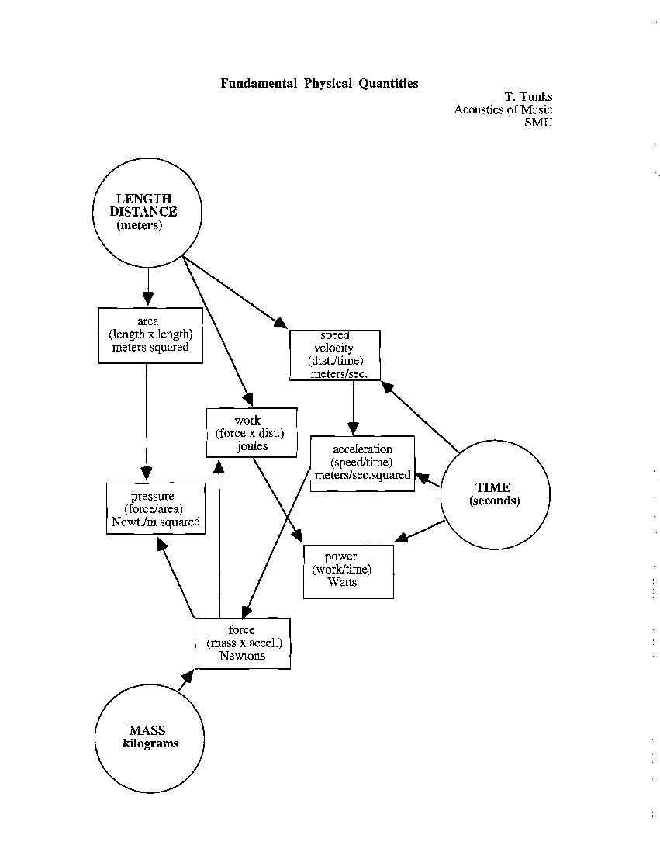
IMPORTANT TERMS
Backus, Ch. 1
Fundamental Physical Quantities

Length - meters, feet (distance)
Time - seconds
Mass - kilograms, pounds
Speed, Velocity - distance per time (meters/second)
Area - length by length (m2)!
Acceleration - velocity per time (meters per second per second, or m/sec.2)
Volume - area by height (m3)
Force - mass by acceleration (1 newton = 1kg/sec2)
Work - force by distance (1 joule = 1 newton by (across) 1 meter)
Pressure - force per area (newtons/m2)
Power - work per time (1 watt = 1 joule/sec)
Vector - a vector quantity is one that takes into account direction
Momentum - the property of a mass in motion to remain in motion
Equilibrium - occurs when the net force acting on a mass is zero, or no acceleration

NOTE: semantically, "by" means "times", and "per" means "divided by"

Backus, Ch. 2
Simple Vibrating systems

vibration - oscillation
periodic motion
period, T
cycle
frequency, f, Hz
simple harmonic motion, SHM
amplitude
displacement
restoring force
momentum
phase
sine curve
pure tone, sinusoid
fundamental frequency
mass - stiffness
natural frequencies
damping
driving force
f=1/T
T=1/f
envelope
wave history
time domain/frequency domain graphs

IMPORTANT TERMS
Backus, Ch. 3
Waves and wave propagation
medium
propagation
compression
expansion (rarefaction)
density
elasticity
longitudinal wave
transverse wave
tension
displacement-time, pressure-time curves
pressure/displacement phase relationship (90 degrees)
wavelength ( λ )
speed of sound (344 m/s at 20 degrees C, 1131 ft/s at 72 degrees F)
s=332 m/s at 0 degrees C + .6 m/s for each degree C different
s=1087 ft/s at 32 degrees F + 1.1 ft/s for each degree F different

s=d/t
t=d/s
d=st
s=fλ
λ=s/f
f=s/λ
reflection
refraction
diffraction
phase
constructive interference, destructive interference
beats (fb=f1-f2)
Doppler effect
efficiency
intensity
inverse square law
absorption
IA = I-IR
absorption coefficient
a = IA/I

IMPORTANT TERMS
Backus, Ch. 4
Complex Vibrations and Resonance

standing wave
node
antinode
λ = 2L
f1 = s/2L
vibratory modes
harmonics, partials, overtones
open tube function (open pipe)
stopped (closed) tube function (stopped pipe)
end correction (1/3 d)
conical pipe function
vibratory modes of membranes and plates
resonance
sympathetic vibration
Helmholtz resonator
linear and logarithmic scales

IMPORTANT TERMS
Backus, Ch. 5
The Ear and Loudness

outer ear
pinna
ear canal (auditory meatus)
eardrum (tympanic membrane)
middle ear
oval window (fenestra ovalis)
round window (fenestra rotunda)
ossicles
hammer (malleus)
anvil (incus)
stirrup (stapes)
eustachian tube
acoustic reflex
stapedius
tensor tynpani
inner ear
cochlea
upper gallery (scala vestibuli)
cochlear duct (scala media)
Reissner's membrane
lower gallery (scala tympani)
basilar membrane
helicotrema
organ of Corti
hair cells
tectorial membrane
intensity (I) in Watts per squared meter
intensity level (IL) in dB (10 log I1/I2)
intensity ratio
sound pressure level
SPL) in dB (20 log p1/p2)
threshold of audibility
Fletcher-Munson curves
equal loudness contours
loudness level (LL) in phons
threshold of feeling (pain)
loudness (L) in sones
masking
masked threshold
partial masking
sound level meter
dB(A)
temporary threshold shift
permanent threshold shift

OSHA occupational standard
90 dB, 8 hrs.;
halve time for each 5 dB increase

presbycousis

IMPORTANT TERMS
Backus, Ch. 6
Tone Quality
timbre
steady state
transient/instrument identification
waveform
harmonic spectrum
Fourier components
resynthesis
phase of partials/waveform/timbre
averaging
average spectrum envelope
loudness spectrum
formants/formant region
long time averaging spectrum (LTAS)
vibrato
chorus effect
aural harmonics
combination tones
simple difference tone (f2-f1)
cubic difference tone (2f1-f2)

IMPORTANT TERMS
Backus, Ch. 7
Frequency and Pitch
cent
US standard notation
frequency ratios
pitch/amplitude
fusion
place theory
volley theory
critical band
roughness
beats
fundamental tracking
periodicity pitch
autocorrelation
harmonic pattern recognition
central pitch processing
tone height
chroma
pitch spiral
context and expectation
dominance region (500-2K Hz)
dominant harmonics (4,5 for bass, 2,3 for upper treble)
frequency discrimination/pitch discrimination
absolute/relative difference limen
absolute pitch
drift in internal standard

