

November 30, 2006

Dear Science Fair Awards Coordinator:

This letter is an invitation to participate as a Special Award donor at the 2007 Beal Bank Dallas Regional Science & Engineering Fair. As you know, each year we encourage area businesses as well as professional and educational organizations to award prizes at the Fair, which is now entering its 50th year.

The Fair will once again take place at the Automobile Building in Fair Park March 24-25, 2007. All judging will be done on Saturday morning, March 24. Orientation for our Special Award judges will take place that morning at 9:00 a.m., and judging will begin immediately after orientation at 9:30 a.m. Judging will be completed Saturday by 1:00 p.m.

There is no minimum or maximum number of awards your organization can donate. The judging criteria and the nature of the award (cash, savings bond, plaque) is up to you. As always, Special Award donors are required to underwrite the cost of the Awards Banquet for the recipient of each prize they donate and that student’s teacher (see enclosed Donor Prize Form for details).

Donors also need to provide judges to determine their winners on Fair day. You provide the awards to us prior to the Fair (this is critical!), your judges determine and report the winners to our officials on March 24, and we take care of the rest!

All Special Award donors are highlighted in the Awards Banquet program and on our official website DallasScienceFair.org.

For your convenience, I am enclosing information and forms that you will be asked to review and complete should you chose to participate. These include a Donor Prize Form, Special Awards Judges Form, Prize Information Sheet and suggested Judging Criteria. Please note that the Judging Criteria are for your general information only- you may prefer to supplement these guidelines with additional criteria that reflect the uniqueness of your organization. We ask that forms be returned by Wednesday, January 31, 2007, or as soon as possible.

The Special Awards component is critical to the success of our Regional Science Fair, and is truly a wonderful way for professionals to support and endorse excellence in education. Should you have any questions whatsoever, please feel free to call Shirley Melton at (214) 768-2495.

Thank you for your support and consideration!

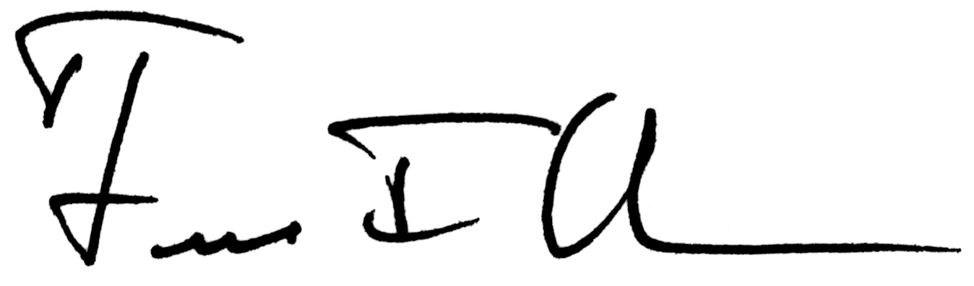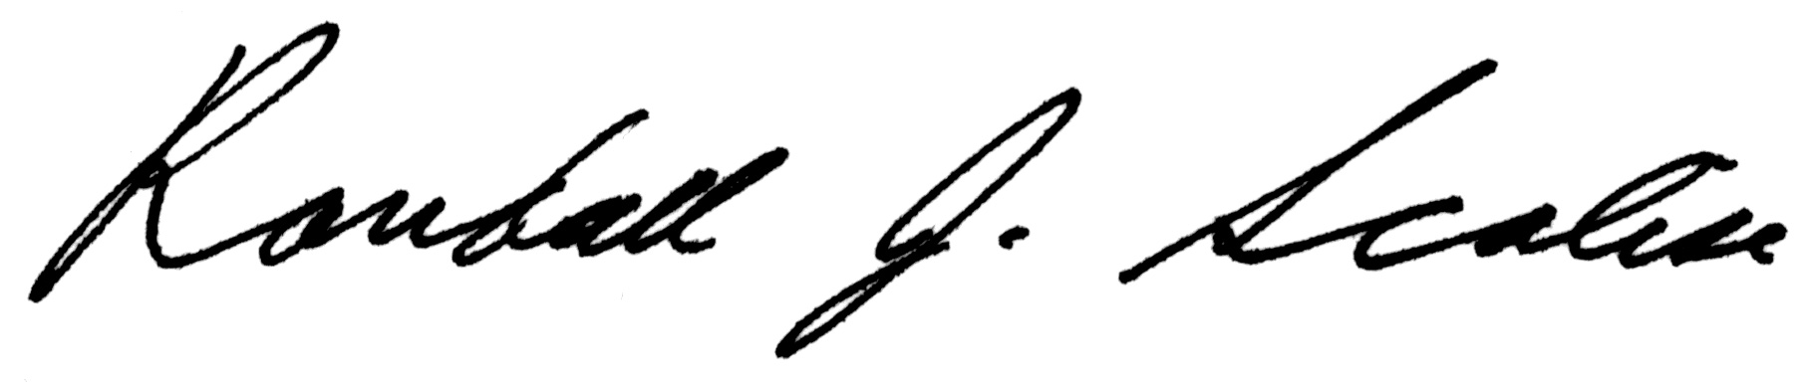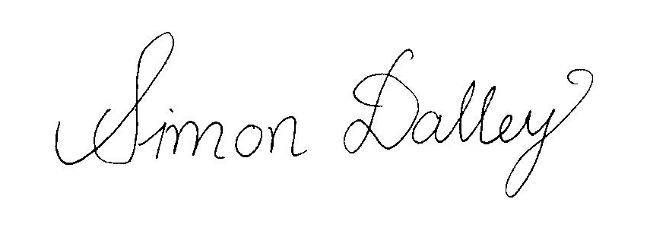
Fred Olness Randall Scalise Simon Dalley

Fair Director Fair Director Fair Director

Southern Methodist University Southern Methodist University Southern Methodist University

