March , 2007

Dear Special Awards Judge:

Thank you for agreeing to be a Special Awards judge at the 2007 Beal Bank Dallas Regional Science & Engineering Fair. We will be back in the Automobile Building in Fair Park on Saturday, March 24, 2007. A map is enclosed that you can also print from our website at http://DallasScienceFair.org.
Your participation as a judge, as well as your organization’s support and generosity, are both critical to the success and continued growth of the Regional Fair. We are sincerely grateful for your time and effort.

To all veteran judges – welcome back! To those of you new to the Fair, we know that you will be inspired by the effort put forth by our exhibitors. We are excited to announce that approximately 700 projects- and 800 students- have been entered into this year’s Fair. Please remember that each has already excelled at their school and/or district levels.

Below is information describing the basic timeline for Special Award judging, as well as a few special reminders and suggestions.

Special Award Judging Information
(Please note Fair Award Judges follow different schedules)

Day/Date: Saturday, March 24, 2007
Place: The Automobile Building at Fair Park (map enclosed and online at http://DallasScienceFair.org)
Parking: Parking is free of charge. The most convenient parking will be immediately adjacent to the Music Hall. You can enter through the First or Grand Avenue entrances to Fair Park. Handicap parking is available immediately outside the main entrances to both the Automobile Building and the Music Hall.

Attire: Suggested attire is business casual, with comfortable shoes.

To Bring: A clipboard, paper and pen are suggested for additional notes you may take.

Timeline:

Judge Breakfast: 7:30 a.m. – 9:00 a.m. (Informal – coffee, doughnuts, etc.)
Judge Orientation: 9:00 a.m. – 9:30 a.m.
Award Judging: 9:30 a.m. – 1:00 p.m.
(Judging time varies by award; judging must be completed by
1:00 p.m. PLEASE NOTE that all students are dismissed from the building promptly at Noon!! The remaining hour is for additional discussion or comparison of projects, if necessary.)
Judges Lunch: 12:00 p.m – 1:30 p.m.

Special Awards
Page 2

During your Special Awards Judge Orientation, you will receive instructions and have ample opportunity to ask any questions you may have. You will also receive a report, broken down by individual science, project number and title, to aid you in your judging process.

We have included in this mailing a suggested “Criteria for Judging”. Please note that these judging criteria are for your general information only. It is recognized that you may prefer to supplement or replace these guidelines with additional criteria that reflect the uniqueness of your organization.

Once again, that you for agreeing to participate on behalf of your organization as a Special Awards judge. Your commitment of time, energy and resources is one of the reasons this Fair is entering its 50th year stronger than ever. Please call Shirley Melton at (214) 768-2495 should you have any questions.

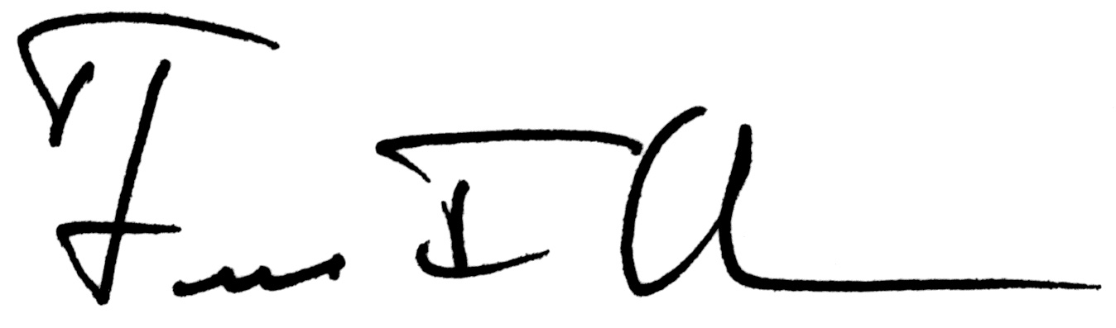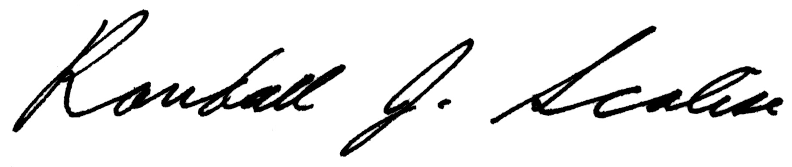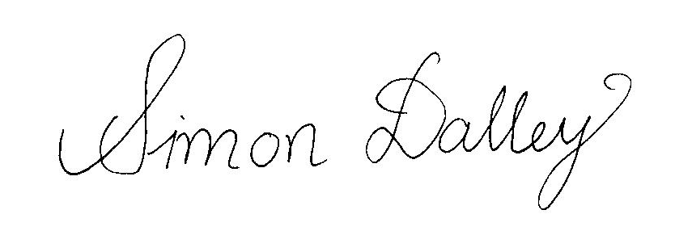

Fred Olness Randall Scalise Simon Dalley
Fair Director Fair Director Fair Director

Southern Methodist University

2007 BEAL BANK DALLAS
REGIONAL SCIENCE & ENGINEERING FAIR
JUDGING CRITERIA

SUGGESTIONS FOR JUDGING A SCIENCE AND ENGINEERING
FAIR PROJECT

A good project should involve the scientific method:

Purpose + Hypothesis + Procedure + Results + Conclusion

The criteria listed below is provided for your information and suggested use:

I. CREATIVE ABILITY 0-30 points

Does the project show creative ability and originality?

II. SCIENTIFIC THOUGHT/ENGINEERING GOALS 0-30 points

Is the problem stated clearly and does the project have a clear objective?

III. THOROUGHNESS 0-15 points

Does the project carry out its purpose to completion within the scope
of its original aims?

IV. SKILL 0-15 points

Does the student have the skills required to do all of the work
related to the project?

V. CLARITY 0-10 points

How clearly is the student able to display and discuss the project?

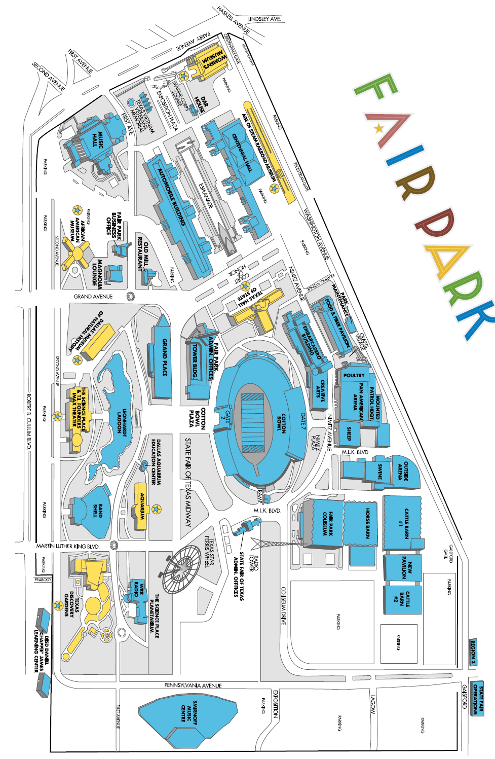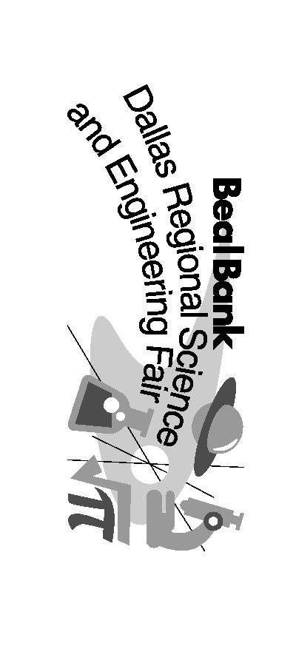
PARKING
PARKING
SCIENCE FAIR HERE !
AUTOMOBILE BUILDING
Enter from South side of building
SCIENCE PLACE
north
GRAND AV.
MARTIN LUTHER KING
ROBERT CULLUM BLVD
3
4
5
6

