November 30, 2006

Dear Potential Judge,

This letter is an invitation to serve as a judge at the 2007 Beal Bank Dallas Regional Science and Engineering Fair. All judging will take place on Saturday, March 24, 2007 at the Automobile Building in Fair Park. The event will be open to the public on Sunday, March 25. The Regional Science Fair is an invaluable educational opportunity for our students, due in large part to the efforts of our over 300 judges. Your participation at the 2007 Fair would be greatly appreciated!

Judge Orientation begins on Saturday, March 24 at 8:00 a.m. (breakfast provided), with judging beginning at 9:00 a.m. All judges are required to participate in the first round of judging, which will be completed by 1:00 p.m. (lunch provided). We encourage as many judges as possible to stay through the second round of judging, which concludes no later than 3:00 p.m. that day.

As a judge, you will be a part of a three-member judging group that will be asked to interview approximately ten students during a two-hour period. Following the interviews, your judge group will evaluate the projects and collectively agree on the students who advance to the second round. Complete information and criteria will be mailed to you prior to the Fair and reviewed during Judge Orientation.

Captains are required to participate in the second round of judging. They (along with all other judges who elect to stay for the second round) determine the Science Fair winners. Captains are also asked to perform a few very simple administrative duties on Fair day.

On the “Judge Information Form”, indicate the grade level you would prefer, the sciences you would like to judge, and whether you would like to be a Captain. We will make every effort to honor your requests. Please either register online at http://www.smu.edu/sciencefair/registration/judge.asp or return the forms by mail or fax by Friday, December 22, if possible.

Thank you for considering our request. I hope to see you on Saturday, March 24!

Sincerely,
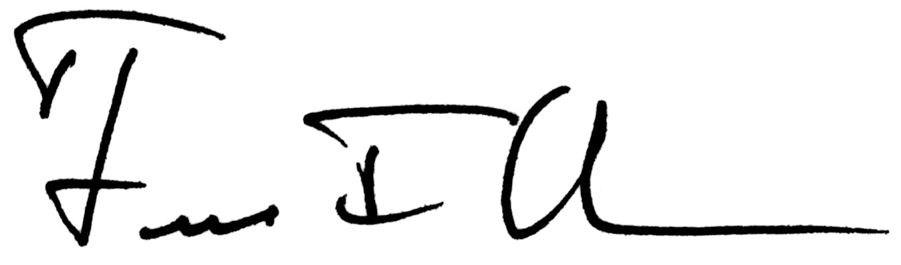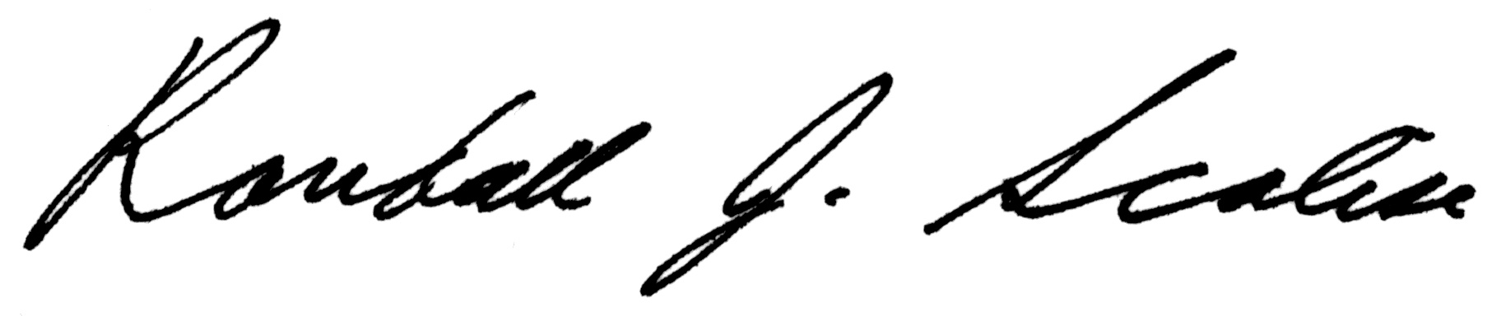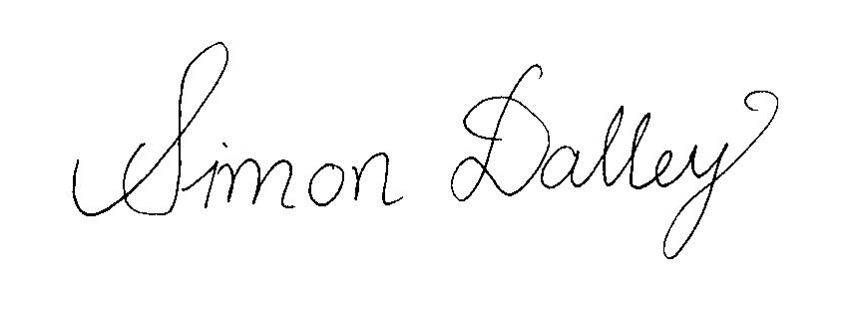
Fred Olness Randall Scalise Simon Dalley

Fair Director Fair Director Fair Director

Southern Methodist University Southern Methodist University Southern Methodist University



