PHYSICS 1311
Lab Exercise #6

Constructing the Orbit of Mars

Introduction
Johann Kepler chose Mars as the planet to study in his effort to understand how the planets really moved. This was a fortuitous choice as you will see.

Prior to Kepler's work, the extant view of the universe held that the planets moved in perfect circles (or combinations of perfect circles) around the Earth. This worked fine until instruments advanced far enough to allow measurements sufficiently precise to show the problems with the theory; the first such measurements were made by Tycho Brahe at the end of the 16th century. After Brahe's death in late 1601, it fell to his former assistant Kepler to interpret the measurements and discover the astonishing truth that they contained.

Among many other position measurements, Brahe had measured the position of Mars against the background stars far more accurately than anyone had done before. Brahe did not have a telescope - that was not invented until about the time of his death. He used a simple gunsight-like sighting device on his angle-measuring sectors. With these devices he measured angles to an accuracy of several minutes of arc. With his later, better instruments he achieved an accuracy of 1 minute of arc, a performance which is considered unbeatable even today using similar equipment.

Kepler realized that he could take advantage of the number of Brahe's observations plus the knowledge of how long it takes Mars to orbit the Sun in order to plot the actual shape of Mars' orbit. It was known to Brahe and Kepler that Mars orbital period is 687 days and Earth's orbital period is 365.24 days.

Kepler took advantage of this knowledge to construct the actual appearance of Mars' orbit. If you measure the apparent position of Mars against the background stars on some date, you know that 687 days later Mars will be back to that exact same point in its orbit. On that later date you observe the apparent position of Mars again. Earth is not back where it was on the date of the first observation because 687 days is not an even multiple of 365.24; it is about 43 days short of two years. Earth is in a different point in its orbit, so you have two observations of Mars in one place from Earth in two places. The printed exercise contains five pairs of positions derived from Tycho Brahe's observations.

The orbit of Mars turned out to be an ellipse. The ellipse is a closed curve of which the circle is a special case.

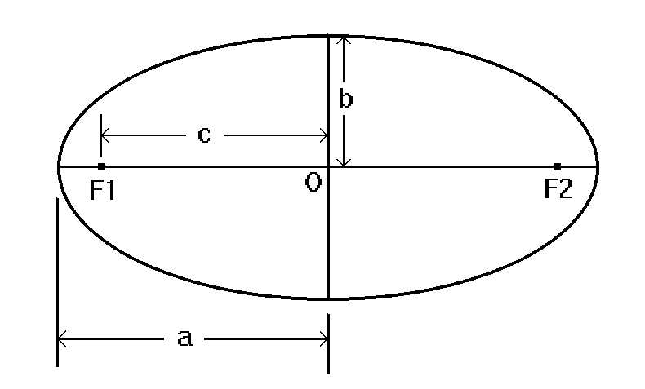

Figure 1 - The ellipse

The components of the ellipse are labeled; a is the semi-major axis (one half the long dimension), b is the semi-minor axis (one half the short dimension), c is the distance from the origin O (the center) to either focus, and F1 and F2 are the two foci.

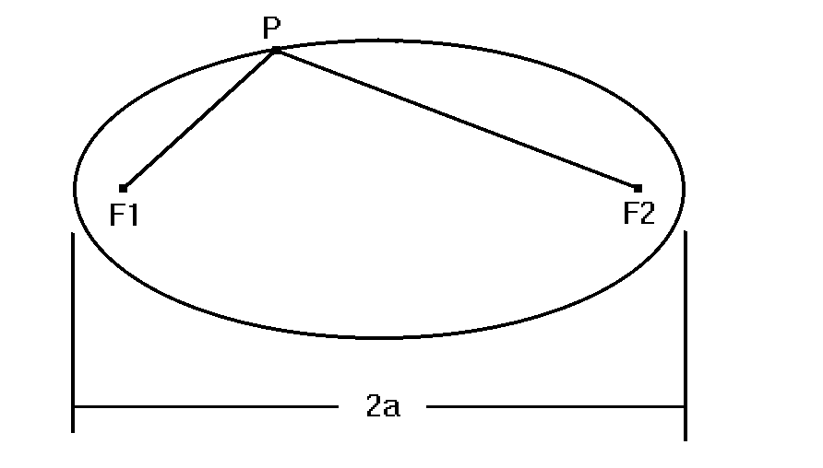

Figure 2 - Point on ellipse

If P represents any point on the ellipse, then
where PF1 and PF2 are the distances from point P to the foci. In other words, the sum of the distances from any point on the ellipse to both foci is equal to the length of the major axis.

An ellipse has one more important property - its eccentricity. Eccentricity is defined as

or, equivalently, as the distance between the center and one focus divided by half the length of the major axis. You can also consider it to be the distance between the two foci divided by the length of the major axis. Note that the eccentricity is a dimensionless number.

If you place both foci at the center so they coincide, the distance between them becomes zero and so does the eccentricity. In this case the ellipse becomes a circle, which is an ellipse with an eccentricity of zero.

The actual data you will use, plus more details, will be found in the printed exercise (LE015) which will be supplied in the lab.

Objectives
1. To explore ellipses.
2. To construct the orbit of Mars in the same way that Kepler did it.

Equipment
Copy of LE015, paper, ruler, protractor, compass, string, pins, pencil, drawing board, tape.

Procedure
1. To explore ellipses.
Here you will use the string, pins, drawing board and pencil. The board provides a drawing surface that you can stick pins into.

Tape a fresh piece of paper onto the board; either blank or lined paper will do. Locate the center of the piece of paper and make a pencil mark there. Orienting the drawing board in landscape format (long dimension horizontal), use the ruler to draw a horizontal line across the paper going through your center point mark.

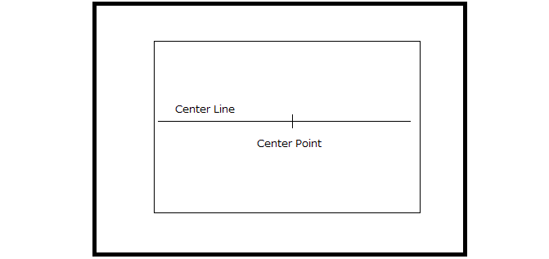

Figure 3 – Paper Setup for Ellipses

Tie the string into a loop which, when looped around the pins, will keep the pencil on the paper.

Measure along your horizontal line and mark points a few centimeters on either side of the center point. Push a pin into the paper (and the board) at each of these points, making sure that the pins are equally spaced from the center. Measure the distance between the pins and record that value. Loop your string around the pins, then put the pencil point in the loop and pull it tight. Now move the pencil around the pins, keeping the loop tight at all times. This will draw an ellipse. Measure the length of the major axis and record the value. Calculate the eccentricity and record that value.

Now choose another distance from the center and place your pins at those points. Draw another ellipse, measure and record the major axis, and compute and record the eccentricity. Repeat this for a third ellipse.

2. To construct the orbit of Mars in the same way that Kepler did it.

First, read the copy of LE015 that you have. Spend enough time to go through it carefully. It contains instructions and data. Follow the procedure contained in the printed exercise. For making your drawing, tape a fresh piece of ruled (not plain!) paper to the drawing board. Orient it in portrait format (long dimension vertical). Use two small pieces of tape to hold it.

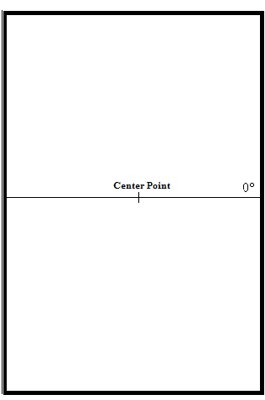

Figure 4 – Paper Setup for Mars Orbit

As before, find the center point of the paper and mark it. Now make a working center point on the nearest ruled line on the paper. It is very important that your working center point be loctaed on one of the ruled lines.

Draw a horizontal axis on the ruled line going through the center point. At the right end of the ruled center line write “0°” at the edge. This is your 0 degree longitude point. Continue by following the procedure in LE015.

For assistance, here is an outline of how to plot the pairs of points in the exercise.

a. Place the center of your protractor at the center of the Earth orbit circle. Align it with the rulings on the paper. Make a mark at the longitude angle of the first Earth position of the pair. Lay your ruler between the center and the mark, then make a point on your Earth orbit circle at the longitude angle of the first Earth position of the pair.

b. Move the center of your protractor to the Earth position you just marked, square it up with the rulings on the paper and lay out a point at the longitude angle given for Mars.

c. Draw a line from the Earth mark to the point you just laid out at Mars' longitude. This is the sight line from Earth to Mars on the given date.

d. Plot the second point of the pair in the same way. Draw the sight line as above.

e. The intersection of the two sight lines is the physical position of Mars. Make a mark at the intersection to mark the position of Mars.

Note: The fourth date in the data table in LE015 is misprinted. It should be 1593 Aug 6.

