PHYSICS 1311
Lab Exercise #7

Measure the Solar Constant

Introduction
The Sun constantly supplies the Earth with energy in the form of sunlight. Without that energy input, the Earth would quickly freeze. In this experiment you will actually measure how much solar energy arrives on Earth.

The experiment uses a jar of water. The black tape in the jar will absorb solar energy and transfer it to the water. It takes one calorie of energy to raise the temperature of one cubic centimeter by one degree Celsius. By placing the jar in direct sunlight for a time and measuring the temperature change in the water you can measure the energy collected by the jar. The amount of solar energy falling on a square centimeter in one second is called the solar constant.

This experiment obviously requires a clear day - if the weather is not suitable other arrangements will be made.

Objectives
1. To set up an experiment to measure the amount of solar energy striking the Earth's surface.
2. Use the setup to measure solar energy input.

Equipment
Large jar specially prepared, thermometer, water, ruler, 1 liter graduated beaker.

Procedure
1. Do this on a really clear day. We will adjust the schedule to get a clear day.

2. First, before going outside, measure and record the collecting area of your jar. This is simply the product of the jar's inside diameter and the height of the area of black tape. You will have to "eyeball" carefully to measure the inside diameter of the jar, as you cannot reach it directly. Record the collecting area in the data sheet. Your area should be something just over 100 cm², but the tape areas in the jars are not identical, so measure yours carefully.

3. Fill your jar with cold tap water, filling it exactly to the top of the black area. You will fill the jar 4 times during this experiment, and you must be very careful to use the same amount of water each time. You should also be sure to fill the jar from the same faucet each time. Do not fill your jar from either a cold water fountain or a hot water faucet; the temperatures will be outside the range of the thermometers. Use the cold water faucet.

4. Take the jar outside and locate a place where you can set up it up facing the Sun. Keep the jar in shade until you set it up, using your own shadow if necessary.

5. Put the jar down on a level surface, take off the lid and immediately take a temperature reading, reading the thermometer to 0.1 degree Celsius if possible. The electronic thermometer will require at least 30 seconds to stabilize at the correct reading. Keep the jar in shade as you do this. Use the first data line labeled "Sun". Record the date in the space provided. Record the time under "Start". Record the temperature under "Temp." Put the lid back on the jar.

6. Now prop the jar up with books, rocks or something else so that the front of the jar is as close as possible to perpendicular to the Sun's rays; this assures maximum absorption of the energy. Allow the Sun to shine on the jar. Figure 1 below illustrates proper setup.

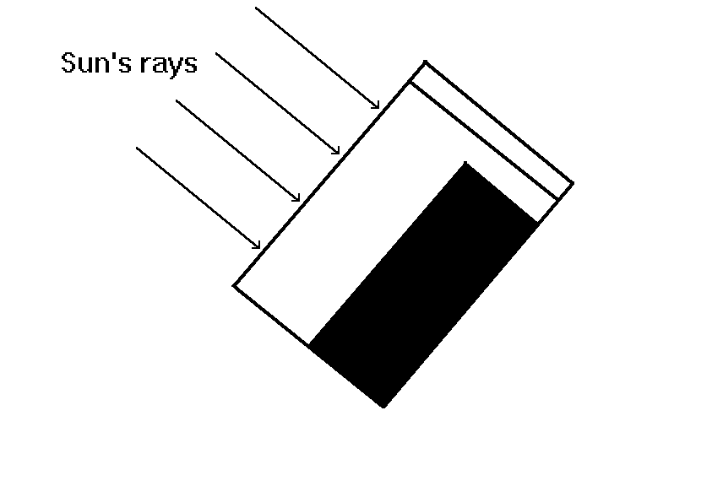
Figure 1 - Performing the experiment

You can use the shadow of the jar lid to determine when the jar is square on to the Sun. Simply adjust the jar's angle until the shadow of the top of the lid becomes a straight line.

7. After the Sun has shone on the jar for exactly 15 minutes, shade the jar again, level it, remove the lid again, take another temperature reading and record the value. Record the time under "End". Record the temperature in the second "Temp" column. Be very careful to make the time interval of Sun exposure precisely 15 minutes.

8. Subtract the starting temperature from the ending temperature and record this in the "Change" column. If the temperature goes down, the result will be negative. This result is the temperature change during the 15 minute period.

9. Calculate the rate of energy input by dividing the total temperature change by the number of minutes of energy collection (15) and enter this in the "Rate" column. This rate is in degrees per minute. Be sure to preserve the sign.

10. Empty your jar - into the graduated beaker after the first measurement and onto the grass thereafter. When you dump your jar into the beaker, measure the volume of water and record that volume in the data sheet. Take the jar inside and refill it with water, being careful to use exactly the same amount of water from the same source as you did for the first measurement.

11. Take the jar back outside to your setup location. All measurements must be taken with the jar in the same or similar position each time. With this next reading you will measure the temperature change due to air temperature. This time you must use some kind of shield (cardboard, book, yourself, etc.) directly in front of the jar to shade it completely. It is important that you not allow any sunlight to strike the jar at any time during this measurement. The reason for this is simple - the jar is in direct contact with the air. Water temperature will move toward the air temperature. Any sunlight will have a warming effect which interferes with the air temperature effect.

12. Now do as before, measuring the temperature, waiting 15 minutes and measuring again. The only difference between this measurement and the first one is that the jar is placed in complete shade. The Sun must not shine on the jar at any time. This allows measurement of heating or cooling of the water due to the ambient temperature of the air. Record your data as above, but using the first line labeled "Shade".

13. Now repeat steps 2 through 10 above. When you are done will have two measurements with the jar in the Sun and two with it shaded. To record your data, use the second "Sun" line first, then the second "Shade" line.

14. Compare the "Change" values for both "Sun" measurements and both "Shade" measurements. They should be about equal and in the range of approximately 2 to 4 degrees C. If they are not about the same, you may have something wrong. Consult the instructor.

15. Now average the two "Rate" values for "Sun" and enter the result in the data sheet. Next average the two "Rate" values for "Shade" and enter the value in the data sheet.

16. Now you calculate the temperature change rate that was caused by the Sun. In this step you account for the temperature change caused by the air. Simply subtract the "rate in Shade" from the "rate in Sun", making use of the sign of the shade rate. Record this rate in the space in the data sheet. You now have the rate of temperature change caused by solar energy.

17. Compute the number of calories per minute absorbed by your jar by multiplying the corrected temperature rise rate by the water volume. Enter this in the data sheet.

18. Now divide the total calories per minute by the collecting area to get calories per minute per square centimeter. This is the provisional solar constant. The value you measure will depend somewhat upon how much atmosphere the Sun's light has passed through before it hit your jar. The most accurate measurement is made from a satellite above the atmosphere; this avoids all atmospheric effects.

